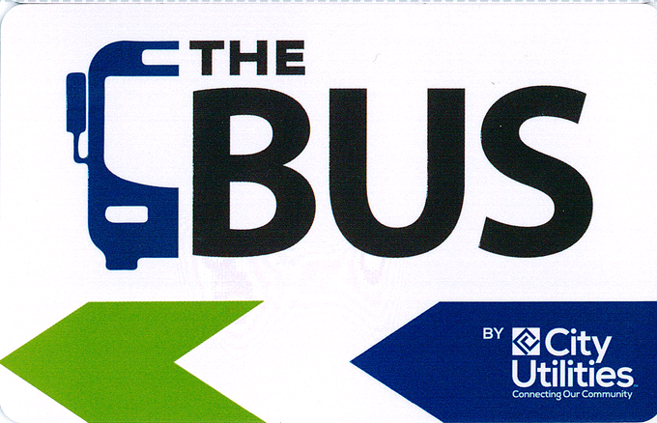
City Utilities Transit is moving forward with our implementation of smartcards. We have completed our testing and are looking to the Fixed Route Advisory committee to purchase your next 7-day or 31-day pass on the smartcard we provided you to help us see the user experience.

You may bring your smartcard to the Sales Window at the Transit Center at 211 N. Main to be loaded with your next purchase. You may place one of the following passes on your card at the regular fare.
Picture of Smartcard

7-Day Youth
31-Day Youth
7-Day Elderly & Disabled
31-Day Elderly & Disabled
7-Day Adult
31-Day Adult

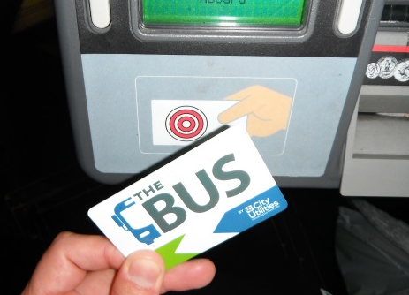
Your smartcard will be initialized upon its first use at the farebox. It is used at the farebox by passing over the front left corner of the farebox. The screen will indicate the type and expiration date of the pass. The driver can assist you with this.

Smartcard use on Farebox

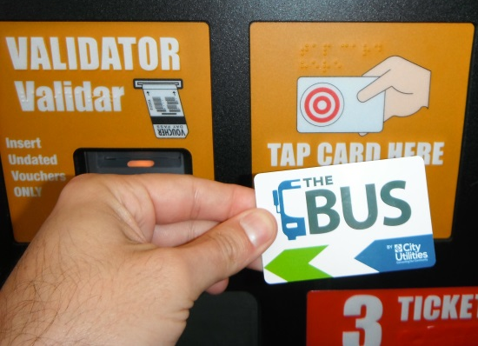
Passes may be reloaded at the Sales Window at the Transit Center or at the Ticket Vending Machines. The Ticket Vending Machines are located at the Transit Center and Transit Offices at Boonville and Division. Ticket Vending Machines will currently only accept cash and change will only be given on a change card. The change card can be redeemed at a Ticket Vending Machine or at a farebox.

Smartcard use on Ticket Vending Machine

A smartcard can only be reloaded with the same type of pass it currently has on it and will extend out the expiration date by the length of the pass loaded on the smartcard. For example, a 31 Day Adult pass on a smartcard with an expiration date of October 8, 2016 can be reloaded with only another 31 Day Adult pass. If reloaded before the current pass expires, the expiration date will be extended on the pass until November 8, 2016 (extended 31 days). If allowed to expire, the smartcard can be reloaded with any of the six types of passes listed above.

