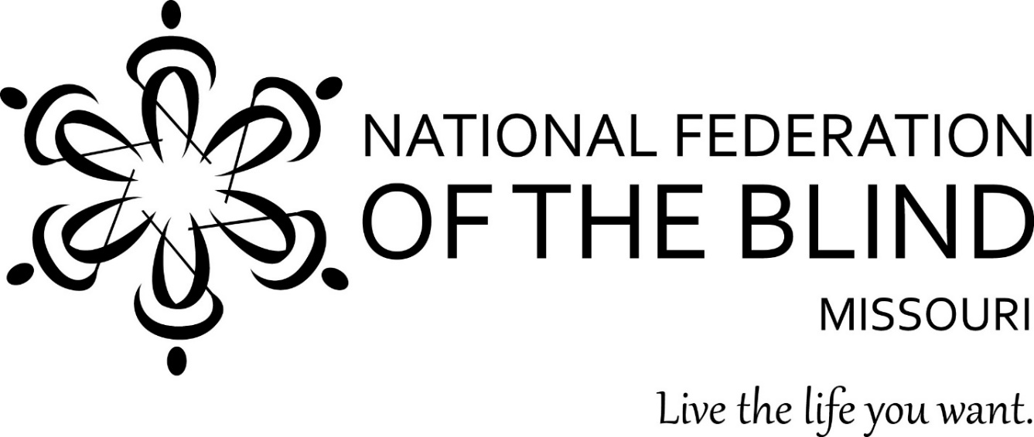

Dear Sir or Madam,

We of the [chapter name] of the National Federation of the Blind wanted to introduce ourselves to you. The National Federation of the Blind is the oldest and largest organization of the blind in the United States. The Federation believes that blindness is not the characteristic that defines you or your future. Every day we raise the expectations of blind people, because low expectations create obstacles between blind people and our dreams. The Federation reaches out into the community to help tear down obstacles on the national, state, and local levels. The National Federation of the Blind has college scholarship programs; Science, Technology, Engineering, and Mathematics (STEM) education programs; The Braille Enrichment for Literacy and Learning (BELL) Academy; and informational seminars on topics such as Social Security, accessible technology, and other programs.

The Federation also understands that not everyone knows the best way to handle expectations for a blind student and their educational experiences. We don’t claim to be the only experts, but we have experience that we are willing to share to help remove obstacles in the educational process.

The following page has contact information for your local chapter of the National Federation of the Blind if you have questions or want to talk to someone nearby. It also lists websites and social media for our organization on a state and national level, so that you can learn about us and our philosophy.

Thank you for your time, and we hope that we can be a useful resource for you in the future.

Members of the [Chapter name]

LOCAL CHAPTER OF THE NATIONAL FEDERATION OF THE BLIND

Chapter name:

Contact name:

Contact phone number:

Contact email address:

Any special instructions for contact:

Chapter meeting date/time:

Chapter meeting location:

Chapter Facebook:

Chapter Twitter:

National Federation of the Blind of Missouri webpage: [www.nfbmo.org](http://www.nfbmo.org)

National Federation of the Blind of Missouri Facebook: [www.facebook.com/nationalfederationoftheblindofmissouri/](http://www.facebook.com/nationalfederationoftheblindofmissouri/)

National Federation of the Blind webpage: [www.nfb.org](http://www.nfb.org)

National Federation of the Blind Facebook: [www.facebook.com/NationalFederationoftheBlind/](http://www.facebook.com/NationalFederationoftheBlind/)

National Federation of the Blind Twitter: [www.twitter.com/nfb_voice](http://www.twitter.com/nfb_voice)

National Federation of the Blind YouTube Channel: [www.youtube.com/user/NationsBlind](http://www.youtube.com/user/NationsBlind)