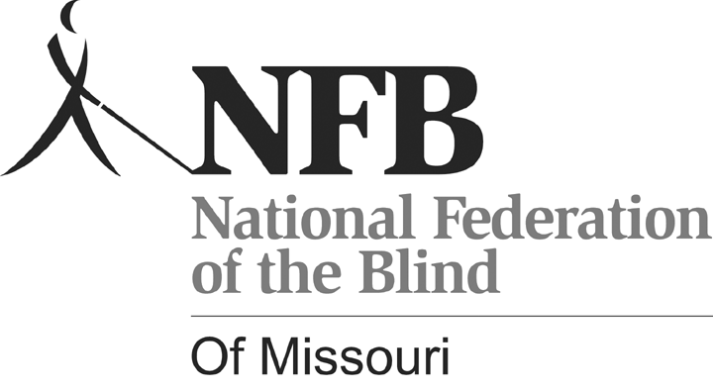
Shelia Wright, President
7928 NW Milrey Drive
Kansas City, MO 64152
Phone (816) 741-6402
www.nfbmo.org

LEGISLATIVE AGENDA OF BLIND MISSOURIANS

PRESENTED TO
THE SECOND SESSION of the NINETY-NINTH GENERAL ASSEMBLY

From: The National Federation of the Blind of Missouri

Date: February 12 & 13, 2018

The National Federation of the Blind knows that blindness is not the characteristic that defines you or your future. Every day we raise the expectations of blind people, because low expectations create obstacles between blind people and our dreams. Blindness is not what holds us back.

This is the message we bring to blind Missourians and the communities we live in. We pledge to be a resource to you and your constituents when they turn to you for help.

The National Federation of the Blind is a membership organization of and for the blind. As a volunteer grassroots organization, we are blind people working on behalf of blind people. We come together on the local, state, and national level to address issues of importance to our fellow blind citizens. We promote programs that encourage self-determination, independence, and equality of opportunity.

Why a Research-Based, Standardized Reading Media Assessment Is Needed

The desirability of learning to read efficiently has never been a question in your education. Not so if one is blind. The equivalent of print for the sighted is Braille for the blind, and this is recognized in the education laws of Missouri in RSMo 167.225. Though the law says that no blind person shall be denied instruction in Braille, it does allow school districts to conduct evaluations to determine whether print or Braille is the most appropriate method for reading and writing for a given student. Far too often print is determined to be the most appropriate reading medium because the process used in making evaluations is flawed and because the strong preference of teachers and school administrators is to teach what they know and use the resources easily available to them.

The consequences for blind students are devastating. Blind people who can see enough to read some print require that it be enlarged. In the early grades this is how it is presented, but when learning to read is replaced by reading to learn, the print gets smaller and the amount of it that one must read gets larger.

It is common practice for students with visual impairments to hold reading materials very close to their face, and/or to hunch their body over the materials when reading. In addition to the posture and other health concerns these reading positions raise, years of field practice and experience have demonstrated that youth who read print materials at very close distances suffer eye strain, headache, neck and back pain, fatigue, and diminished concentration, reading speed, and comprehension. How can any positive association be formed if this is what reading means? Consequently, any valid assessment should ensure that children are evaluated when sitting up straight and with materials held or placed at standardized distances.

Senate Bill 681, introduced by Senator Jacob Hummel, is designed to modify Missouri's statutes so that Section 167.225 mandates the use of the National Reading Media Assessment (NRMA) or another research-based assessment. Knowing the resistance we have seen from special education administrators, we firmly believe that adding “standardized” to the definition of assessment to be of great importance. We know hundreds of adults and many children who have been denied the opportunity to learn Braille. A research-based, assessment could have avoided their education being compromised. Our state must have a clear standard which is both reliable and valid to use in determining who will be taught print, who will be taught Braille, and when both print and Braille are appropriate. Bringing blind people into the workforce demands this change given that 80% of employed blind people read Braille. We urge the Missouri General Assembly to embrace literacy for the blind with the same vigor that our society embraces literacy for the sighted.

Accessible Voting In All Elections

The Help America Vote Act (HAVA) recognizes the right of the blind to vote privately and independently by requiring nonvisual access for the blind through the use of accessible voting systems in all federal elections. Electronic voting technologies, designed and properly configured with nonvisual access, provide blind voters with the ability to cast their votes privately and independently and to verify, without sighted assistance, that their ballots accurately reflect their voting choices. Electronic voting systems were certified and purchased, and Missouri received federal funds for each polling place to provide at least one accessible voting machine. All certified machines in Missouri provide a paper trail.

The Missouri Secretary of State’s Office is evaluating newer machines that mark directly onto the paper ballot. The options are there if legislation is passed to make the paper ballot the official ballot of Missouri and when the existing machines need to be replaced, the technology will be available. The accessible machines are already required for the state to comply with HAVA. Some election boards may set these machines up more frequently than others. We ask that they be used consistently in all elections. The cost of setting them up should be minimal since “text to speech” options are available. Concerted efforts are made to get voters to the polls; Missouri should assure that when they arrive, they have the means to cast their ballots privately and independently.

Beyond the example and financial assistance HAVA has provided to emphasize accessible voting, there are two federal laws that require all elections to be accessible to bring Missouri into compliance. Voters with disabilities have the same right to vote privately and independently as do voters without disabilities. When accessible voting machines are not present in state, county, and municipal elections, blind, visually impaired, and other print disabled voters are denied an equal opportunity to cast their ballot privately and independently. This is a violation of Title II of the Americans with Disabilities Act and Section 504 of the Rehabilitation Act of 1973. As a recipient of federal funds, Missouri and our Election Boards are required to comply with Section 504 of the Rehabilitation Act.

Additionally, the Americans with Disabilities Act guarantees equal access for individuals with disabilities to the benefits of the services, programs, or activities of a public entity. Public entities must provide individuals with disabilities an aid, benefit, or service, that is as effective in affording equal opportunity to gain the same result or benefit as provided to others. Public entities shall furnish appropriate auxiliary aids and services where necessary to afford individuals with disabilities an equal opportunity to participate in and enjoy the benefits of a service, program, or activity of a public entity. To be effective, the auxiliary aids and services must be provided in such a way as to protect the privacy and independence of the individual with a disability.

Whether the financial responsibility falls on the State of Missouri or the County Election Boards is a technicality that must not continue to preclude the full participation of blind, visually impaired, or other disabled Missourians who could benefit from the use of accessible voting equipment. Please assert due diligence in regard to bridging the gap that has prevented this legislation from passing successfully in the past, and grant disabled voters the opportunity and the right afforded us to have the same privilege in every election that you value and take for granted as your right as a citizen of Missouri and of the United States of America.

Salary Range for Rehabilitation Services for the Blind Counselors

The National Federation of the Blind is a strong proponent of education and training, knowing that it is a window to the dream of living the lives we want. The Vocational Rehabilitation counselors with Rehabilitation Services for the Blind are a valuable asset who contribute to the success of blind Missourians. Unfortunately, the salary afforded to these valuable professionals is markedly less than the Vocational Rehabilitation counselors for those with other disabilities through the Division of Vocational Rehabilitation. Though the work is essentially the same, workers for the blind make less because of the classifications found n the Department of Social Services. However, the level of compensation for these comparative positions are not equal and are in need of your attention to address this inequity.

For years Rehabilitation Services for the Blind has had a problem attracting and keeping highly qualified counselors with a Masters Degree and a level of experience that translates into quality, competent, dedicated, and effective counselors. The National Federation of the Blind of Missouri has encouraged raising the pay of RSB counselors to match the salary range for their counterparts in the Division of Vocational Rehabilitation. This would result in retention of highly motivated and empathetic individuals. Regretably our suggestions have yet to be acted upon, and as a result retention of qualified counselors continues to be a problem. We urge that you increase the salary range for counselors who work at RSB so that they match those of counselors who work in the Division of Vocational Rehabilitation. Until you do, the agency for the blind will have trouble recruiting and keeping the counselors the blind need to get the education and training that make us productive tax payers.

