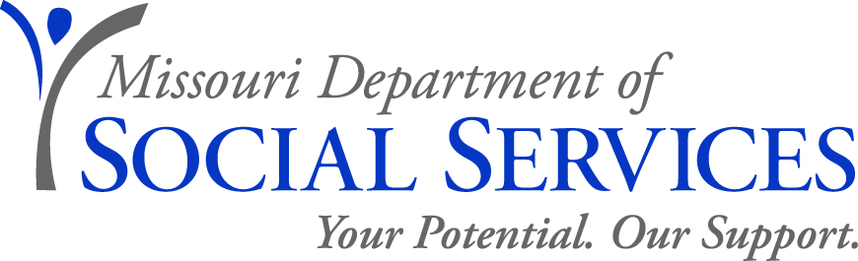

CAREER OPPORTUNITY

REHABILITATION TEACHER FOR THE BLIND
Family Support Division, Rehabilitation Services for the Blind (Cole County)
September 25, 2018

The Family Support Division, Rehabilitation Services for the Blind, is seeking candidates for a full-time position as a Rehabilitation Teacher for the Blind at the Rehabilitation Services for the Blind Jefferson City District 2 Office. This position is located at 3418 Knipp Dr, A-2, Jefferson City, MO 65109.
JOB DUTIES:
- Makes assessments of the impact the loss of vision has on blinded persons, assesses needs of the client and takes steps to assist in compensating for the loss of vision.
- Provides counseling services to individual clients as necessary to help in realistically accepting the loss of vision and to assist the client in remaining a contributing member of the family and community.
- Participates with a rehabilitation counselor and mobility specialist as a member of the rehabilitation team to provide comprehensive services to clients.
- Provides direct teaching services to blind and visually impaired persons in their own homes.
- Interprets services available to blind and visually impaired persons and determines what services are needed and desired.
- Teaches skills necessary for daily living and homemaking activities.
- Teaches braille, scriptwriting, typing and other communication skills, as needed.
- Gives limited travel instruction, with both sighted guide and cane, about the client's home and immediate surroundings.
- Teaches handicrafts for therapeutic purposes.
- Assists blind and visually impaired persons in obtaining and operating special aids and devices such as talking book machines, magnifying aids and homemaking aids.
- Works with the family and other persons in the community as indicated by the needs of the blind or visually impaired person.
- Refers persons in need of eye care, other medical care or special services to an appropriate provider.
- Works cooperatively with personnel in other agencies to enable the blind and visually impaired persons to achieve maximum services and independence.
- Keeps records and makes reports as required.
- Orders equipment and training aids necessary for effective client training and job performance.
- Serves as case manager for all Living Rehabilitation clients and Older Blind services clients.
- Evaluates the need for and teaches blind diabetics in the use of adaptive devices to measure blood sugar and insulin.
- Performs other related work as assigned.
QUALIFICATIONS: Graduation from an accredited four-year college or university with specialization in orientation and mobility, rehabilitation counseling, education, social work, behavioral sciences, home economics (with emphasis in home management) or closely related areas.. The individual must also be able to demonstrate proficiency in and teach Braille, alternative skills of blindness and basic orientation and mobility, before the end of probation as evidenced by successfully completing and obtaining a passing score on a recognized Braille test evaluated by Rehabilitation Services for the Blind.

SALARY RANGE: Annual salary range is $34,416.00 - $48,852.00
HOW TO APPLY: Individuals who meet the required qualifications as specified above and are interested in this position must fill out the DSS Employment Application, resume and any applicable transcripts by email or fax to Jonni Clark at (573) 751-4723 or Jonni.Clark@dss.mo.gov . When emailing your application to Ms. Clark; please specify which position and county you are applying for.
If you have questions regarding this position, please contact Katy Cawdron at 573-751-3434.

RECRUITMENT AREA: Accepting Applications from all qualified candidates.

APPLICATION DEADLINE: October 10th, 2018 at 5:00 p.m.

Applications will be subjected to review prior to scheduling interviews

*** Experience Working with Blind or Visually Impaired Persons is preferred but not required***

DSS IS AN EQUAL OPPORTUNITY EMPLOYER

