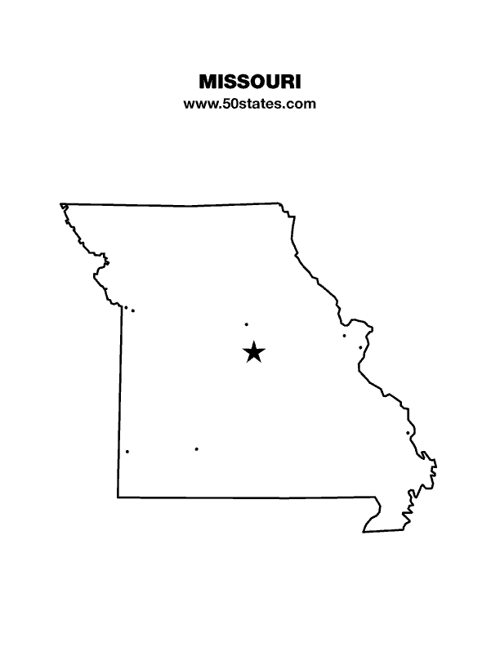
The Blind Missourian
September 2018

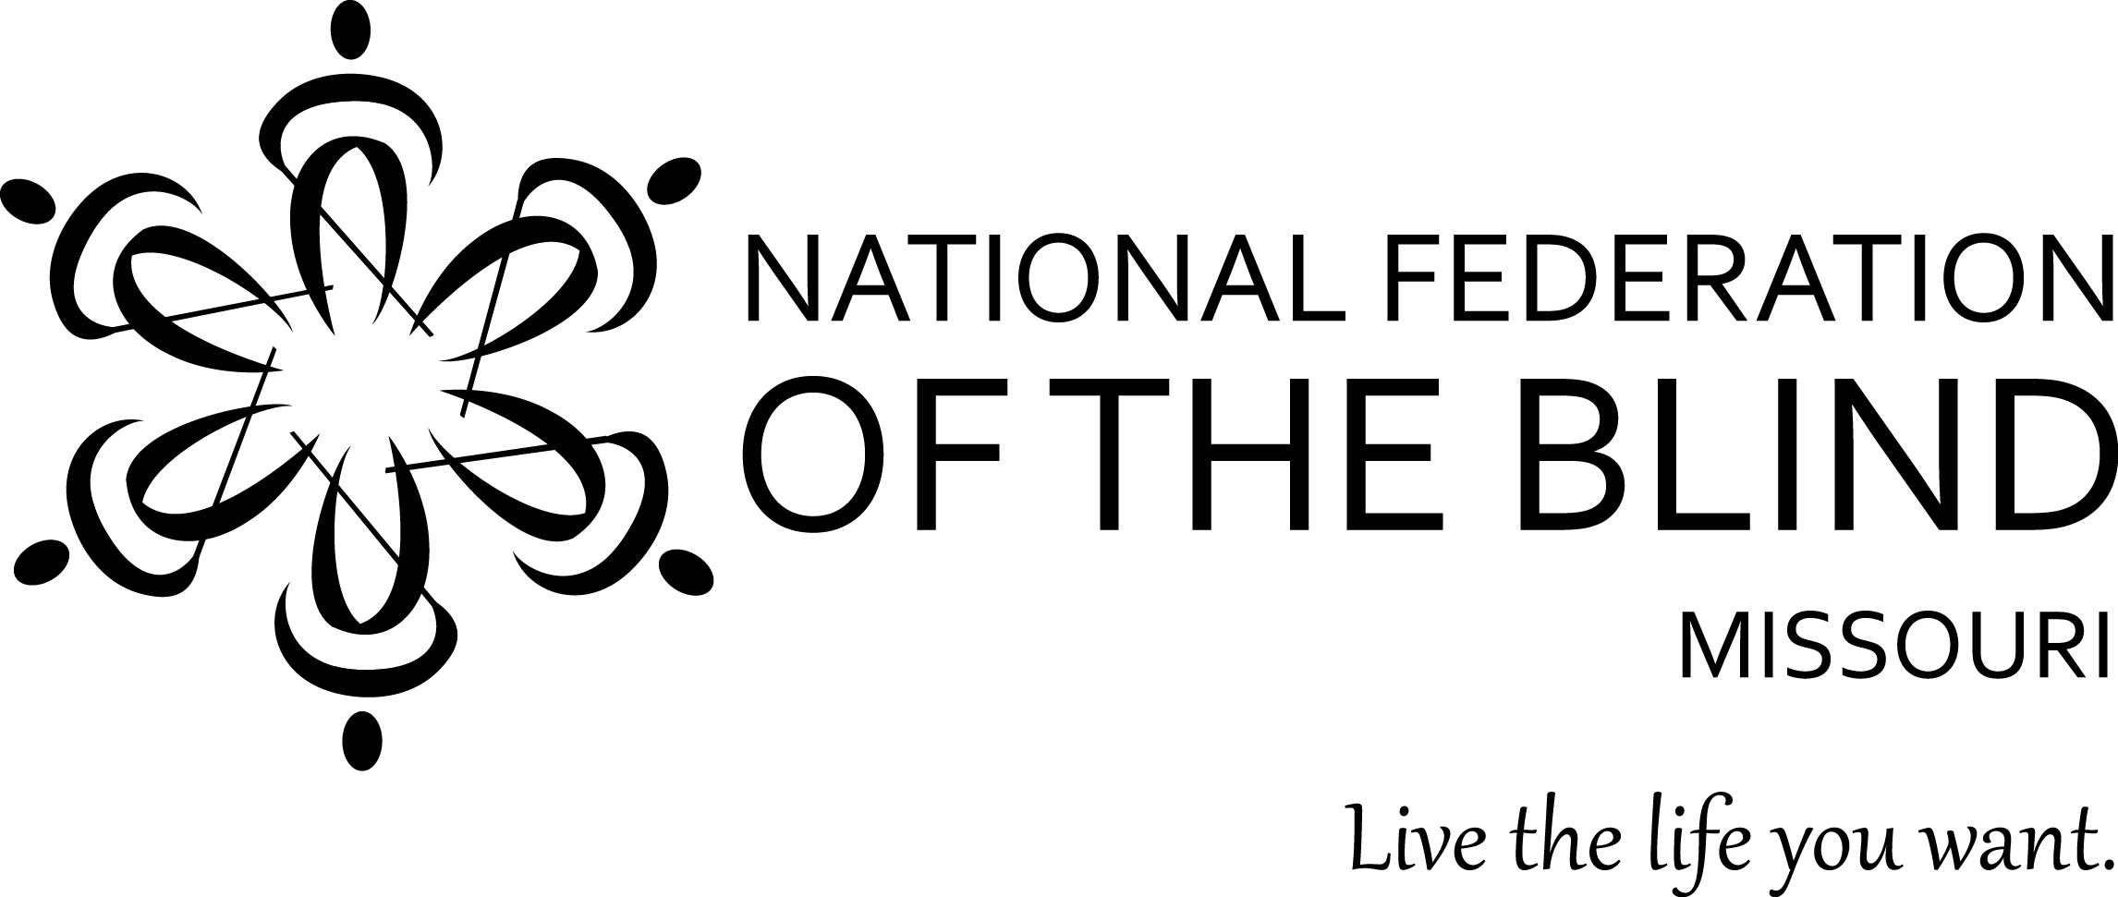

Table of Contents

Congratulations to Robin House
by The Missouri Affiliate 1

The Bells Ring in the West by Debbie Wunder 3

St. Louis BELL by Jenny Carmack 5

Shianne Ramsey Represents Missouri
at Braille Challenge! by Kathy Hurley 6

More on the Blind Pension Settlement by Gene Coulter 8

2018 Float Trip by Christopher Tisdal 9

Fun Fundraising Events 10

One Minute Message 11
NFB Pledge 11

Robin House
By The Missouri Affiliate

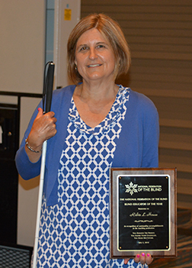
Photo of Robin House holding her plaque at National Convention

Editor’s note: While only one person could put pen to paper and let the world know what an awesome person Robin is, her friends and family in the Missouri Affiliate are proud and honored to have her among us, and for this reason, our state president requested this by-line be used.

Each year at our national convention, which is held in July, we present the Blind Educator of the Year Award. The Blind Educator of the Year Award is designed to be given to individuals who are blind who have been able to get into the teaching profession. As noble as the profession is, it has too often barred entrance to blind people from participating. For a long time, blind people were kept out of the teaching field because school administrators doubted that we could be the kind of role models that would inspire their children. They also incorrectly assumed that we could not create the discipline required to have an effective classroom. Teacher by teacher we have proved them wrong, but it is still a tremendous accomplishment when a blind person gets a job teaching sighted students, and each year we do our best to recognize one of these special people who do so much to shape the world of the future. Robin House is one such person, and she is very deserving of all the good that can be said about her.

I first met Robin House when she was a NFB scholarship winner in 2000 and attending her first national convention. Over the past eighteen years Robin has excelled in the field of education. Robin works in the St. Louis Public School District (STLP) as an elementary school guidance counselor. For those not familiar with St. Louis, this school district only covers the City of St. Louis. She has worked for this district over twelve years. In the early years of her career, Robin worked in a school called “Newcomers” where a large percentage of the children were from other cultures and new to our country. For many of the students and their families English was not their primary language. Robin worked to become certified in ESL (English as a Second Language) to expand her skills and to better serve her students.

Robin is an integral part of the staff at Stix Early Childhood Center, where she has worked for a number of years. She is highly regarded by the principal, her coworkers at Stix, and other educators throughout the STLP District.

Whether working individually with a child, teaching a class, or providing parent support services, Robin’s innovative approach when teaching creates memories and skills upon which her students can build. In her position she serves her district in many capacities: counselor, teacher, LEA Representative at IEPs, teacher in charge, and the test site coordinator. She deals with many behavioral problems, social issues, family crisis, grief groups, etc. Whether conducting a lesson in the classroom or working one-on-one with a student, Robin is able to get students involved in the lessons being taught.

Robin House is an outstanding educator and is very committed to excellence whatever the task at hand. She continues to challenge herself professionally to gain new skills to assist her in her work. In December, 2016, Robin expanded her credentials to include her Licensed Professional Counselor (LPC) and is currently working to become certified as a Play Therapist (PT).

In addition, Robin is an active member of the National Federation of the Blind of Missouri and has demonstrated her strengths as an Educator and as a Federationist through involvement in several youth programs throughout the years including the first NFB Science Academy as the Lead Teacher, Mission Believe: the sky’s the limit director for middle school youth, and our annual Braille Enrichment for Literacy and Learning Academy (BELL). Her interactions with students always seem so natural. They demonstrate caring, intuitiveness, creativity, and confidence. When our BELL ringers wrote an article for our Blind Missourian publication about their experience at our 2018 BELL Academy, I noted that they all included at least one of the activities Robin planned and led. In addition, she serves on our NFB of Missouri State Scholarship Committee and Chairs our Sports and Recreation Committee.

Congratulations to Robin House on her accomplishments in the field of education and on receiving the 2018 Blind Educator of the Year Award. We applaud our colleague and friend and are proud you are a part of the National Federation of the Blind of Missouri.

The Bells Ring in the West
By Debbie Wunder

When we think of children some words are inescapable. One such word is future, and we use that word in the hope that their future will be good and that the good will be reflected back to the parents and the community who helped raise them. In our organization we call our magazine for the parents of blind children Future Reflections. It is for these future reflections that we offer the Braille Enrichment for Literacy and Learning (BELL) Academy.

Partnering with our Kansas Affiliate, on June 18 through 29 we were able for the first time to bring the BELL Academy to the west side of the state. There were six first time BELL ringers, and a seventh being a veteran ringer who had attended our Saint Louis Academy twice before.

We started our day with thirty minutes of slate writing. In the beginning there were some moans and groans, but it soon became one of our students’ favorite activities. One student enjoyed it so much that she started asking if she could do other assignments using her slate instead of the brailler. Tom Anderson taught Braille for twenty-seven years at the Colorado Center for the Blind. He is the state coordinator for the Kansas BELL Academy. Tom both awed and amazed the students with his twenty-eight words a minute slating.

Students enjoyed their daily music class. We were very lucky to have three music teachers, all offering different components of music. Students experienced how to read Braille music, rhythm playing, and singing while reading their songs in Braille.

Art class was held daily for forty minutes. While having fun, our students worked on fine motor skills which included cutting, gluing, stringing beads, and making shadow box art. They had a great time while honing their skills. We were very excited when one of our art teachers said that she had felt reluctant to learn Braille, but in observing the excitement of the children, she thought it was time for her to take on the challenge, and with great enthusiasm she did.

Every day there was silent reading and then reading to an adult partner. Reading is at the core of our program, but we make it so much fun and surround it with other activities that it doesn’t seem like work, but rather another activity in a series of wonderful adventures.

We bought each student a small cardboard box that we called a memory box. Memory boxes were labeled with each child’s name, and each day they would Braille their favorite memory and put it in the box. If they had time, they would write a note for another bell ringer’s box. At the end of the program, each student took their memory box home. We encouraged them to keep adding positive daily memories and to review them from time to time as a fun way to remember their participation in the program and the benefits of the Braille they had learned.

OneTouch, a self-defense program, was introduced to the children by certified instructor Amy Wilson. They had a great deal of fun during this class and acquired valuable techniques that will provide the basis for further learning that can help keep them safe. Another physical activity was running the ninja rope. This is a fifty-foot rope with knots ten feet before the end of the rope to allow the children to know they are nearing the end. They hold on to a pc pipe as they run the length of the rope. They ran three times with the goal of improving their speed, which everyone did.

We feel that we had a great first year in Kansas City. This could not have happened without so many wonderful volunteers, financial donations, donated supplies, and most of all the families who trusted us with their children. We so appreciate all our wonderful bell ringers who laughed with us, learned with us, and grew with us.

Together, the Kansas and Missouri affiliates of the National Federation of the Blind completed our first duo BELL Academy, and we will see you in 2019!

St. Louis BELL
By Jenny Carmack

The St. Louis BELL Academy took place from July 23rd to August 3rd. There was a total of seven bell ringers, three of whom were returning and four who were new to BELL. There were also eight volunteers who worked hard to make our BELL Academy a big success.

We were very busy during our two weeks of BELL. The bell ringers wrote and read silly stories, learned about Braille music, wrote jokes to read to each other, learned letters and contractions using balls and muffin tins, and played games such as Uno and Go Fish. The bell ringers also worked on a few science experiments such as how to make water disappear and turning an egg into a bouncy ball. One of the favorite activities this year was our tactile art creations. The bell ringers made pictures by gluing yarn, buttons, foam stickers, sequence, beads, and craft sticks to a poster board. Of course, we cannot forget some of the old favorite activities that we also did such as using the running rope, Braille Twister, playing the recorders, and Louis Braille May I.

This year during the BELL Academy we had the opportunity to participate in two field trips. The first one was to the St. Louis Arch. Volunteers and bell ringers rode the Metro Link down to the Arch grounds and walked along a nice path to the Arch. We had a guided tour through the museum which had a variety of items we could hold or touch. We also learned about the history of St. Louis and how the Arch came to be. We were able to enjoy a video of how the Arch was built, especially since the video had audio description on it. Afterward we had a picnic lunch under some shade trees before heading back on the Metro Link. Our second field trip was to Mr. Wizzard’s Frozen Custard. Everyone walked to this frozen treat shop, giving us the opportunity to practice some of our traveling skills. Each bell ringer went to the counter and ordered and paid for their own treat which they had previously selected from a Braille menu. Many bell ringers and volunteers said this was their favorite field trip of all.

This year we had two different times in which the parents and families had the opportunity to learn about the BELL Academy and the National Federation of the Blind (NFB). On the first Friday of the BELL Academy we had a parent information seminar. A few of the volunteers talked with the parents about the activities done during BELL and about the NFB and its benefits and opportunities. During this seminar the volunteers and parents had the opportunity to get to know each other and share some of their personal experiences. The second opportunity was a traditional one. The families were invited to an end of BELL performance. The bell ringers put on a musical performance which Ms. Shawnee had helped them to learn over the two weeks. They also read a short essay which they had written about their experiences from this year’s BELL Academy.

It seemed that everyone enjoyed themselves this year. Many of them are looking forward to coming back next year. The volunteers are pleased with how the program went this year, and everyone is looking forward to another exciting BELL Academy next year with even more bell ringers.

To learn more about all of the wonderful work and experiences at the St. Louis BELL Academy this year, you can visit the National Federation of the Blind of Missouri Facebook page to find pictures with descriptions, or if you do not have Facebook, you can find a short sample on our affiliate website at www.nfbmo.org.

Shianne Ramsey Represents Missouri at Braille Challenge!
By Kathy Hurley

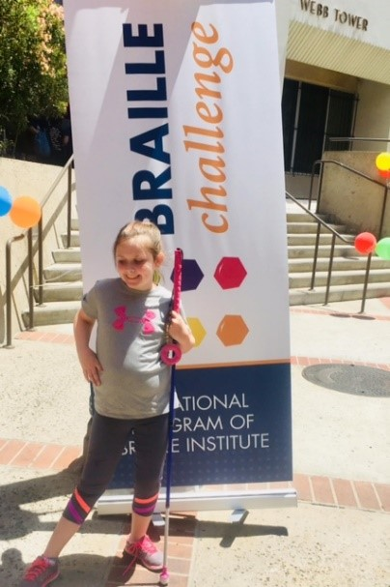
Photo of Shianne Ramsey outside, standing in front of a Braille Institute Sign

“My favorite part was when we marched into the building, and everybody clapped and cheered! And the band was in front of us playing! I felt so special,” Shianne said!

On Friday, June 15th, Shianne flew to Los Angeles, California to compete in the National Braille Challenge sponsored by Braille Institute. She was both excited and a little nervous. The University of Southern California hosted the Braille Challenge. Contestants stayed on campus and were provided a room, food and activities while there. Shianne and her mom chose to go to the water park on Friday, very relaxing after a long plane ride. Grandma and Grandpa went to the dinosaur museum. Then dinner was provided and some evening meet and greet activities. It was interesting to meet families from all over the United States and Canada. Shianne and her friend Salome were the only contestants from Missouri.

Saturday morning the contestants were divided into five groups of ten each with their leaders outside the building. Part of the USC band marched in front of the group as they entered the auditorium. Family and friends clapped and cheered as they walked in and were seated up front. Then each contestant stood in turn and was introduced by name and the state they represented. More cheering and clapping!

Then the fifty contestants were off for the morning to be tested. There were groups for family to attend, lunch break and more testing. Later that evening there was a wonderful banquet with dinner, a talk from the 2018 teacher of the year, and then the Braille Challenge winners in each of five age groups were announced. Although Shianne was disappointed not to win, her mom assured her just being there was a great accomplishment. Then there was a dance with live music. Shianne had a great time dancing with grandpa, mom, and even alone.

Although Shianne did not place this year, she had a life changing experience and was challenged to continue to grow in reading and writing Braille. The young people who attended were the best Braille readers and writers in the nation and she met many of them. Her family is so proud of the great job she did in qualifying this year.

On Sunday we got to go to Santa Monica Pier before heading home in the afternoon. Shianne and her mom rode roller coasters, and we dipped our hands into the Pacific Ocean. Very cold!

We used Uber with great success in California. Shianne had many new experiences and grew in confidence during the trip. On the flight home the pilot announced Shianne as a Braille Challenge finalist. The passengers clapped and cheered! She loved that! “I’m famous,” she said!

Shianne just turned nine and attends public school in Jefferson City, Missouri. As a side note, she was awarded a JCPS Difference Maker Award at the August school board meeting in Jefferson City for her promotion of Braille at her school and for representing Jefferson City at Braille Challenge.

More on the Blind Pension Settlement
By Eugene Coulter

As I stated in the March Blind Missourian, the Blind Pension case has been resolved, and since that article, notices were mailed out on July 16. To be eligible one must have received the Blind Pension or Supplemental Aid to the Blind between February of 2001 and June of 2010. The amount a person will receive depends on how much of that period you received the pension, so amounts can vary from about $15 to $4,300. A person who is currently receiving benefits need NOT do anything, and they will receive their payment sometime before May 15, 2019.
For those who are not receiving benefits, there are claim forms that need to be completed. Likewise, if you are a surviving spouse or nearest living relative of a deceased recipient there are different claim forms that need to be completed. The required claim forms are at the Department of Social Services website and need to be submitted by October 15, 2018. Payments for persons having to submit a claim form must be made by August 12, 2019.

From the July 16 letter:
“On March 30, 2018, the Cole County Circuit Court entered a Judgment approving a Class Action Settlement Agreement under which the blind pensioners who received blind pension payments between February 1, 2001, and June 30, 2010, are entitled to file a claim for compensation for the amount that the Department underpaid their blind pension payment for that time period plus an agreed amount of interest on those underpayments. If you received Blind Pension or Supplemental Aid to the Blind benefits during this time period you are a member of the class, and if you are currently receiving the pension, you are entitled to payment of the amount that you were underpaid, plus interest on the underpayment, minus 25% of the total for payment of the attorneys' fee for the lawyers who represented the class in the case (Class Counsel). You do not need to file any claim or other paperwork to receive this payment if you are currently receiving the pension.

If you would like to read the Class Action Settlement Agreement, you may do so on the Social Services website.”
To access the website, go to https://dss.mo.gov/blind-pension-settlement.htm where you can find all of the documents on the settlement including the claim forms. If you are not currently receiving benefits or are an heir and have questions about completing the forms, you can contact the class action attorneys at the Saint Louis University Legal Clinic at 314-977-2778.

It is possible that the payments could be made much sooner than May 15, but it is wise for all of those expecting these funds to plan on the later date. As someone very wise once said, “Do not count your chickens before they are hatched.” It will be nice to put this chapter into the history books for all concerned.

2018 Float Trip
By Christopher Tisdal

The 2018 Annual Float Trip sponsored by the Sports and Recreation Committee of the National Federation of the Blind of Missouri was held August 17-19 at the Bass River Resort in Steelville, Missouri.

The group consisted of State President Shelia Wright, Sports and Recreation Chair: Robin House, Alice Hebert, Amy and Bill Wilson, Jessie Plumlee, Melissa and Ben Kane, and Christopher Tisdal.

Being out in nature and under the stars is so AWESOME! Hearing the sounds of the birds without traffic going by every second was calming and relaxing. We tried to build a fire on Friday night, however, the ground was still too wet for this. Then came Saturday!

Everyone woke up early filled with excitement. We rode a bus to the location where we put the rafts in the waters of the Courtois. We were not the only ones on the river that day. There were people who had coolers with a radio built into the cooler, never knew this was possible.

We began our floating and soon were introduced to the water, not by turning over or jumping in the water, but by being sprayed or squirted by a water device instead, or should I say by an eleven-year-old, two-legged “shark”. The river was low, so we didn’t have to worry about strong currents, however, we did have to get out and drag the raft when hitting rock bottom. This gave people time to cool down and splash water on one another. Then there were times we got out of the rafts and just did some swimming around, unless you were like the state president and forgot you were not a fish riding the current and leaving the people you were with. We enjoyed the nice scenery and saw a few turtles and a lot of fish.

Saturday evening was really nice with a bar-b-que dinner, and later there were s’mores for those who wanted to make them.

This was a great weekend for strengthening friendships and getting to know each other! We look forward to having the float trip next year so be on the lookout for a Save The Date!

Fun Fundraising Events
The Lewis & Clark Chapter is proud to be hosting its first annual
Trivia night on Saturday October 27, 2018. The doors will open at 5:15 PM and trivia will begin at 6 PM. It will take place at the Overland Community Center, 9225 Lackland Rd. The cost is $20 per person or $160 per table (each table seats eight people). The cost includes light snacks, and participants can bring food and drinks. Sorry, no tickets will be sold at the door, they must be purchased in advance.
If you are interested, contact a member of the Lewis & Clark Chapter.
Feel free to share this information with others. Thanks, Jenny Carmack jcarmack314@gmail.com call or text 314-239-9776
The Columbia Chapter will be holding its annual Trivia night on November 3, 2018. It will be held at the St. Thomas More Newman Center, 602 Turner Avenue Columbia, Missouri. The doors will open at 5:30 PM, and trivia will begin at 6:30 PM. The cost is $20 per person or $160 per table (each table seats eight people). Students are $15 with a current student ID. Free light snacks and food for purchase will be available. Sorry, no alcoholic beverages are allowed; there will also be fun side games and prize-winning opportunities.

For more information contact Debbie Wunder at: 573-268-6989 or debbiewunder@charter.net
Get your team together or come alone and we will put you with some other trivia fans. Just come and join us for a great evening of fun.

One Minute Message
It is fantastic when we have a seminar or a long airplane ride and are able to explain the goals of our Federation, but very often all we get is an elevator ride or brief chat as we check out at a restaurant. The one-minute message is designed to help us clearly and concisely explain our Federation with the hope that it will cause people to have a better understanding of our goals and to want to learn more. Here is the one-minute message for those who wish to learn it and be ready for the next time you only have a minute to explain who we are and what we do.

The National Federation of the Blind knows that blindness is not the characteristic that defines you or your future. Every day we raise the expectations of blind people, because low expectations create obstacles between blind people and our dreams. You can live the life you want; blindness is not what holds you back.

“Live the life you want” is our tag line.

PLEDGE OF THE
NATIONAL FEDERATION OF THE BLIND

I pledge to participate actively in the effort of the National Federation of the Blind to achieve equality, opportunity, and security for the blind: to support the policies and programs of the Federation and to abide by its Constitution.

Board of Directors
National Federation of the Blind of Missouri

Officers:
Shelia Wright, President Julie McGinnity, First Vice President
Gene Fleeman, Second Vice President Dacia Cole, Recording Secretary
Erin Magoon, Corresponding Secretary Carol Coulter, Treasurer

Board Members:
Eugene Coulter Roger Crome Jenny Carmack
Amy Wilson Chris Tisdal Melissa Kane
Daniel Garcia President Emeritus, Gary Wunder

Chapter Presidents
Dacia Cole, Columbia Amy Wilson, Old Drum Chapter
Melissa Kane, Jefferson City Ben Vercellone, Springfield
Daniel Garcia, Kansas City Chris Tisdal, Lewis and Clark
Roger Crome, Mineral Area Chapter Dan Keller, Show-Me State Chapter

Blind Missourian Editor Carol Coulter
Proof Readers Helen Stevens, Shelia Wright, and Gary Wunder
Read by Elisabeth Coulter

FREE MATTER FOR THE

BLIND AND PHYSICALLY

HANDICAPPED

NFB of Missouri
1504 Furlong Dr.
Columbia, MO 65202

