NEW YORK CITY, AN ICONIC DESTINATION
,

AUCTIO NIN ABOX.COM
No Partner Fees & Fr ee Shipping

!4Jl,f4muican,
._. CLASSICS

YOUR GETAWAY FOR TWO INCLUDES:

3 Days/ 2 Nig hts Accommodations at the Grand Hyatt New York

- All Room- Relat ed Taxes

- Free Concierge Reservat i on Service

- Broadway Gold Entert ainment Package
...»Ill

16\

Va c at io n
L en gt h

E s t im at e d
Va lu e

3 Days/ 2 Night s

$2,100

A L od g in g
rm
Op ti on s

GrandHyatt New York

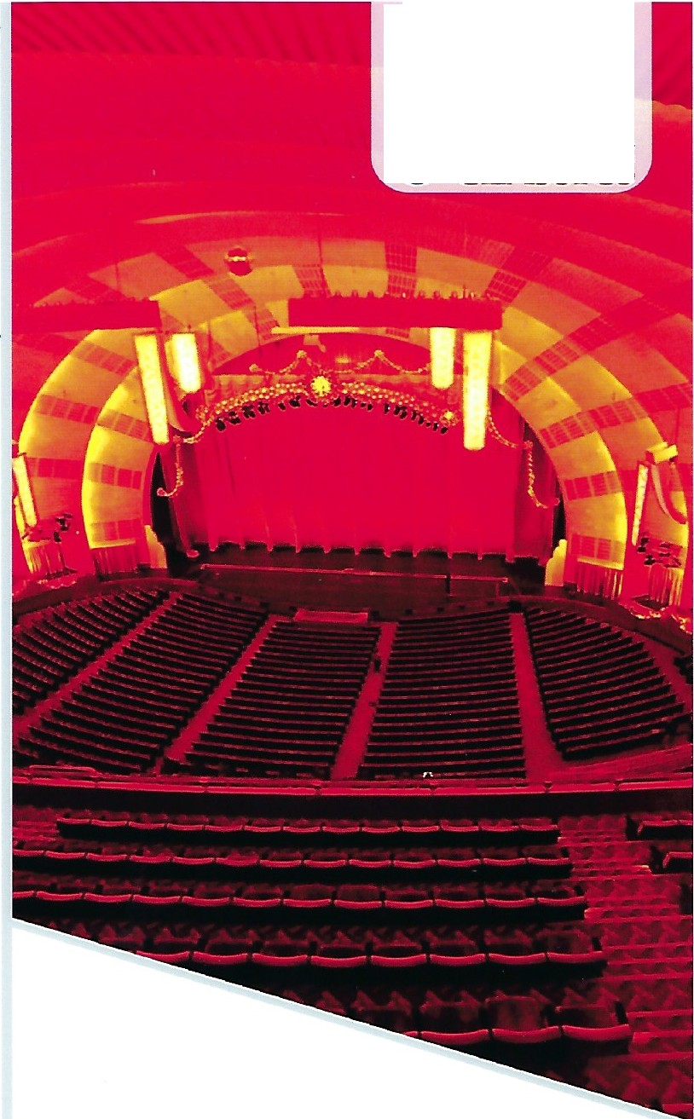

TERMS AN D COND ITIONS: TRAVE L PACKAGE IS NON-REFUNDABLE AND SUBJECTTO AVAILABILITY. CERTIFICATES/GIFT CARDS CANNOT BE REPLACED. BLACKOUT DATES: SEP 15--21, NOV 3-5, DEC 31. ENTERTAINMENTTICKETSARE SUBJECTTO AVAILABILITY, SOME RESTRICTIONS MAYAPPLY. A MIN IMUM 30 DAY ADVANCE RESERVATION IS REQUIRED. TRAVEL IS VALID FOR 12 MONTHS FROM DATE OF I SSUE. BLACKOUT DATES MAY APPLY ANO HOLIDAY TRAVEL MAY REQUIRE A SUPPLEMENTAL FEE.

(GW9252-BD) (MS-023)

