CMAAWARDS, COUNTRY MUSIC'S BIGGEST NIGHT!
,
AUCT IONINABO KC;©M
No Part ner Fees & Free Shipping
IA9111,5llmulau,,
CLASSICS

YOUR TRIP FOR TWO INCLUDES:

3 0ays/ 2 Nights Accommodations at the Sherat on Hot el Nashville

- Round Trip Economy Cla ss Air

- $200 Transfer All owance

- Daily Complimentar y Brea kfast

- All Hotel Taxes

- 2 Tickets to the CMA Awards Show wit h 300 Level Seat ing
i..». P)

Vacation
Lengt h

3 Days I 2 Nights

(Upgraded Seating Available for Additional Charge)
Estimated
Value
16\

A Lodging
rm
Op ti on s
$10,000

Sheraton Hotel Nashville

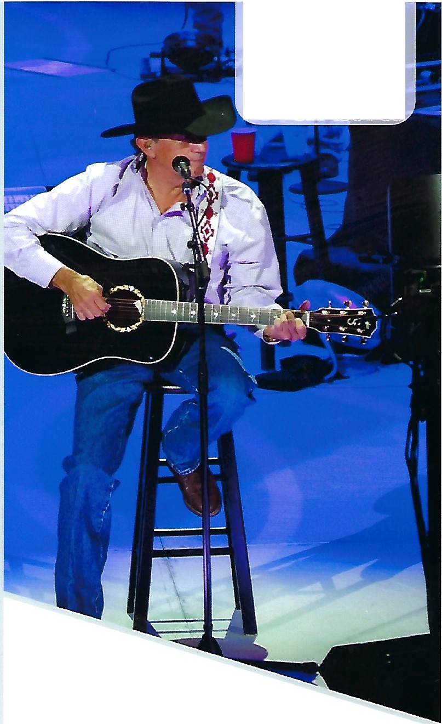

TERM S AND CONDITIO NS : TRAVEL PACKAGE IS NON-REFUNDABLE AND SUBJECT TO AVAILABILITY. CERTIFICATE S/GIFT CARDS CANNOT BE REPLACED. RESERVATIONS MUST BE MADE AT LEAST 45 DAYS IN ADVANCE OF TRAVEL. PACKAGE ORIGINATES FROM CONTIGUOUS US. HOTEL MAY BE SUBSTITU TED WITH EQUAL ORS IMILAR ACCOMMODATION S. BLA CKOUT DATES MAY APPLY ANO HOLIDAY TRAVEL MAY REQUIRE A SUPPLEMENTAL FEE.

(AW2B00-B1) (MS-045)

