Announcements from Wolfner Library

Two Author Talks Scheduled!
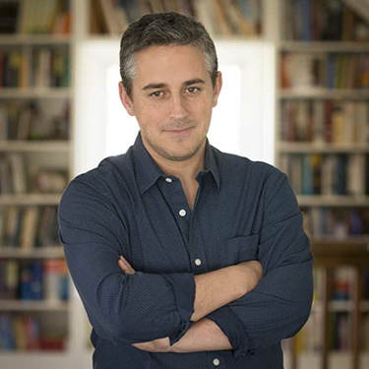
Wolfner Library is proud to announce that two authors will be speaking with patrons via conference call this winter.

Jan. 30, 2020 – 7 p.m.
Alex George, author of A Good American (DBC01391) and Setting Free the Kites (LP033425; DB 97103, coming soon)
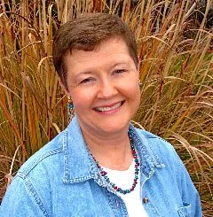
Born in England, George calls Columbia, Missouri, his home and is known for his literary, historical, coming-of-age novels.

Feb. 27, 2020 – 7 p.m.
Charlotte Hubbard, author of the Seasons of the Heart series (MDB00132)
Hubbard, who also penned the Angels of Mercy series, writes Christian fiction series and is a former resident of Jefferson City, Missouri.
If you would like to register for one or both events, contact Amy at wolfner@sos.mo.gov or call 800-392-2614. Registered patrons will be given the conference call phone number. Registration is limited to 25 patrons per session. If needed, a second session may be scheduled.

Wolfner Library 2020 Adult Winter Reading Program
Wolfner patrons selected American Regionalism as the theme for this year’s Adult Winter Reading Program. We’ll explore the nation by diving into the various regions of our country. You may choose to read a mystery set in New England or a western exploring the Rocky Mountains, or explore a region with a book of your choice.
The challenge is simple: Read 5 books set in different geographic areas.
When you sign up for the program, we’ll send you a log (in large print, braille, or electronic format) to track your progress. We also will have a list of suggested readings and three pre-loaded cartridges available with ideas about how to fulfill your personal challenge. As always, reader advisors can provide additional reading ideas or help record your progress.
The program begins January 2 and will run through March 9. Registration opened on December 1, 2019, and will continue through February 24, 2020. The deadline for submitting the books read as part of the challenge will be March 16, 2020. To qualify for prizes, you must complete five goals.
Register today by contacting your reader advisor at 800-392-2614 or e-mailing Amy at wolfner@sos.mo.gov!

