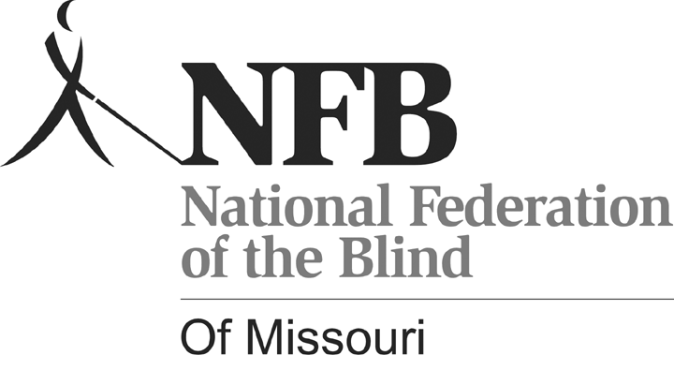
Shelia Wright, President
7928 NW Milrey Drive
Kansas City, MO 64152
Phone (816) 741-6402
www.nfbmo.org

LEGISLATIVE AGENDA OF BLIND MISSOURIANS

PRESENTED TO
THE SECOND SESSION OF THE ONE HUNDREDTH GENERAL ASSEMBLY

From: The National Federation of the Blind of Missouri

Date: February 17 & 18, 2020

The National Federation of the Blind knows that blindness is not the characteristic that defines us or our future. Every day we raise the expectations of blind people, because low expectations create obstacles between blind people and our dreams. Blindness is not what holds us back.

This is the message we bring to blind Missourians and the communities we live in. We pledge to be a resource to you and your constituents when they turn to you for help.

The National Federation of the Blind is a membership organization of and for the blind. As a volunteer, grassroots organization, we are blind people working on behalf of blind people. We come together on the local, state, and national level to address issues of importance to our fellow blind citizens. We promote programs that encourage self-determination, independence, and equality of opportunity.

Why Braille Is A Necessary Part of The Independence and Success of the Blind

It is said that learning to read is one of the greatest accomplishments of man, and if blind people are to succeed, literacy must be a part of our skill set. This is why we have Braille, the finger equivalent of what most see with their eyes. Only when literate are we able to meet the challenge of expanding our knowledge on a wide variety of subjects and gain an understanding of our world. By using Braille, we are able to read things for ourselves. While audio and electronic means of access are essential to living in our society in the age of advanced technology, there is no substitute for reading something yourself. The importance of having the ability to communicate in writing and knowing where to use punctuation and understanding how to spell is a fundamental skill. Especially is this so if you plan to do a white collar job.

In our schools, less than 10% of blind children are getting the benefit of learning Braille. At least part of the problem is determining early on who will be most efficient reading Braille, who will be so using print, and which children can benefit significantly from learning both. Print is too often decided upon because it is considered normal, but children who are functionally blind but have some sight pay the cost in eye strain, headaches, and the inability to read rapidly or for long periods. Our blind children soon associate reading with discomfort and real pain.

Studies clearly show that most blind people who are employed know and use Braille. This should speak volumes to the need for it, but while sighted students are learning to read, blind students are being evaluated using a number of inadequate tools. By the time students are expected to read in order to learn, our schools are just deciding to teach our blind children to read Braille. The forecast is gloomy; they are behind, and unless they and their teachers and outside tutors make a herculean effort, this is where they will stay—behind.

Getting and keeping a job relies on skills. Fundamental among these are reading and writing. Audio and video enhance the lives of our citizens, but they do not replace reading and writing, especially for blind folks. As the governor makes one of his priorities employment first, we have the responsibility to do what will make blind people employable and provide for them and the rest of our society the fruits that productivity brings to us all.

Employment First Legislation

The Governor has clearly stated his intention that Missouri will become an Employment First state and will be an example employer which businesses can emulate. HB 1276, sponsored by Representative Unsicker, clearly defines a community based, integrated setting as the appropriate employment goal for people with disabilities and envisions their integration into competitive employment. The legislation outlines the requirements that the trainers of people with disabilities will meet. Additionally, the bill outlines the training requirements of those state workers providing job employment services for those with disabilities. Through this carefully crafted piece of legislation, HB 1276 outlines a state priority to increasing access to community based, inclusive, competitive employment based on quality supports that uses a person’s wants and needs to build an employment plan that is person focused. The National Federation of the Blind knows that people with disabilities can and do work in competitive settings as members of their workplace community. We support this legislation and ask you to do the same so that the number of us who enjoy real, remunerative employment continues to rise. Real jobs for real pay is the backbone of creating an inclusive community that fosters mutual respect for people of all abilities. With the use of assistive technology and the learning of necessary skills like Braille, the blind can and are successful in employment settings. We ask you to join us in supporting Representative Unsicker in bringing to fruition the benefits that will come from the passage of HB 1276—people with varying disabilities experiencing the dignity and self-support that comes with equal pay for equal work.

Blind Pension Legislation

HB 1270, sponsored by Representative Unsicker, has one simple but essential function, to remove the word certified from the law regarding correspondence with blind pension recipients. The well-intentioned insertion of the word certified has caused significant expense to the state as well as to blind recipients who are often forced to go to the post office to pick up mail that would otherwise be found in their box. Not only is this an unnecessary expense; it reduces the time blind pension recipients have to fill out the yearly recertification required and has caused a number of blind people to be terminated and subsequently reinstated, again at significant cost to the state of Missouri and its blind residents who receive the pension. Therefore, HB 1270 seeks to remove the word certified from the laws governing Blind Pension. Many blind Missourians have experienced significant issues due to the certified mail requirement, and that is why the National Federation of the Blind of Missouri strongly supports this legislation as presented.

The Recording of IEP and 504 Meetings

HB 1540 seeks to allow parents and legal guardians to record IEP and 504 meetings. Often meetings are long, and having good notes is crucial. The IEP team consists of the parents and half a dozen or more school personnel. A lot of information is exchanged, and some of it is highly technical and difficult for parents to initially understand. If one is blind and the information is presented in a form he or she cannot read, the problem becomes even more difficult and added emphasis falls to understanding exactly what is said. even if the parents are able to follow along well enough to fully participate in the decision making, recalling the necessity and reasoning for certain decisions is difficult at best. For many people who are blind, an effective method for taking notes is to record the meeting. Unfortunately, many school districts have put policies into place to limit the access to this method for parents and guardians. This leads to misunderstanding and frustration for both parents and school personnel. Therefore, the National Federation of the Blind of Missouri supports this legislation, and on behalf of blind parents in Missouri, we ask you to support the passage of HB1540.

