Are you ready for work?
ACE Academy
Where low vision, blind, DeafBlind students and families prepare
for success

Fuel Your Launch into College and Work at ACE Academy

Employers seek capable, competent and confident people with strong collaboration, advocacy and resiliency skills.
Building these essential transition skills will help you “ACE it”!

Coming

April 24-26, 2019

To the

Hampton Inn & Suites

St. Louis/Chesterfield, MO

Space is Limited
Register with: Ellen Clapper
Rehabilitation Services for the Blind of Missouri
Ellen.Clapper@dss.mo.gov
573-526-1846

ACE Academy sets low vision, blind, and DeafBlind students apart and
gives a competitive edge

Strengthen Self-Advocacy skills

Collaborate with your voc rehab team

Connect with peers, professors and coworkers

Discover the secret social skills to succeed

Discuss your disability in a positive way

Navigate assistive tech for literacy while avoiding technology traps

Explore career through networking

Strategize for independent living & travel

Meet your Coaches
Your blind coaches build rapport with participants while delivering fully accessible, fun and engaging interactive trainings
More About ACE Academy

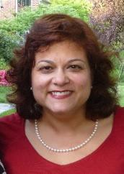

Eileen Rivera Ley
is a thought leader, author, and executive coach. A strategist and advocate, she trains executives and people with disabilities throughout the country. Her company, Blind Savvy USA™ develops nationally respected programs including: Blind and Socially Savvy, Low Vision Logic Training and Life Can Be Sweet - Managing Diabetes and Vision Loss. Legally blind since birth, she earned an MBA from the Wharton School of Business and a BA from Harvard College. Ms. Ley was honored as one of Maryland’s Top 100 Women in 2011, and her company was selected as one of Maryland’s Top 100 minority business enterprises in 2013.
https://www.linkedin.com/in/eileen-rivera-ley-mba-a9059b1a/
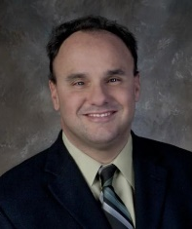

David DeNotaris
is an inspirational speaker, author, trainer and executive coach. For over 25 years, he has empowered individuals and organizations to transform obstacles into opportunities. David delivers captivating and uplifting messages for teams and crowds of all sizes. He creates customized workshops and trainings for government agencies, universities, community-based organizations, and businesses. Legally blind since birth, David has assisted thousands of individuals achieve competitive, integrated employment. He earned his MA in Leadership Training and Development and his undergraduate degree from East Stroudsburg University of Pennsylvania.
https://www.lin kedin.com/in/david-denotaris-237b476/
ACE Academy is a pre-employment transition service and solution crafted by disability experts at Skys the Limit Communications, LLC. David DeNotaris and his team are passionate about helping blind and low vision people excel. Each intensive ACE Academy training module is fully inclusive, highly energetic, interactive and fun. Students enjoy hands-on practice, role plays and games which promote participation and fully engage learners in a supportive team setting.
Students participate in discussions with blind and low vision peers, role models and interviewers. Participants also learn through case studies, team projects, and practice interview sessions. The Academy’s stackable modules include: Self-Advocacy Success through Story Telling, Career Exploration with Informational Interviews and Podcasts, Communication: Sharing Strengths and Abilities with Stories.

