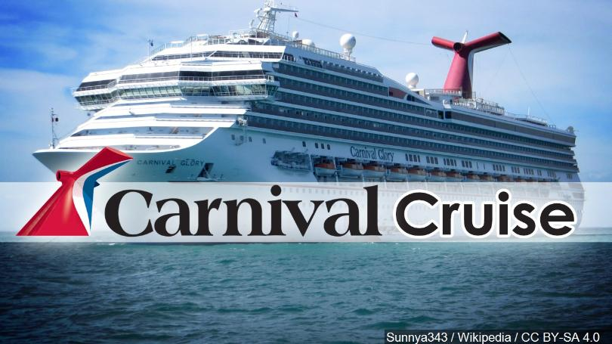

WIN A 7 DAY

CARIBBEAN CRUISE FOR 2 !

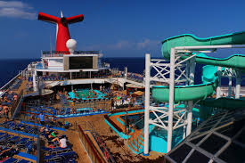

$3,000

VALUE

7 DAY / 6 NIGHT

CRUISE

**OCEANVIEW**

**$800**

**Airfare Included!**

$10.00 for each chance to win.

Winner will be drawn on October 3rd, 2020

You do not need to be present to win.

Cruise sets sail on Feb. 28, 2021 out of New Orleans. Changes can be made without penalties prior to November 30th, 2020.

Sponsored by: **National Federation of the Blind of Missouri**

OCEANVIEW

ROOM!

$500 CARNIVAL

GIFT CARD