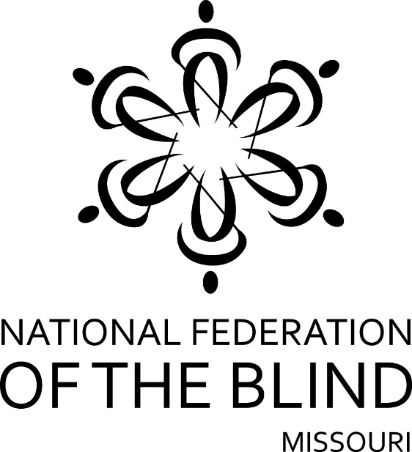

FIFTY-EIGHTH ANNUAL CONVENTION

NATIONAL FEDERATION OF THE BLIND
OF MISSOURI

June 5, 6, 7, 2020

Together At Home
All Across Missouri and Beyond
Via Zoom

The National Federation of the Blind knows that blindness is not the characteristic that defines you or your future. Every day we raise the expectations of blind people, because low expectations create obstacles between blind people and our dreams. You can live the life you want; blindness is not what holds you back.
Pledge

I pledge to participate actively in the efforts of the National Federation of the Blind to achieve equality, opportunity, and security for the blind; to support the policies and programs of the Federation; and to abide by its Constitution.

Welcome to our fifty-Eighth annual state convention

Members of the Lewis & Clark Chapter of the National Federation of the Blind of Missouri are proud to host this year’s annual state convention and the NFB of Missouri’s first ever Virtual Convention. We want to extend a warm welcome to each of you.

Those who are registered for the convention can connect to all convention activities via Zoom. Most of the convention will be occurring on the NFB of Missouri account which is #7148529230. There are two meetings on Friday that will have a different access ID number; these will be the Parents of Blind Children Seminar and the Resolutions Committee. The access ID for these two meetings is #5732684245. We have directions and numbers to help you connect on the back page of this agenda and on our webpage at HTTPS://NFBMO.ORG

Door prizes will be given throughout the convention, and each chapter is encouraged to send their donations to Jenny Carmack, Door Prize Chair, of our Lewis and Clark Chapter.
You must be registered for the convention to be eligible for door prizes. When a name is drawn, the individual must raise their hand. Each person who wins a door prize will be contacted by the Lewis & Clark Chapter after the convention to make arrangements to get your door prize to you.

We are pleased to have Jeannie Massay, as our National Representative. Jeannie is here on behalf of President Mark Riccobono. She is Treasurer of our National Federation of the Blind Board of Directors, Chair of our National Membership Committee, and President of the National Federation of the Blind of Oklahoma.

Our Transition and Change: The Opportunities Hiding inside the Fear Seminar on Friday afternoon is one of the events on Friday you don’t want to miss. The seminar will be from 1:00 PM to 4:00 PM. Below is a brief description of what to expect.
The National Federation of The Blind talks a lot about philosophy, but after you’ve heard all the words, what are the real techniques that make living with blindness not only possible but doable and enjoyable? Can blind people live by themselves, cook and clean, buy clothes, arrange them, and dress attractively? If we are blind and diabetic, can we manage our diabetes, and if so, how can we do it? Can we handle daily routine tasks such as banking, grocery shopping, and paying bills? What do we do with that stack of mail that ends up arriving in print? To find the answers to these questions and those that come up during the course of the seminar, please join us on Friday, June 5 from 1 PM to 4 PM. Admission is free, and you are guaranteed a chair. Please register for the convention so you will be eligible for the door prizes drawn during the seminar.
The National Federation of the Blind of Missouri appreciates our Corporate Sponsors. This year we will be offering a Corporate Sponsor Showcase on Friday afternoon from 4:15 to 5:15 PM. We encourage you to join and learn more about our 2020 Corporate Sponsor and the products they carry.

Thank you NanoPac, Inc. for being a 2020 Silver Sponsor for our 58th Annual State Convention!

NanoPac provides sales and service of AT products for low vision and blindness. With 4 representatives assigned to the state of Missouri we offer solutions including Braille displays/notetakers, Braille embossers, screen reading and magnification software, GPS, digital talking book players, scan/read/Braille systems, and video magnifiers.
www.nanopac.com

FRIDAY, June 5, 2020

FRIDAY MORNING

8:30 AM – 9:15 AM – Gentle Yoga for Beginners by Blind Alive Hosted by Dacia Cole and the Missouri Sports & Recreation Committee

10:00 AM – 12:00 PM - National Federation of the Blind of Missouri Board of Directors Meeting

FRIDAY AFTERNOON

1:00 PM – 4:00 PM – Transition and Change: The Opportunities Hiding Inside the Fear – Debbie Wunder, Seminar Coordinator

4:15 PM – 5:15 PM – Corporate Sponsor Showcase – Vincent A. Cianfrone, NanoPac, Inc.

FRIDAY EVENING

6:30 PM - 7:30 PM – Parents of Blind Children Seminar – Linda Coccovizzo, Chair, Missouri Parents of Blind Children Group
6:45 – 7:45 PM - Missouri Association of Guide Dog Users – Stephanie McDowell, President

8:00 PM - Resolutions Committee - Gary Wunder, Chair

8:30 PM - Missouri Association of Blind Students Seminar —Roman Solano, President

Saturday Morning, June 6
General Session

9:30 AM - Call to order

9:35 AM - Opening Ceremonies Presented by the Lewis & Clark Chapter – Christopher Tisdal, President

9:45 AM - Convention Starters

10:00 AM - A Bridge between Our National President and You – Jeannie Massay, National Representative and Treasurer of the National Federation of the Blind Board of Directors

10:40 AM - Fit Break — Missouri Cane Drivers

10:45 AM - Meeting the Challenges in Today’s World - Keith Roderick, Deputy Director, Rehabilitation Services for the Blind, Family Support Division, Missouri Department of Social Services

11:10 AM - At Your Library and Beyond - Leslie Bowman, Director, Wolfner Braille and Talking Book Library

11:35 AM - I Can Connect - Brenda Whitlock, Missouri Coordinator, Missouri Assistive Technology Project

11:55 AM - Morning Wrap-Up

12:00 PM - Adjourn For Lunch

Saturday Afternoon Session

1:30 PM - Chapter Presentations: Who Will Be King & Queen for 2020? - Carol Morgan, Chair, Ways and Means Committee

1:40 PM - My Path to A STEM Career - Gregory R. Bowman, Associate Professor, Director Folding@home, Department of Biochemistry & Molecular Biophysics, Washington University School of Medicine

2:05 PM - Embracing Change Creating New Opportunities, and Expanding Personal Career Goals - Daniel Garcia, Julie McGinnity, and Robin House

2:35 PM - NFB Education and Outreach Programs for Youth – Jenny Carmack

2:50 PM - Blind Mentors for My Child – Carla Kearns, Board Member, National Organization of Parents of Blind Children (NOPBC)

3:00 PM - Fit Break – Missouri Cane Drivers

3:05 PM - Blind Hockey: An Emerging Sport – Sean Borah, Captain, Saint Louis Blues Blind Hockey Team

3:30 PM - Run, Walk, or Roll - Annie Donnell, President, Achilles International, St. Louis

3:45 PM - My First Washington Seminar - Seyoon Choi, Student, Saint Louis University

3:55 PM - Comments & Announcements

4:00 PM - Adjourn

Saturday Evening Banquet

7:00 PM - Banquet of the National Federation of the Blind of Missouri - Randy Carmack, Master of Ceremonies

- Invocation

- Crowning of the King and Queen

- Recognition of Corporate Sponsor

- Introduction of Special Guests

- Presentation of Scholarships and Special Awards

- Banquet Address: Jeannie Massay, National Representative and President of the National Federation of the Blind of Oklahoma

SUNDAY, June 7
Final General Session

2:00 PM - Call to Order

2:05 PM - Presidential Report – Shelia Wright

2:30 PM - Report of the Audit Committee — Gene Fleeman, Chairman, NFB of Missouri Audit Committee

2:40 PM - Treasurer's Report — Carol Coulter, Treasurer

2:55 PM - Building the Federation – Jeannie Massay, National Membership Chair, National Federation of the Blind

3:15 PM - Resolutions and other Business

3:30 PM - This Job Qualifies As Essential and We Need All of You As Workers – Carol Morgan, Chair, Ways & Means Committee

3:40 PM - Old Business

3:50 PM - New Business:
Appropriation of Funds to tenBroek, National Treasury, Jernigan, Sun, National Convention Stipend, 2021 NFB of Missouri Scholarship Program, etc.

4:00 PM - Adjourn

Where to find us on Zoom
There are three ways to join the convention on Zoom.

• Connect by telephone by dialing: 312-626-6799 and using Meeeting ID #7148529230.

• If you can connect by using the internet or a Zoom App on your computer or smart phone simply use the URL that follows: HTTPS://ZOOM.US/j/7148529230.

• If you have this document or a convention announcement on your device, you can tap on the link and it will put you directly into the meeting.

There will be two meetings on Gary Wunder’s Account. On Friday evening.
The dial-in number is 646-558-8665
And the ID is 5732684245.
The URL link is: HTTP://ZOOM.US/J/5732684245

During our convention, if you need help to connect, you can contact Gary Wunder at 573-874-1774.

Please know that when you join the Zoom meeting, you will be muted. This will be true on Saturday and Sunday Sessions. To be recognized and speak on the floor you will need to raise your hand and wait to be recognized. The cohost will unmute you when it is your turn to speak. You should be sure that you have been muted after you speak.

Thank you for participating in our first virtual convention.

