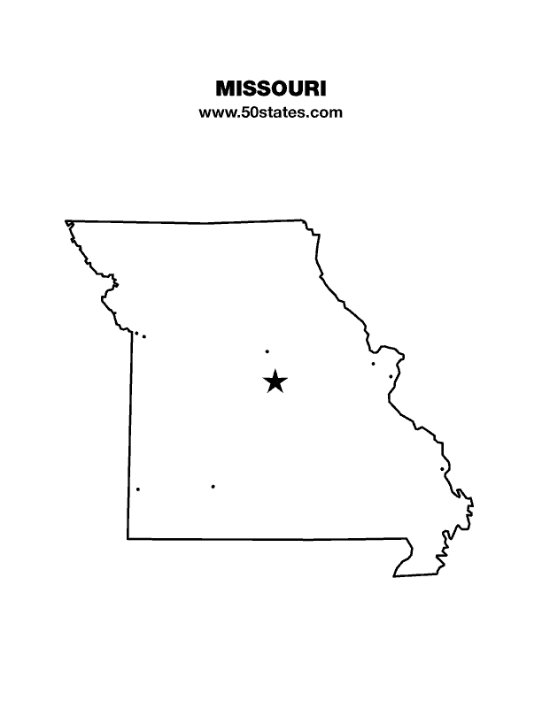
The Blind Missourian
October 2020

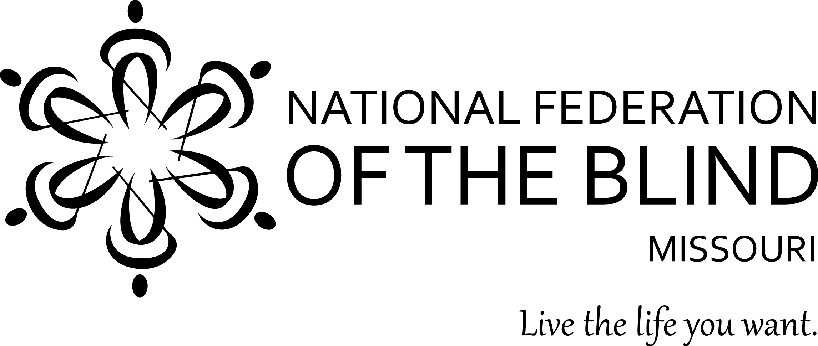

Table of Contents

National Braille Challenge by Jenny Carmack 1

The Bells Ring On by Jenny Carmack 2

Blind Mentors for My Child by Carla Keirns 3

Announcing STEM2U by Jenny Carmack 5

Get Your Kicks on Route 66 by Eugene Coulter 5

When the Virus Came to Wunderland by Gary Wunder 6

News from Wolfner Library: by Amy C. Nickless 7

Up Coming State Conventions 9

One Minute Message 12

NFB Pledge 12

National Braille Challenge
By Jenny Carmack

The National Braille Challenge is the only academic competition for students in grades one through twelve who read and write braille. The students are divided into five categories based on grade level and are tested in areas such as reading comprehension, proof reading, writing speed and accuracy, spelling and interpreting charts and graphs. The National Braille Challenge began in 2000. It was developed and is implemented by the Braille Institute.
This year the National Braille Challenge began like it does each year. At the beginning of the year there were over 1,100 students who participated in regional competitions around the United States and Canada. After regional competitions are completed, the scores are tallied, and in April the competition’s finalists are announced. The top ten scorers from each division will go on to the finals, so there are fifty students who go on to the final competition of the National Braille Challenge. Typically, the students and their families travel to Los Angeles, California, to participate in two days of contests, fun, and the awards ceremony. However, like everything else this year, things had to be done differently. This year each finalist completed their testing with a local proctor, after which completed tests were mailed to the Braille Institute where they were scored. In addition, each finalist received a “Swag Bag” which contained prizes and activities. Then on July 31 the award ceremony was held virtually. There is a recording of the ceremony’s live stream on You Tube.
In Missouri, students participate in the regional competition (first round of the challenge) in St. Louis at the Missouri School for the Blind or in Kansas City, Kansas, at the Kansas School for the Blind, depending on where they live in the state. Each year many students from Missouri participate in the National Braille Challenge. We are proud of each participant for all of their hard work they put in to get ready for the challenge. We encourage all braille users to participate in the challenge. This year we want to give special recognition to the Missouri students who went on to the finals and were also winners of the challenge.
Congratulations to Shianne Ramsey who competed in the Freshman division (third and fourth grades). Shianne is a fourth grader. She was a Missouri BELL Academy participant for four years. Shianne placed first in her division at the finals. Next, congratulations go to Salome Cummins who also participated in the Freshman division. Salome is a third grader. She has been a Missouri BELL Academy participant for five years and counting. Salome placed second in her division. We would also like to congratulate Nathan Deeds. Nathan and his family moved out of state a couple of years ago, but Nathan was a Missouri BELL Academy participant for five years. Nathan participated in the challenge in the Junior Varsity division (seventh through ninth grades), and he won the excellence in charts and graphs award. Note that these three winners in the Braille Challenge have been participants in our Braille Enrichment for Literacy and Learning (BELL) Academy in Missouri. Shianne, Salome, and Nathan, we are so proud of each of you. Keep up the excellent work! Always remember, “keep calm and Braille on.”

The Bells Ring On
By Jenny Carmack

In January we were all looking forward to our seventh annual Braille Enrichment for Literacy and Learning (BELL) Academy. We were excited to try some new things as well as continuing with some favorite traditions. We were hopeful that our outreach efforts would connect us with some new families. But, in the spring, as the COVID-19 Pandemic was in full force and most summer activities began to be cancelled or postponed, it became clear that our traditional BELL Academy would not happen. This realization was a disappointment for everyone. We couldn’t, not have a BELL Academy! We needed to do something to keep our BELL Academy going! But, what would that be? How would that work? The wheels began to turn, and creative juices began to flow.
Fast forward to mid-May. A new plan had evolved. With the collaboration of some BELL Academy leaders from across the nation, we introduced BELL Academy In Home Edition! The first ever virtual BELL Academy was available nationwide. There were three different two-week sessions for families to choose from. There were videos created by BELL Academy teachers which were uploaded and available for families to access at their convenience. There were Zoom meetings created for families to have live lessons and children to have social time. Each day of the two-week session local affiliate BELL Academy teachers connected with families and children to enhance the personal connections. Also, Seedlings generously donated 2 books to each BELL Academy child (Bell Ringer).
In Missouri we had seven Bell Ringers and made connections with four new families. We recognized that families were frustrated with the virtual learning that took place at the end of last school year and that everyone was facing “Zoom burn out.” Given this information we’re excited about this year’s participation. We have had several positive interactions and built some long-term connections. All of the BELL Academy families enjoyed their BELL Academy sessions. One of our longtime Bell Ringers told us that she would be at BELL no matter what - every year - until she is too old, and then she wants to be a BELL volunteer. Another one of our returning Bell Ringers said that he loves Braille Twister, and he wants to make Braille Twister mats for his parents so they can have competitions to see who can form the letters or signs fastest. (Good luck to his mom and dad!) A new Bell Ringer enjoyed making magnetic braille letters and wants her family to mix up the letters of her name so that she has to put them in the correct order again. A young man who was a new Bell Ringer liked raising his sunflowers from seeds they planted during one activity. He checked on them several times a day, and when he had to be gone for a weekend, he made his mom promise to check on them every day until he came back. Some of the other activities during the BELL Academy this year included: decorating canes and learning shades, working tactile puzzles, creating shapes or pictures out of braille dots, playing Red Light Green Light, writing and sharing silly stories, and much more.
As you can see, we had a successful BELL Academy this summer. We worked on braille and other blindness skills, made new connections, made memories, and had fun! We accomplished everything that we usually set out to do in our BELL Academy; we just did it a little differently. So, you pesky pandemic, not even you can stop the National Federation of the Blind’s BELL Academy. The bells ring on here in Missouri and across the country!

Blind Mentors for My Child
By Carla Keirns

My little boy was fourteen weeks old when the doctor told us he was blind. Blind. It was Halloween. We had arranged to see an eye doctor because both my husband and I had worn glasses as babies, mine with cute silver frames, his with dark plastic. We thought he might need eye surgery, as two of his aunts had as babies, but we were completely unprepared to hear he was blind. We were also confused, because he could clearly see. What he could see, we could not tell.
The next few weeks were a whirlwind of meetings with doctors, case managers, and early intervention evaluations. We lived in New York at the time, so we met with the children’s specialist for our region from the New York State Commission for the Blind. He was full of information about assistive technology, working with schools, summer camps, and the importance of social skills training.
One Sunday afternoon a few weeks later, we made our way to a neighborhood library and met David Stayer, a social worker blind from birth, and the rest of the National Federation of the Blind of Greater Long Island. We explained that we were new to blindness and that as sighted parents we were eager to find help for our son, but we didn’t know what he would need.
David said, “Your children are our children. We know. Don’t worry about that.” My heart melted.
Russell is seven now, and I have seen David’s promise in action again and again in working with the NFB. Russell was voted into our local chapter of the NFB this spring and was excited to receive his membership coin. He loves that he has friends and so many aunts and uncles to help show him the way. We have been to BELL Academy in St. Louis two summers, virtual BELL at Home this summer, and when people ask whether they are his favorite, he lists “my blind friends” among his most important people.
In St. Louis he learned to take public transportation from his teachers in St Louis on their way to get a special tactile tour of the museum under the Gateway Arch. He has seen films with audio description. He has learned to love Braille. Last week when he was asked to spell the word “mother” he insisted he wanted to spell it in Braille. The teacher didn’t know that he was sneaking in a dot-5 m because he wasn’t quite sure how to spell it out.
I have been to Washington DC, Albany, NY and Jefferson City, MO with the NFB and learned so much about how to change law and policy. Russell came to Albany at twenty months old in the tiniest blue blazer you’ve ever seen, accessorized with a sippy cup. He is looking forward to a chance to go to Jefferson City with us soon.
I have learned a lot about law and advocacy in relation to special education, disability services, accessible transportation, and dozens of other topics that we need for Russell to develop to his potential. Many of the challenges we have faced I learned about first from the NFB and NOPBC Facebook groups, trainings, leaders, and publications. I would never have known to ask how they were going to get my son’s textbooks in Braille if I hadn’t read about other families’ struggles. I needed to know how to get sheet music in large print for my budding piano player, and within a few hours of posting on the NOPBC Facebook group, I had a dozen options.
I keep telling my sighted friends that Russell can do anything he wants to do except fly a plane, and our blind friends keep reminding us that you can fly by instruments.
We look forward to seeing Russell grow up in the Federation. The way to a mother’s heart is through her children, and you have earned mine.

Announcing STEM2U
By Jenny Carmack
I am proud to share that Missouri is one of fifteen states that will
be hosting a free virtual STEM program for students. The program is available for students who live here in Missouri and are in grades three through twelve. The STEM (Science, Technology, Engineering and Mathematics) field is rapidly growing and changing. We believe that blind students should feel confident and capable in participating in any part of this field that they want to. If you or a student that you know is interested in the STEM field, is not sure about STEM, or would like to work on using non visual techniques, then this program is what you need. This program is being offered free over Zoom on Saturday October 17th or November 14th from 2 to 5 PM. Unfortunately, by the time this goes out in the newsletter it will be too late for the October date so register by November 4 to get in on the November 14 session. Visit www.nfbmo.org/stem for more information and to find the link to register. Please feel free to contact me anytime with any questions. My contact information is Jenny Carmack NFB of Missouri STEM2U Coordinator, jcarmack314@gmail.com call or text: 314-239-9776.

Get Your Kicks on Route 66
By Eugene Coulter

The Queen City of the Ozarks is beckoning us to the birthplace of Route 66 for our 59th annual convention at the Doubletree Hotel in Springfield, Missouri, from March 25 through March 28, 2021. The Doubletree has undergone an expansion which includes beautiful new meeting rooms, as well as a new parking garage. The Old Drum and Show Me Chapters are anxious to show everyone a wonderful time, and if you have some extra time, they invite you to check out what Springfield has to offer, including one of the nation’s premier Aquariums (rated second best in the entire country) and the original Bass Pro Shop.
Room rates are only $102.00 a night plus tax, and reservations can be made now by calling the hotel at 417-831-3131. The hotel is located at 2431 North Glenstone Street. Convention registration information should be available within a few weeks. Let us keep our fingers crossed that we can all get together and have a bigger and better convention than ever!

When the Virus Came to Wunderland
By Gary Wunder

Let me begin by thanking all of you who have expressed your concern and best wishes to Debbie and I as we work through COVID-19. At one level how we are doing is very simple: we are not in the hospital, and we are not in the graveyard. Thanks be to God for that.
But how we are doing is actually a bit more complicated. We have come to believe that the coronavirus is not something you get and then pass beyond. We fear there are some lingering aspects. Debbie finds that certain foods she once liked now taste bitter. Other food seems to have no taste at all. Both she and I experience what we best categorize as brain fog; we want to use someone’s name in a story, but we can’t come up with a name. We can tell every bit we know about the personality, accomplishments, and things we love about the person, but the name we cannot get. It is somewhat harder to stay on task now. We know what needs to be done, but it seems like it can wait. Certainly it can wait, just like it did yesterday and the day before and the day before that. Within less than an hour, Debbie can get a rash that can be felt and itches terribly. In the next hour, it may be gone. I experience some dizziness that I have never felt before. We find that the nights come earlier and the mornings don’t find us jumping out of bed quite as eagerly as before.
Do we feel bad? No, not really. Do we feel sick? Again, not really. But have we fully recovered, and do we feel as good as we did six months ago? We don’t.
We are afraid about what science can’t tell us. Given that we have now had the virus, do we have some immunity? If we do, how long will it last? If we are exposed again, will a second attack from this foreign invader be more destructive? Think about how many objects can withstand the first blow of a hammer but give way after three or four strikes.
We are frustrated by the fact that science and politics appear to be at war. To us this seems nonsensical. We don’t know how we caught the virus, but four members of our family tested positive, and so did we when tested on July 6. We isolated ourselves like monks in a monastery, but we didn’t turn away the very infrequent family visitor. We did not hug and we social distanced, but we did not wear a mask when in the company of our children and grandchildren. This leads us to believe that the virus isn’t just transmitted through contact with surfaces, through a sneeze, or through a cough. Rather, we believe that people who spend long enough in a room together are liable to contract the virus as they breathe the circulating air.
We are grateful to be alive, and we are glad to do whatever it takes to stay that way. We are not interested in arguing how effective a mask is. If it is the least bit effective, we are going to wear it. We are not interested in arguing about the virtue of social distancing. If keeping a respectable distance means that we don’t make you sick and don’t get sick again ourselves, we are glad to do it. Like everyone who reads this, we sometimes have a hard time distinguishing between being too cautious and imprudently foolish. We miss hugs and meals with our Federation Family, but we will gladly forgo that for the time being in the name of life and safety. Thank you for the prayers, the kind thoughts, and the offers to help. The best thing you can do for us is to be as safe as you can. We continue to need you in our lives.

Editor’s note: With everyone stuck at home because of the Covid-19 Pandemic, we are finding ourselves with little to occupy our time. These next two items will hopefully give people the chance to do things they might otherwise not have been able to do.

News from Wolfner Library:

Amy C. Nickless Adult Services Librarian
Wolfner Library

Patron Programs:
For any of the programs or book clubs, contact Wolfner at wolfner@sos.mo.gov or call 800-392-2614 to register and receive your information to join the event!

Wolfner Library Fall Book Club Selections

October:
October 15 at 2 p.m. Novel Reads: Setting Free the Kites by Alex George (DB 97103; LP033425). Alex George will be joining the book club for this event! This session is open to all interested patrons.
October 23 at 2 p.m. Good Books: Hope Unseen: The Story of the U.S. Army’s First Blind Active-Duty Officer by Scott Smiley with Doug Crandal (DB 71909; BR 19133)
October 30 at 2 p.m. Big Ideas: This Land is their Land: The Wampanoag Indians, Plymouth Colony and the Troubled History of Thanksgiving by David Silverman (DB 97804; BR 22939)

December:
December 2 at 2 p.m. African American Topics: Something to Celebrate by Felicia Mason, Monica Jackson, and Margie Walker DB 57518

Workshops Offered for Patrons:

“Identifying Fake News” Information Literacy Workshop

Lockdown Your Digital Life
October 20 at 2 p.m. or December 9 at 10 a.m.: Based on the model from Oasis, a training program for older adults, Wolfner staff will host a workshop that focuses on protecting oneself from scams and other real-life digital issues.

New Patron Workshop
November 5 at 2 p.m.: Wolfner staff will host a workshop featuring overviews of BARD and WolfPAC. Organization staff are also welcome to attend.

Michael Hingson Presents: From Virus to Victory—A Special Wolfner Library ZOOM Event
November 10 at 7 p.m.: Join Wolfner Library for a very special ZOOM event featuring Michael Hingson, author of the #1 New York Times Bestseller, Thunder Dog (DB 73300, BR 19434).
Amidst the challenges and uncertainties of today’s pandemic, we can survive and thrive. Michael Hingson, survivor of the 9/11 terrorist attack and bestselling author of Thunder Dog, shows how audiences can live and stay calm when confronted by unexpected changes in their lives.
To register, call 800-392-2614 or visit https://tinyurl.com/michael-hingson-wolfner.

Missouri Assistive Technology Workshop
November 17 at 3:30 p.m.: This workshop will cover programs aimed at increasing access to assistive technologies for disabled Missourians, including the Telecommunications Access Program (TAP) and ICanConnect. This workshop is open to educators, caregivers, and organization staff in addition to patrons. More about Missouri Assistive Technology can be located at https://at.mo.gov/.

Professional Programs:

An Overview of Wolfner Library Services Webinar:
October 27 at 10 a.m.: With more than 155,000 Missourians with visual disabilities and over 460,000 with physical disabilities, there are individuals in your community who would benefit from Wolfner Library services. Learn how your patrons may qualify for these free services, become shared patrons, and have materials delivered directly to their homes and devices. Learn about the new offerings at Wolfner Library, including programming delivered via Zoom, prerecorded storytimes, and more! Presented by Adult Services Librarian Amy Nickless and Youth Services Librarian Lisa Hellman. Register using the following website address: https://attendee.gototraining.com/r/8872965786541650946

Up Coming State Conventions
The affiliates of the National Federation of the Blind hold individual state conventions throughout the year. Below you will find a list of upcoming state conventions that are being held virtually. For a complete list of state conventions visit: https://www.nfb.org/about-us/state-affiliates/state-conventions. This is your opportunity to travel the country without leaving the safety of your home. Visit other affiliates and meet new people and come away with new ideas for your own conventions,

Rhode Island State Convention
October 16-17, 2020
Virtual
For more information, please visit nfbri.org.

North Carolina State Convention
October 16-17, 2020
Virtual
For more information, please visit nfbofnorthcarolina.org.

Wyoming State Convention
October 17, 2020
Virtual
For more information, please visit nfbwyoming.org/index.html.

Alaska State Convention
October 23-24, 2020
Virtual
For more information, please visit alaskanfb.org.

South Dakota State Convention
October 23-24, 2020
Virtual
For more information, please visit nfbsd.org.

Tennessee State Convention
October 23-24, 2020
Virtual
For more information, please visit nfbtn.org.

California State Convention
October 23-25, 2020
Virtual
For more information, please visit nfbcal.org.

Colorado State Convention
October 29 – November 1, 2020
Virtual
For more information, please visit nfbco.org.

Delaware State Convention
October 30-31, 2020
Virtual
For more information, please visit nfbde.org.

Iowa State Convention
October 30-31, 2020
Virtual
For more information, please visit nfbi.org.

Illinois State Convention
October 30 – November 1, 2020
Virtual
For more information, please visit nfbofillinois.org.

Connecticut State Convention
October 30 – November 1, 2020
Virtual and Meriden
Four Points Hotel
For more information, please visit nfbct.org.

November 2020

Arkansas State Convention
November 6-7, 2020
Virtual
For more information, please visit nfbar.org.

Georgia State Convention
November 6-8, 2020
Virtual
For more information, please visit nfbga.org.

Minnesota State Convention
November 6-8, 2020
Virtual
For more information, please visit nfbmn.org.

Ohio State Convention
November 6-8, 2020
Virtual
For more information, please visit nfbohio.org.

Michigan State Convention
November 6-8, 2020
Virtual
For more information, please visit nfbmi.org.

Maryland State Convention
November 6-8, 2020
Virtual
For more information, please visit nfbmd.org.

Washington State Convention
November 6-8, 2020
Virtual
For more information, please visit nfbw.org.

Nevada State Convention
November 13-14, 2020
Virtual
For more information, please visit nfbnevada.org.

December 2020

Puerto Rico State Convention
December 12, 2020
Virtual
For more information, please visit nfbpr.org.

One Minute Message

The National Federation of the Blind knows that blindness is not the characteristic that defines you or your future. Every day we raise the expectations of blind people, because low expectations create obstacles between blind people and our dreams. You can live the life you want; blindness is not what holds you back.

Pledge of the
National Federation of the Blind

I pledge to participate actively in the efforts of the National Federation of the Blind to achieve equality, opportunity, and security for the blind; to support the policies and programs of the Federation; and to abide by its Constitution.
Board of Directors
National Federation of the Blind of Missouri

Officers:
Shelia Wright, President Melissa Kane, First Vice President
Jenny Carmack, Second Vice President Becky Boyer, Recording Secretary
Daniel Garcia, Corresponding Secretary Carol Coulter, Treasurer

Board Members:
Eugene Coulter Roger Crome Robin House
Amy Wilson Chris Tisdal Dacia Cole
Jeff Giffen President Emeritus, Gary Wunder

Chapter Presidents
Columbia Chapter, Eugene Coulter, 573-474-3226
Old Drum Chapter, (Warrensburg) Amy Wilson, 660-441-1907
Jefferson City Chapter, Rita Lynch, 573-634-3865
Springfield Chapter, Becky Boyer, 417-771-9022
Kansas City Chapter, Daniel Garcia, 816-505-5520
Lewis and Clark Chapter, (St. Louis) Chris Tisdal, 314-440-1684
Mineral Area Chapter, (Farmington) Roger Crome, 573-701-8409
Show-Me State Chapter, (meets via conference call) Dennis Miller, 660-234-5351

Blind Missourian Editor Carol Coulter
Proof Readers Helen Stevens, Shelia Wright, and Gary Wunder
Read by Elisabeth Coulter

FREE MATTER FOR THE

BLIND AND PHYSICALLY

HANDICAPPED

NFB of Missouri
1504 Furlong Dr.
Columbia, MO 65202

