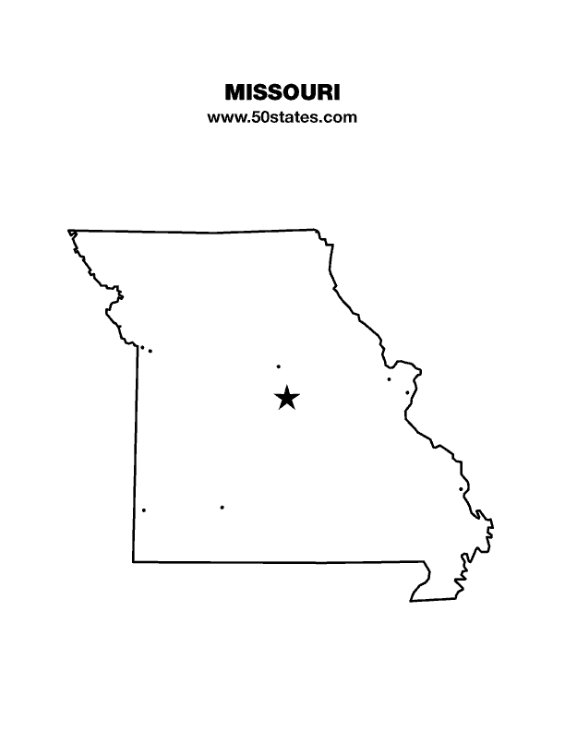
The Blind Missourian
March 2022

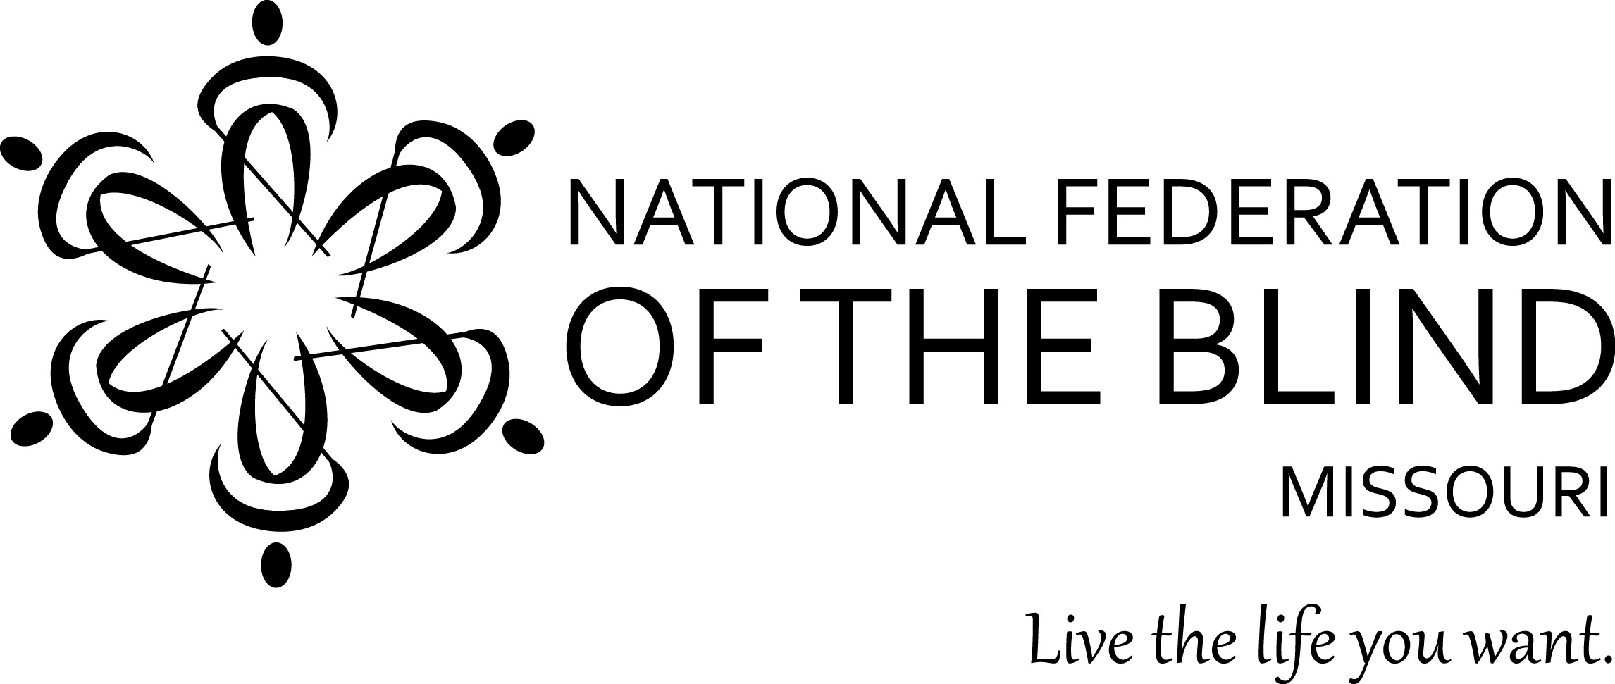

Table of Contents

2022 Legislative Fact Sheet 1

A Life Changing Experience by Svetlana Ehlers 6

Zoom To Washington DC by Debbie Wunder 7

My First Washington Seminar by Annette Nowakowski 8

What Can Chapters Do to Be Active at
the Local Level? by Daniel Garcia 9

Chapter Election Results by Carol Coulter 11

NFB Pledge 12

One Minute Message 12

Shelia Wright, President
7928 NW Milrey Drive
Kansas City, MO 64152
Phone (816) 741-6402
www.nfbmo.org

LEGISLATIVE AGENDA OF BLIND MISSOURIANS

PRESENTED TO
THE SECOND SESSION OF THE ONE HUNDRED AND FIRST GENERAL ASSEMBLY

From: The National Federation of the Blind of Missouri

Date: February 21 and 22, 2022

The National Federation of the Blind knows that blindness is not the characteristic that defines us or our future. Every day we raise the expectations of blind people because low expectations create obstacles between blind people and our dreams. Blindness is not what holds us back.

This is the message we bring to blind Missourians and the communities we live in. We pledge to be a resource to you and your constituents when they turn to you for help.

The National Federation of the Blind is a membership organization of and for the blind. As a volunteer, grassroots organization, we are blind people working on behalf of blind people. We come together on the local, state, and national level to address issues of importance to our fellow blind citizens. We promote programs that encourage self-determination, independence, and equality of opportunity.

Why Braille Is a Necessary Part of The Independence and Success of The Blind

It is said that learning to read is one of the greatest accomplishments of man, and if blind people are to succeed, literacy must be a part of our skill set. This is why we have Braille, the finger equivalent of what most see with their eyes. Only when literate are we able to meet the challenge of expanding our knowledge on a wide variety of subjects and gain an understanding of our world. By using Braille, we are able to read things for ourselves. While audio and electronic means of access are essential to living in our society in the age of advanced technology, there is no substitute for reading something yourself. The importance of having the ability to communicate in writing and knowing where to use punctuation and understanding how to spell is a fundamental skill. Especially is this so if you plan to do a white-collar job.

In our schools, less than 10% of blind children are getting the benefit of learning Braille. At least part of the problem is determining early on who will be most efficient reading Braille, who will be so using print, and which children can benefit significantly from learning both. Print is too often decided upon because it is considered normal, but children who are functionally blind but have some sight pay the cost in eye strain, headaches, and the inability to read rapidly or for long periods. Our blind children soon associate reading with discomfort and real pain.

Studies clearly show that most blind people who are employed know and use Braille. This should speak volumes to the need for it, but while sighted students are learning to read, blind students are being evaluated using a number of inadequate tools. By the time students are expected to read in order to learn, our schools are just deciding to teach our blind children to read Braille. The forecast is gloomy; they are behind, and unless they and their teachers and outside tutors make a herculean effort, this is where they will stay—behind.

Getting and keeping a job relies on skills. Fundamental among these are reading and writing. Audio and video enhance the lives of our citizens, but they do not replace reading and writing, especially for blind folks. As the governor makes one of his priorities employment first, we have the responsibility to do what will make blind people employable and provide for them and the rest of our society the fruits that productivity brings to us all. To this end, we believe that a comprehensive approach to enhancing the educational experience for all students with blindness or low vision is not only the right thing to do but is absolutely necessary if the blind youth of today are to compete with their peers in the future global market.

Blind Students Rights to Independence Training and Education Act (Henceforth referred to as the BRITE Act)

In the spirit of addressing the building of literacy and capacity for success, Representative Brenda Shields has sponsored HB 2150 that takes a multi-level, comprehensive approach to addressing the current imbalance for blind students. This Act will require an increase in the availability and utilization of Braille instruction for all children who would benefit from the learning of this skillset. The Act outlines an approach of addressing Braille instruction and combining this with a range of Assistive Technology that would be available to the student in the classroom and at home. Another important aspect to independence and success in competitive employment is the access to Orientation and Mobility which is necessary for the blind to learn to navigate independently using the available tools and learning to increase recognition of tactile and audible clues to assist in safe, independent navigation. Additionally, the BRITE Act encourages proactivity of those involved in the instruction of blind students through continuous education and self-improvement for these professionals. The NFB is asking for your help to create an equal and fruitful learning environment for all children. You can make a difference by supporting the passage of HB 2150.

Blind Pension Legislation

HB 1925, sponsored by Representative Walsh Moore, and HB 1564, sponsored by Representative Griffith, both have one simple but essential function, to remove the word certified from the law regarding correspondence with blind pension recipients. The well-intentioned insertion of the word certified has caused significant expense to the state as well as to blind recipients who are often forced to go to the post office to pick up mail that would otherwise be found in their box. Not only is this an unnecessary expense; it reduces the time blind pension recipients have to fill out the yearly recertification required and has caused a number of blind people to be terminated and subsequently reinstated, again at significant cost to the state of Missouri and its blind residents who receive the pension. Therefore, HB 1925 and 1564 seek to remove the word certified from the laws governing Blind Pension. Many blind Missourians have experienced significant issues due to the certified mail requirement, and that is why the National Federation of the Blind of Missouri strongly supports this legislation as presented.

Accessible Voting In All Elections

There are multiple bills that have been introduced in the House that address voting from a variety of points of view. The National Federation of the Blind believes that the ability to cast a private ballot securely and independently is a sacred promise allowed to every American through our constitution. We understand that discussions must be had related to voting. It is in the spirit of this understanding that we are not promoting or opposing any particular piece of legislation. We are, however, restating our position on the imperativeness of accessible voting for all of us. Below, we discuss the reasons behind our assertions and ask that, as you debate voting legislation throughout the session, you keep in mind how sacred your vote counting is to you. With this in mind, you will better empathize with our positions and the value we place on casting a ballot independently and privately.

The Help America Vote Act (HAVA) recognizes the right of the blind to vote privately and independently by requiring nonvisual access for the blind through the use of accessible voting systems in all federal elections. Electronic voting technologies, designed and properly configured with nonvisual access, provides blind voters with the ability to cast their votes privately and independently and to verify, without sighted assistance, that their ballots accurately reflect their voting choices. Electronic voting systems were certified and purchased, and Missouri received federal funds for each polling place to provide at least one accessible voting machine. All certified machines in Missouri provide a paper trail.

The Missouri Secretary of State’s Office is evaluating newer machines that mark directly onto the paper ballot. The options are there if legislation to make the paper ballot the official ballot of Missouri is passed. The work of the Secretary of State will also be invaluable when the existing machines need to be replaced.

Accessible machines are already required for the state to comply with HAVA. Some election boards may set these machines up more frequently than others. We ask that they be used consistently in all elections. The cost of setting them up should be minimal since “text to speech” options are available. Concerted efforts are made to get voters to the polls; Missouri should assure that when they arrive, they have the means to cast their ballots privately and independently.

Beyond the example and financial assistance HAVA has provided to emphasize accessible voting, there are two federal laws that require all elections to be accessible to bring Missouri into compliance. Voters with disabilities have the same right to vote privately and independently as do voters without disabilities. When accessible voting machines are not present in state, county, and municipal elections, blind, visually impaired, and other print disabled voters are denied an equal opportunity to cast their ballot privately and independently. This is a violation of Title II of the Americans with Disabilities Act and Section 504 of the Rehabilitation Act of 1973. As a recipient of federal funds, Missouri and our Election Boards are required to comply with Section 504 of the Rehabilitation Act.

Additionally, the Americans with Disabilities Act guarantees equal access for individuals with disabilities to the benefits of the services, programs, or activities of a public entity. Public entities must provide individuals with disabilities an aid, benefit, or service that is as effective in affording equal opportunity to gain the same result or benefit as provided to others. Public entities shall furnish appropriate auxiliary aids and services where necessary to afford individuals with disabilities an equal opportunity to participate in and enjoy the benefits of a service, program, or activity of a public entity. To be effective, the auxiliary aids and services must be provided in such a way as to protect the privacy and independence of the individual with a disability.

Whether the financial responsibility falls on the State of Missouri or the County Election Boards is a technicality that must not continue to preclude the full participation of blind, visually impaired, or other Missourians with disabilities who could benefit from the use of accessible voting equipment. Please assert due diligence regarding bridging the gap that has prevented this legislation from passing in the past, and grant people with disabilities the opportunity and the right afforded us to have the same privilege in every election that you value and take for granted as your right as a citizen of Missouri and of the United States of America.

Accessible Medication Labeling

Taking medication as prescribed is an essential aspect of remaining healthy. This chore is one that can become extremely challenging at best and can result in medication errors that result in critical illness and even death if the wrong medication is taken. Many people who are blind rely on the shape and size of medication bottles, the type of lid on the bottle, the size and shape of the medication itself, and the feeling of the inscription or split lines on the medication. The problem with this method is that bottles can remain the same size with similar lids for months or years, and suddenly, either the manufacturer or the pharmacy changes it up for whatever reason. A pill that is small and squared may have a brand that is more economical for the pharmacy that produces this pill in a larger oblong format. Some brands of medications are solid caplets while others are capsules. With all of this in mind, it is not difficult to see how this is a problem when one cannot read the label. There is technology available to create labels that provide an audible output as well as Braille and large print. This technology requires pharmacy staff to run the medication bottles through a label maker based on the end user’s mode of accessibility. Many pharmacies may not want to offer the accessibility if there is another pharmacy within twenty-five miles. This becomes problematic for those without access to affordable transportation, something most blind people share. Other states have legislatively addressed this issue based on the desire for businesses within their state to become compliant with the ADA and Section 504 of the Rehabilitation Act of 1973. We believe this issue is of great importance and would welcome the opportunity to work with you on the development of legislation that resolves this situation.

To that end, we have included in this packet proposed Model Language for Accessible Prescription Labeling. We ask you to sponsor this legislation and help us enhance the health and safety of all Missourians.

A Life Changing Experience
By Svetlana Ehlers

My name is Svetlana Ehlers; I was a first timer for the Jefferson City seminar. This was the greatest experience I ever had. I had visited the Capitol before with another group, but never had the chance to visit with legislators. When I say that this was the greatest experience, I really mean it. One of the fun experiences I had was visiting my senator, Tony Luetkemeyer, and his dog Truman. The senators and representatives listened to all the topics we talked about, and some of them even said that they would sponsor or even write the bill. This made me happy because it meant what I was saying was getting through to them. I also had an opportunity to participate in a meeting in the Office of the Governor with one of Governor Parson’s Assistants.

After this experience, I'm thinking that I want to become a politician. I use to think talking to legislators would be very daunting, but that is not the case any longer. I am glad that I was able to help make a difference, both for me and my blind peers.

Zoom To Washington DC
By Debbie Wunder

This year was no different for blind Missourians as was the past four decades. The only difference was our mode of travel. For over four decades the blind of Missouri traveled to DC by bus, car, train, and even by flight. We had planned to do so again this year, but a few short days before leaving Missouri, we got the word that congress was discouraging citizens from visiting the capitol in person. So, in typical fashion, again for the second year due to covid restrictions, we quickly switched our meetings to virtual via zoom.

Because of the possibilities that zoom brings to our modern world, we have been able to continue Federation business as usual. For the past two years, chapters across our nation held monthly meetings virtually, affiliates continued having state conventions virtually, and my favorite of all, we still were able to work with blind children through our at home edition of BELL Academy.

Washington Seminar always starts with our Student Division having a seminar and auction. On Monday evening the federation kicks off the week with the great gathering in, and what a great gathering it is. There are usually seven hundred to nine hundred federationists from across the nation sharing thoughts, asking important questions, and hearing from our legislative team explain our legislative priorities. This great gathering is always kicked off by words from our amazing national president, Mark Riccobono. His words are always inspiring, and full of wisdom and truth.

Missouri always answers the call for help and this year was no different. We had members participate from all of our chapters. Meeting virtually allowed many more members to attend than would have been possible if we were in person. We, of course, are thankful for the virtual possibility, but we look forward to being together again on the hill in person.

Thanks to everyone who participated in the Washington Seminar. As a result of our advocacy, our bills garnered many new cosponsors. The Access Technology Affordability Act (H.R.431) in the House jumped from 118 to 130 cosponsors and in the Senate (S.212) increased from 34 to 35. The Medical Device Nonvisual Accessibility Act (H.R. 4853) gained 17 cosponsors, bringing the total to 27. The Transformation to Competitive Integrated Employment Act (H.R. 2373) gained 10 cosponsors in the House, bringing the total to 34. In addition, the lead Senate cosponsor of the Transformation to Competitive Integrated Employment Act, Senator Steve Daines, spoke at our Great Gathering-In. You can see what we can accomplish when we all row the boat together. Let us continue to build our Federation family.

My First Washington Seminar
By Annette Nowakowski

“That government is the strongest of which every man feels himself a part.” This quotation by Thomas Jefferson aptly expresses my feelings as I participated in the 2022 Washington Seminar. From my point of view, there was no reason not to participate. The seminar was virtual which made it easy to attend. I had recently retired from my job and so was free during the day. Finally, there were two bills which, if passed, would directly affect my life, health, safety, and well-being namely, the Twenty-first Century Websites and Application Accessibility Act and the Medical Device Nonvisual Accessibility Act. I testified about HR 4853, The Medical Device Nonvisual Accessibility Act. I related my personal experiences of the impossibility of operating a home heart monitor which was not accessible to me. I spoke to four congressional offices over the course of three days. It was an exhilarating feeling to know that when I was telling my story, hundreds of others across the country were telling their story as well. I am thankful that we still have the privilege to do this in a free country.

Besides my feelings about my participation in the Washington Seminar, I was also impressed by the organization that went into this seminar at the state and national level. There was plenty of opportunity to review the fact sheets on each bill, plenty of opportunity to practice presentations at meetings, and many examples of mock presentations to listen to. I noted the student participation in the mock presentations as well. At the end of the day after meeting with our senators and representatives, we met with NFB national staff to recap events and ask questions if needed.

The great Gathering-in was the crowning point of the Washington Seminar. President Riccobono delivered a passionate speech which emphasized how we will no longer be left out or thought of after the fact. He hammered in on the theme to do it right from the beginning, that is, to “build back better with the blind!”

I am so glad that I participated in this seminar. It gives me a feeling of empowerment, and I know our participation will bear fruit. For example, when I first volunteered for this project, there were ten cosponsors for HR 4853. On February 23, there were 27 cosponsors, and I’m sure these numbers will grow. It proves that we have to take action together to make change. I close with these words from former President Barack Obama on February 5, 2008 in a Super Tuesday speech who said, “Change will not come if we wait for some other person, or if we wait for another time. We are the one we’ve been waiting for. We are the change that we seek.”

What Can Chapters Do to Be Active at the Local Level?
By Daniel Garcia

The September 2021 Blind Missourian featured an article titled “Connecting the Dots: Chapter, State, and National,” which documented a presentation given by President Emeritus Gary Wunder during our Leadership seminar on May 22, 2021. In his presentation, our former president pointed out that many NFB chapters are not involved in the local level as much as we ought to be. The question then becomes: what can chapters do to be active at the local level?

During the May 15, 2021, NFB of Kansas City Chapter Meeting, we heard a short presentation from Eric Bunch, who represents Kansas City’s 4th district in the city council. According to information gathered in his website, he cofounded BikeWalkKC, a nonprofit that advocates for Kansas City to be a more walkable city. Prior to being elected to the city council, he had served for four years on the Mayor’s Bicycle and Pedestrian Advisory Committee.

Below are some notes that I compiled from the recording of the meeting. Although some of the information is specific to Kansas City, many of the same principles can be used by chapters in other cities. To put these words into action, the NFB of Kansas City has recently created a new committee dedicated to Civic Engagement. The roll of the committee is not only to engage city government, but also to start working with other civic organizations to advance the rights of the blind in Kansas City.

Notes from presentation given by Councilman Eric Bunch
NFB of Kansas City Chapter Meeting May 15, 2021

How to Engage City Hall

Develop a policy agenda: what is it that you want to accomplish?

Get to know your city council member: set up meetings, know what you are asking him or her to do.

Partner with other organizations: BikeWalkKC is a great place to start, the Policy Manager is Michael Kelly, coalesce around specific policy agenda, this helps to develop a cohesive message.

Visibility: be present at council meetings, become familiar with legislative process, consider giving public testimony.

Get involved in city commissions, committees, and boards.

What has been happening in Kansas City with regards to pedestrian safety:

The city recently launched the Vision Zero Program. This initiative started in Scandinavia. The principle of this initiative is that no traffic fatality should ever happen. We need to make systemic changes. Among other things, this encompasses preventing distracted driving, encouraging people to wear seat belts, preventing people from drunk driving, etc. The streets have to be designed differently. In so doing, we focus not only on the drivers, but also pedestrians. This came out of a resolution that councilman Bunch authored. It was approved unanimously. To start with, we focus on places where there are problems with driver and pedestrian safety. The most dangerous intersections are near high-frequency bus lines. This is a partnership between the city and other agencies, including the Kansas City Area Transportation Authority.

Sidewalks:
The ordinance on sidewalks is somewhat cloudy as to who is responsible for fixing sidewalks. A few years ago, there was an $800 million infrastructure bond. The City Council decided to spend $7.5 million on sidewalks. There are still many curbs without ramps. The city is in a consent decree with the Department of Justice due to this issue. Since there is limited funding for sidewalk repair, the homeowner may still be responsible for this. Councilman Bunch suggested that to motivate homeowners to fix sidewalks, there could be a 50/50 cost sharing or that the city could give loans. Ideally, we would want to leverage economy of scales by having contractors repair many sidewalks at once rather than one sidewalk at a time.

Some properties do not have sidewalks because they were built before the area was annexed to the city; they are thus grandfathered in. New developments are required to have sidewalks, but the city cannot compel property owners to build a sidewalk where there is none. The city can require that once sidewalks are built, the property owner needs to repair them. Building a new sidewalk is more expensive than repairing one. Call 311 to report bad sidewalks. Since there is limited funding, this is a way to catalog where the need is.

Chapter Election Results
By Carol Coulter

In the last issue, I reported the election results for the Jefferson City, Lewis and Clark, and Old Drum chapters. Here are the results for five more of our chapters. Congratulations to everyone.

Columbia Chapter: President, Gary Wunder; Vice President, Dacia Cole; Secretary, Gail Bryant; Treasurer, Elisabeth Coulter; and Board Member, Gene Coulter.

Ivanhoe Chapter: President, Linda Black White; Vice President, Courtney Parker; Secretary, Cherylette Caldwell; Treasurer, Janis Tillman; Board Member, Brenda Ester.

Kansas City Chapter: President, Daniel Garcia; First Vice President, Willa Patterson; Second Vice President, Linda Coccovizzo; Secretary, Ben Blagg; Treasurer, Jeff Giffen; First Board Member, Sarita Cann; Second Board member, Tony Waterhouse-Leal; Ruby Polk continues to serve on the board as Immediate Past President.

Show-Me Chapter: President, Dennis Miller; Vice President, Dan Keller; Secretary, Carol Morgan; Treasurer, Gene Fleeman; Board Member, Bryan Schulz.

Springfield Chapter: President, Janice Grisham; Vice President, Becky Boyer; Secretary, Hal Boyer; Treasurer, Mary Yearwood; Board Members, Connie Cameron and Ben Vercellone.

Pledge of the
National Federation of the Blind

I pledge to participate actively in the efforts of the National Federation of the Blind to achieve equality, opportunity, and security for the blind; to support the policies and programs of the Federation; and to abide by its Constitution.

One Minute Message

The National Federation of the Blind knows that blindness is not the characteristic that defines you or your future. Every day we raise the expectations of blind people, because low expectations create obstacles between blind people and our dreams. You can live the life you want; blindness is not what holds you back.

Board of Directors
National Federation of the Blind of Missouri

Officers:
Shelia Wright, President Melissa Kane, First Vice President
Jenny Carmack, Second Vice President Becky Boyer, Recording Secretary
Daniel Garcia, Corresponding Secretary Carol Coulter, Treasurer

Board Members:
Eugene Coulter Dennis Miller Robin House
Amy Wilson Randy Carmack Jeff Giffen President Emeritus, Gary Wunder

Chapter Presidents
Columbia Chapter, Gary Wunder, 573-874-1774
Old Drum Chapter, Warrensburg, Preston Peters, 816-263-0947
Jefferson City Chapter, Chris Griggs, 573-418-9284
Springfield Chapter, Janice Grisham, 417-761-0253
Kansas City Chapter, Daniel Garcia, 816-505-5520
Lewis and Clark Chapter, St. Louis, Jenny Carmack, 314-239-9776
Mineral Area Chapter, Farmington, Roger Crome, 573-701-8409
Show Me State Chapter, meets via conference call, Dennis Miller, 660-234-5351
Ivanhoe Chapter, Kansas City, Linda Black-White 816-923-7074

Blind Missourian Editor Carol Coulter
Proof Readers: Shelia Wright, Daniel Garcia and Grace Warn
Read by Elisabeth Coulter

FREE MATTER FOR THE

BLIND AND PHYSICALLY

HANDICAPPED

NFB of Missouri
1504 Furlong Dr.
Columbia, MO 65202

