2023 Student Seminar
Finding Your Path Forward

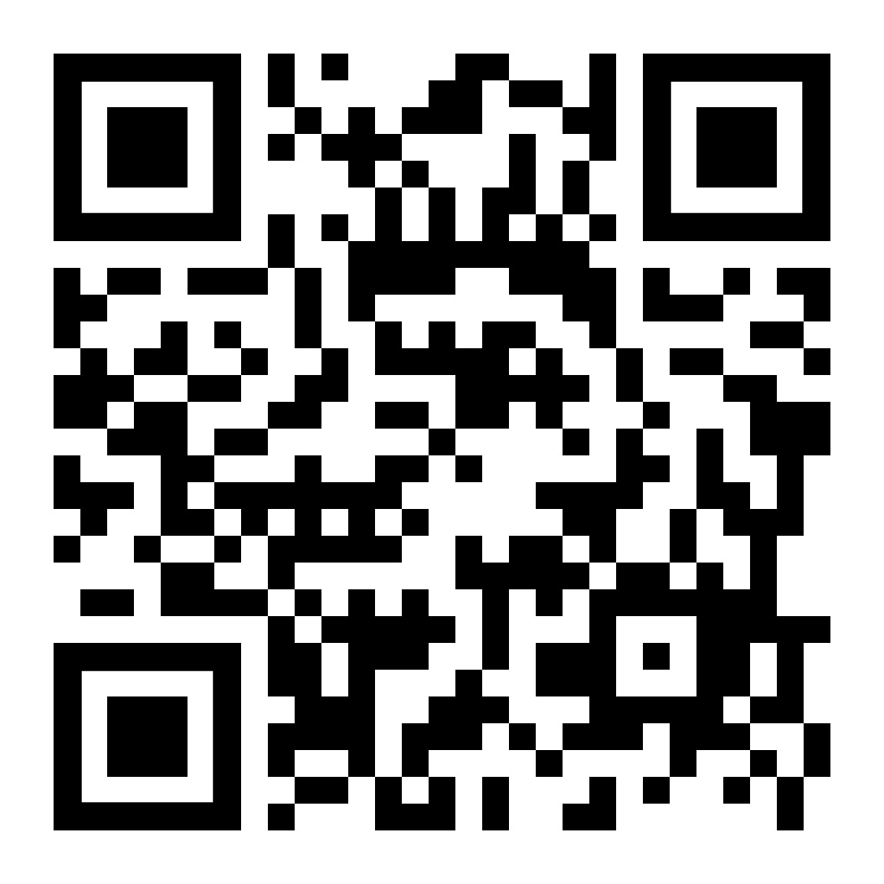
The Missouri Association of Blind Students (MOABS) and the National Federation of the Blind of Missouri invites you to join us on for an exciting evening full of engaging presentations and numerous chances for networking opportunities.
Friday, April 14th (5:00 PM) - (8:00 PM)
Hilton St. Louis Airport: 10330 Natural Bridge Rd. St. Louis, MO - Salon D - F
Register here!
Direct any questions to Seyoon Choi
schoi@nfbmo.org
(314) 650-8306

Get ready for an incredible evening with us!
The student led seminar, themed Finding Your Path Forward, is the perfect opportunities for blind students and their families to learn, network, and mentor from one another. Whether you’re a high school senior getting ready to take that giant step forward into higher education, a longtime cane user who may be thinking of taking a new path forward with a guide dog, or are looking to find your way forward with a more independent lifestyle through one of the National Federation of the Blind’s fantastic training centers, our seminar will have something for everyone! Join us as we hear from many fantastic panelists and presenters about how we as blind people can find our own way forward to live the lives we want.

