**Sponsor SHEET**

|  |  |  |
| --- | --- | --- |
| # | Name | Amount |
| 1 |  |  |
| 2 |  |  |
| 3 |  |  |
| 4 |  |  |
| 5 |  |  |
| 6 |  |  |
| 7 |  |  |
| 8 |  |  |
| 9 |  |  |
| 10  Total |  |  |

If you have more sponsors, please use an additional sheet.

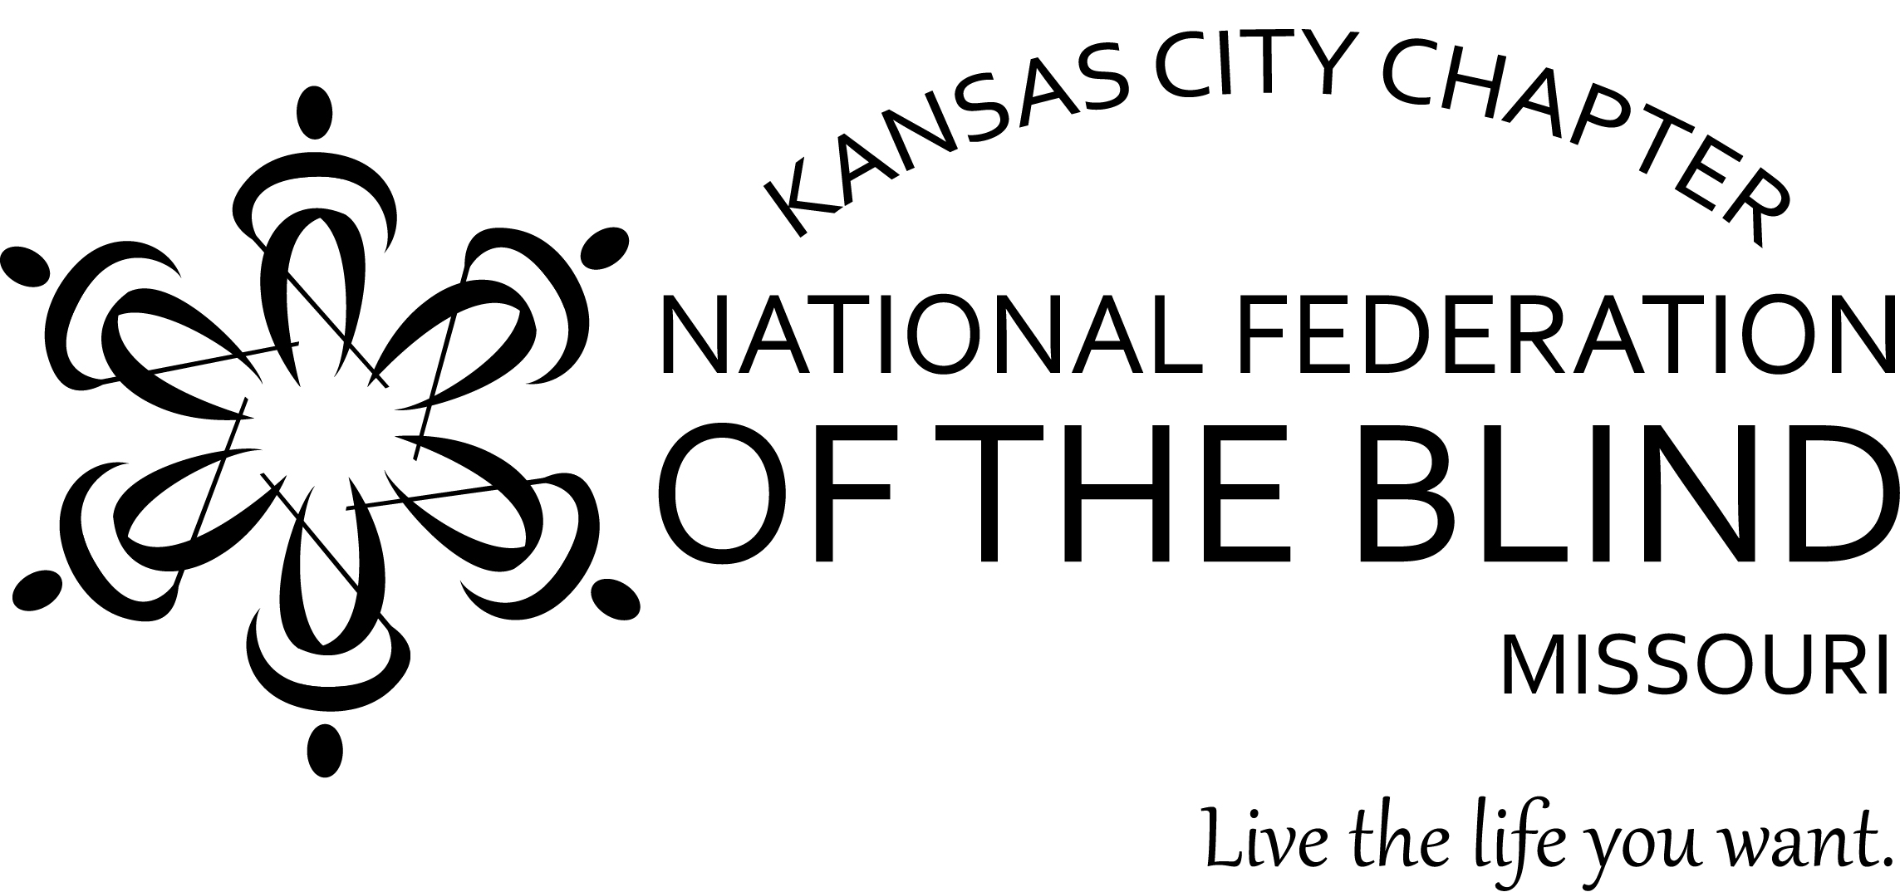

WALK FOR INDEPENDENCE 5K Walk.

**Saturday, May 11, 2024**

**Starting at Loose Park Pavilion**

**ABOUT THE WALK FOR INDEPENDENCE 5K Walk**

You can help by obtaining sponsors and joining us for our 2024 walk on Saturday, May 11.

Registration begins at 9:00 a.m. at the Loose Park Pavilion at 5200 Wornall Road. The Park entrance is between 51st and 55th Streets. The registration fee is $10.

You may turn in your sponsor sheet, donations, and registration fee in advance or at registration on the day of the walk. Checks should be made payable to: **NFB - Kansas City**. You can turn in the money you raised until July 13.

The 5K walk will begin at 10:00 am (rain or shine) at Loose Park and will make its way through Wornall Road, Meyer Boulevard, Ward Parkway, and 55th St.

To obtain more information about this event or the National Federation of the Blind, you may contact us at 816-621-0902

The National Federation of the Blind knows that blindness is not the characteristic that defines you or your future. Every day we raise the expectations of blind people because low expectations create obstacles between blind people and our dreams. You can live the life you want; Blindness is not what holds you back.

**REGISTRATION**

Name:____________________________________

Address:__________________________________

_________________________________________

Phone:____________________________________

Emergency Contact Information:

Name:___________________________________

Phone:__________________________________

**WAIVER**

I hereby waive all claims against the National Federation of the Blind, State affiliates, chapters, and any personnel for any injury I might suffer in this event.

Signature:_________________________________

If the walker is under the age of **18**, signature of parent or guardian is required below.

Signature:_______________________________