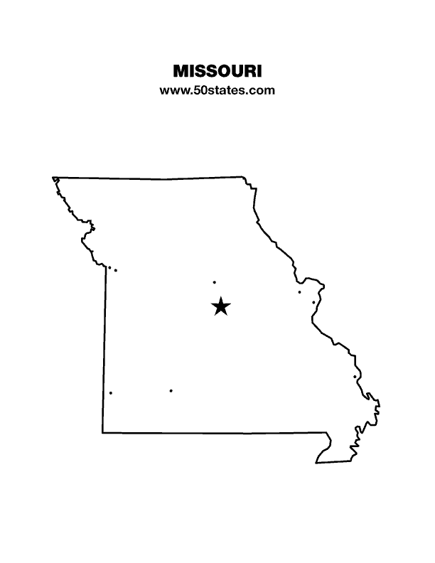
The Blind Missourian
June 2026

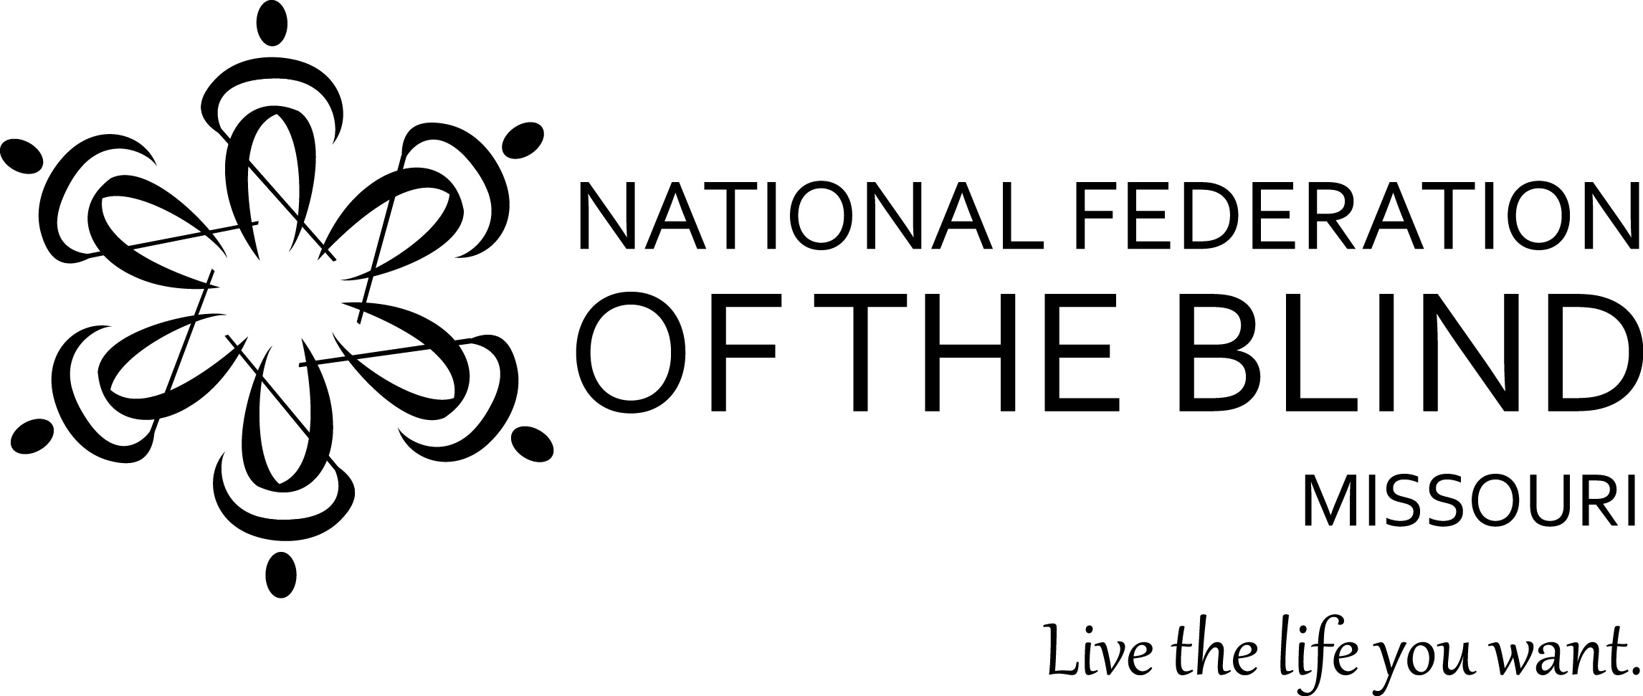

Table of Contents

2026 Presidential Report by President Shelia Wright 1

Resolutions Passed at the 2026 State Convention 5

Proclamation 12

Randy Carmack by Gene Coulter 13

The Belief Message 14

2026 Presidential Report
By President Shelia Wright

It has been a great convention so far. I would like to thank our Jefferson City Chapter for all the hard work they have done and are doing this weekend to make this a great convention. I know that they started about a year ago and have worked throughout the year in anticipation of hosting this convention. Please let them know how much we appreciate their work.

We started earlier in the convention, looking at our brand architecture, and we talked about our National Federation of the Blind brand values last night. I want to continue with a few other sections from our brand architecture that I would like for us to focus on for a few minutes this morning.

The National Federation of the Blind advances the lives of its members and all blind people in the United States. We know that blindness is not the characteristic that defines you or your future. Every day we raise the expectations of blind people because low expectations create obstacles between blind people and our dreams. Our collective power, determination, and diversity achieve the aspirations of all blind people.

This is much more than rhetoric. It is the belief message of our organization. It is heartfelt and it is true to every part of the National Federation of the Blind. This is why we recommend that members learn our belief message and encourage chapters to include it in their meetings, particularly when welcoming new members.

The National Federation of the Blind is the only organization directed by blind people that believes in our full capacity and has the power, diversity, determination, and love to transform our dreams into reality. One of the unique things about us is that we are blind people leading blind people. That is why our constitution requires that the president and vice presidents must be blind and requires that a majority of both our boards and our membership must be blind. All our members must understand why this is true. You ask: “Why is this important?” Our lived experiences allow us to know what is needed and what is not. We welcome friends and family who want to collaborate with us to change public attitudes and develop opportunities for blind people to live the life they want.
The public has misconceptions about us, and far too often they assume that our sighted family or friends must help us with anything they cannot imagine they could do if they were blind. I have been asked more than once if Jeff applies my makeup or picks out my clothes. I am sure all of you have had equally bizarre questions, and we can only turn the question into a short opportunity to briefly educate with a kind response.

Our brand experience really speaks to me: I feel hopeful and motivated because of the love and encouragement within the National Federation of the Blind to grow and achieve my dreams while also contributing to advance our collective aspiration for all blind people to be valued and respected in society.

Most of our members will say that people come in looking for answers. They come in looking for people like themselves, but most of us who stay around stay in because it is a part of us. We feel it, we benefit from it, and we want to give back so those who come behind us have fewer obstacles and the opportunities that the NFB provides.

Your experience may be a little different than mine. To belong, to be loved, to be encouraged, and to be able to give and make a difference in the quality of life for those who come behind us are motivating and empowering. So, I encourage you to use our information in our branding materials in your chapters, and to talk about and get even more familiar with who we are.

I want to turn now to the work we are doing in the National Federation of the Blind of Missouri. Pam [Allen]talked about membership, and I want to talk about the growth of our Missouri affiliate. Currently, we have seven chapters, and all those chapters are working hard to help conduct the work of the National Federation of the Blind. We need more members. There is as much work that could be done as is being done, if we had enough hands to do the work, to help with that work. So, when you meet other blind people, you can use some of our messaging to get started. Sometimes those first few sentences when you meet someone new are the hardest, and I use some of our messaging to help me get the conversation or presentation started.

When you meet a blind person, please tell them about the National Federation of the Blind. I know when I go to a restaurant and it is really good, I am going to tell people about it. When I go to a store and the clerks are extremely helpful, I am going to tell my blind friends about it. When you find something good, you talk about it. So do not stop with food and stores and other things you like. Tell everyone about the National Federation of the Blind because it is important to us, and it can change our lives and the lives of other blind people who have never even heard about the National Federation of the Blind. I want to recognize the Lewis and Clark Chapter, who have gained 18 new members since last year's state convention. President Jenny Carmack led this tremendous growth. Janice Grisham was selected to participate in the IEP Academy in May of 2025. Since participating in the academy, she has led a seminar for two groups of parents and answered questions about the IEP and how the NFB can be a resource to them. These seminars occurred at our BELL Academy in St. Louis and in conjunction with our STEM2U program in August.

If you know of families that need help with their blind student’s IEP, we can help match them with an advocate who can assist them. We want to be available to help parents navigate that and sometimes it means talking with them and letting them know what kinds of things they can ask for, what blind kids really need. In terms of blindness skills, most of them are new to blindness, so we have three or four people across the state now who have and are willing to help parents navigate their children’s IEP and receive the services they need. We are glad to add Janice to that group of people.

Jenny Carmack is our youth coordinator. Jenny uses materials that are prepared by our national office; however, she is extremely creative and produces a lot of her own materials for activities. She does an amazing job at planning and conducting our BELL Academy, our cane drivers, and our Mission BEAM program. She will be talking about these programs later this morning so I won’t say much more about them. However, I will say that Jenny does a tremendous job. Thank you, Jenny!

I want to move on to the topic of funding. Our affiliate has been blessed to occasionally get bequests. They have allowed us to do a lot of things that other affiliates cannot do. We are getting to a point where we are going to need to do one of two things, find new funding sources, or be careful at what we say yes to. On an average year, we spend around $100,000. Our state convention fund raising efforts are our most successful. At this convention, you see a lot of fundraising happening; in fact, in recent years probably 75 to 80 percent of our fundraising occurs at the convention. If we want to maintain the programs and activities of the affiliate, we simply must find new funding sources. We desperately need all our members participating in the projects our Ways and Means Committee launches. Currently, our committee has launched projects over the past three years, which have averaged approximately ten thousand dollars a year. As you can see, our fundraising does not match our expenses. We need your ideas and we need each of you working on raising money to support our programs. It is not up to the Ways and Means Committee to raise the money. It is up to all of us. So, when we have raffle tickets or fundraisers, I ask all of you to help raise that money so that we can do the impressive things that we do.

Before I leave this topic, I want to recognize Diane Harris. Diane has many talents and she often uses them to help with our fund raising by making banana bread to sell to our members. She also crochets and donates the crafts that she crochets to the affiliate to use in fund raising. This past year her projects raised $950. On behalf of our affiliate, we certainly appreciate everything you do to help with funding our movement.

This year, we began a new giving opportunity which we are calling MO Gives. It is a monthly contribution to the NFB of Missouri, which is withdrawn directly from your checking or debit account. The minimum donation is $10 per month, which is drawn on the 15th of the month. Let me make one thing clear: we started this with one provision; no one can reduce or stop giving to the PAC Plan to participate in MO Gives. If that should happen, it will be necessary to discontinue the MO Gives program, because we cannot allow it to interfere with our commitment to PAC at the national level. The MO Gives program in 2025 brought in approximately a thousand dollars. I encourage you to give monthly to the NFB of Missouri. Please see Carol Coulter, and she will be glad to get you signed up. If you are not on the PAC Plan or MO Gives, and you need to decide between the two, please choose PAC.

I know that money spent on a local level is helpful. Money spent on the state level is more helpful because the reach is greater, and money spent on a national level can go even further. As an affiliate of the National Federation of the Blind, it is our responsibility to not just support our chapters, but to pass on funds raised to the state organization and to support the national level. We are the National Federation of the Blind, not just the National Federation of the Blind of Kansas City or whatever chapter you are a part of, not just the NFB of Missouri, but we, the members, are the National Federation of the Blind. We are not in the banking business. So, it does not do a lot of good to accumulate a lot of money. Chapters should be trying to get members to state convention and to national convention. I like to think of the national convention as the place where you can really appreciate what the National Federation of the Blind really is. It is hard to see what we do when you get little glimpses, but when you can see the full picture at our national convention, then you really understand what the National Federation of the Blind really is. It is not too late for some of you to consider going to the National Convention in Austin. Yes, that main hotel may already be filled, but there are plenty of rooms in nearby overflow hotels. If money is the issue for first-timers, there are funds that can help you if you act right away, as the deadline for applications will end on April 15th. You could be considered for a Kenneth Jernigan scholarship, but our state affiliate, at each convention, dedicates funds to helping our members go to national convention. These stipends will not pay for all expenses, but they can really help offset some of the expenses of the convention. If you have never gone to our national convention, please consider making this year's convention your first. I am going to stop there and just say that I love being president of the National Federation of the Blind of Missouri, but I cannot do it without each of you. I frequently call upon those who have volunteered and already are engaged to help. If you would like to serve on committees, write letters, help with our programs, and take on new challenges, identify where your interest lies and let me know you are available and where you would like to serve. Every person has a place in this organization; every person has skills and talents that others may not have, and every person can really make the National Federation of the Blind of Missouri stronger than what it is today. Engage, and together let us build the National Federation of the Blind.

As I do every year with this report, I recommit myself to the National Federation of the Blind of Missouri to do all that I can do to carry out the work of the National Federation of the Blind. Will you join me in our NFB Pledge and reaffirm your commitment?

I pledge to participate actively in the efforts of the National Federation of the Blind to achieve equality, opportunity, and security for the blind; to support the policies and programs of the Federation; and to abide by its constitution.

Here are the resolutions passed at the 2026 NFB of Missouri state convention.

2026-02 Regarding The Kansas City Wheel

WHEREAS, the Kansas City Wheel is one of Kansas City’s newest and most celebrated public attractions; and

WHEREAS, a group of blind individuals attempting to enjoy the attraction were recently informed that they could not bring their white canes into the gondolas and were instead required to surrender their canes to Kansas City Wheel staff for storage during the ride; and

WHEREAS, this forced removal of essential mobility tools constitutes a blatant and dangerous act of discrimination, directly denying blind individuals their independence, safety, and dignity; and

WHEREAS, the Americans with Disabilities Act, along with Section 209.150 of the Revised Statutes of the State of Missouri, unequivocally prohibits denying access or imposing unnecessary conditions on blind individuals solely because of their disability; and

WHEREAS, the white cane is not a discretionary item, but an indispensable mobility aid required for safe and independent travel; and

WHEREAS, despite these clear legal requirements, the Kansas City Wheel continues to enforce a policy that strips blind riders of their white canes and thereby violates federal and state law: Now, therefore,

BE IT RESOLVED by the National Federation of the Blind of Missouri, in convention assembled this 12th day of April, 2026, in the City of Columbia, Missouri, that we strongly condemn and rebuke the discriminatory, unlawful, and safety-compromising actions of the Kansas City Wheel and its staff; and

BE IT FURTHER RESOLVED that we demand the immediate and unconditional reversal of this illegal policy so that blind individuals may ride the Kansas City Wheel with their white canes at all times, without surrendering them and without interference; and

BE IT FURTHER RESOLVED that we call upon members of the public, disability advocates, civic leaders, and all who value justice and equal access to stand with us by contacting Kansas City Wheel management, expressing their objection to this dangerous and discriminatory policy, and insisting on swift compliance with the law; and

BE IT FURTHER RESOLVED that we pledge to pursue all appropriate actions—including formal complaints, public education, and, if necessary, legal remedies—until the Kansas City Wheel ends this discriminatory practice, restores full access to blind riders, and demonstrates sustained compliance with federal and state law.

Resolution 2026-03 Regarding the FSD Portal

WHEREAS, the Family Support Division (FSD) administers various programs for Blind Missourians including Blind Pension (BP) and Supplemental Aid to the Blind (SAB); and

WHEREAS, FSD has created a portal for consumers to access their benefit status and while the portal is somewhat accessible to blind people using screen reader technology; and

WHEREAS, the portal does not allow the submission of annual review forms with one of the reasons given being that a signature is required, though many financial institutions such as banks and even the Internal Revenue Service allow for electronic signatures; and

WHEREAS, there are discrepancies such as in the date shown for the return of the annual review form as the portal shows that review forms are due a month later than the form that consumers receive in the mail, the result being a letter threatening to terminate benefits if the portal date is chosen: Now, therefore,

BE IT RESOLVED by the National Federation of the Blind of Missouri in convention assembled this 12th day of April, 2026, in the City of Columbia, Missouri, that we urge FSD immediately to allow for BP and SAB annual forms to be submitted through the portal and that the due dates shown on the portal for review submission be corrected.

Resolution 2026-04 Regarding Abusive Lawsuits Placing Predatory Profit over Equitable Access for the Blind

WHEREAS, the National Federation of the Blind of Missouri believes that the internet is not a luxury but the modern town square and that, as society moves further into the digital age, blind Missourians must have equal access to commerce, education, entertainment, and community life; and

WHEREAS, the Americans with Disabilities Act serves as a vital civil rights protection by requiring that digital storefronts and online services be as accessible and navigable as physical locations; and

WHEREAS, an accessible website often marks the difference between independence and exclusion for blind people seeking to shop for groceries, pursue an education, obtain information, and participate fully in civic and social life; and

WHEREAS, the National Federation of the Blind of Missouri strongly supports meaningful digital accessibility and believes that progress should be measured by improved access rather than by the volume of litigation; and

WHEREAS, this organization opposes “sue-and-settle” tactics that seek quick financial settlements without producing meaningful remediation and is concerned by lawsuits brought by parties who have no genuine intent to use a service or who have not given a business a fair opportunity to correct an access barrier; and

WHEREAS, such opportunistic legal tactics can foster resentment and damaged relationships between the disability community and the businesses blind people wish to patronize, thereby undermining the broader cause of equality and inclusion; and

WHEREAS, the Federation believes that a ninety-day remediation period can provide businesses acting in good faith a reasonable opportunity to bring their websites and digital services into compliance while preserving the fundamental requirement of accessibility; and

WHEREAS, many business owners may themselves be harmed by website developers and coders who sell inaccessible digital products without understanding accessibility requirements and who are too rarely held accountable for delivering defective products; and

WHEREAS, although several bills now moving through the Missouri General Assembly, including HB 1674, HB 1694, HB 1755, HB 1780, HB 1842, HB 2056, HB 2150, HB 2312, and SB 907, touch upon these issues, the National Federation of the Blind of Missouri speaks here not to endorse any single measure but to affirm the broader principle that accessibility must be required while civil rights protections must not be twisted into tools for predatory profit: Now, therefore,

BE IT RESOLVED by the National Federation of the Blind of Missouri in convention assembled this 12th day of April, 2026, in the City of Columbia, Missouri, that this organization reaffirm its strong support for the Americans with Disabilities Act and for the principle that websites and other digital services must be accessible to blind people on equal terms with others; and

BE IT FURTHER RESOLVED that this organization declare its opposition to abusive litigation practices that seek financial gain without advancing meaningful accessibility and that rely upon recruited plaintiffs, bad-faith claims, or the withholding of a fair opportunity to remedy technical barriers; and

BE IT FURTHER RESOLVED that this organization support policies that allow a reasonable ninety-day period for good-faith remediation of digital accessibility barriers so long as such policies preserve the civil rights of blind people and lead to genuine compliance rather than delay or avoidance; and

BE IT FURTHER RESOLVED that this organization call for greater accountability from website developers, coders, and other vendors who create and sell inaccessible digital products to businesses and organizations in Missouri; and

BE IT FURTHER RESOLVED that this organization commit itself to working with Missouri’s business community, policymakers, and other stakeholders to promote inclusive technology, strong community partnerships, and a digital landscape in which accessibility is a requirement and not a suggestion.

Resolution 2026-05 Regarding Missouri’s Participation in Texas v. Kennedy

WHEREAS, Section 504 of the Rehabilitation Act of 1973 has for more than fifty years prohibited discrimination on the basis of disability in programs and activities receiving federal financial assistance and has served as a cornerstone of civil rights protections for blind people and other disabled people in the United States; and

WHEREAS, the lawsuit Texas v. Kennedy seeks to weaken federal enforcement of Section 504 and threatens protections that blind Missourians rely upon in education, employment, public services, health care, and full participation in community life; and

WHEREAS, the National Federation of the Blind has warned that Missouri is one of nine states participating in this lawsuit and has called upon members in those states to urge their governors and attorneys general to withdraw from the case; and

WHEREAS, disability-rights advocates report that, after public objection, the states withdrew their claim that Section 504 itself is unconstitutional, but the lawsuit continues to challenge the updated federal rules implementing Section 504; and

WHEREAS, the nine remaining states have begun to attack Section 504 as it pertains to the integration mandate from the landmark United States Supreme Court decision of Olmstead V. l L.c., 527 U.S. 581 (1999); and

WHEREAS, this mandate requires that specialized services be available to us in our local communities; and

WHEREAS, these services include Braille instruction, Orientation and Mobility, activities of daily living, training to use accessible technology, and services from rehabilitation counselors; and

WHEREAS, Missouri should stand for the equal treatment, dignity, independence, and civil rights of blind people rather than lend its name or resources to litigation that threatens those protections: Now, therefore,

BE IT RESOLVED by the National Federation of the Blind of Missouri in convention assembled this 12th day of April, 2026, in the City of Columbia, Missouri, that this organization call upon Missouri Attorney General Catherine Hanaway and Governor Mike Kehoe to withdraw the State of Missouri immediately from Texas v. Kennedy; and

BE IT FURTHER RESOLVED that this organization declare Missouri’s continued participation in litigation attacking the enforcement framework of Section 504 to be contrary to the interests of blind Missourians and other disabled people; and

BE IT FURTHER RESOLVED that this organization urge the Attorney General and all appropriate state officials to affirm publicly Missouri’s support for Section 504 of the Rehabilitation Act of 1973 and for the full civil rights of blind and disabled people.

Resolution 2026-06 Regarding Access for the Blind to Autonomous Vehicles

WHEREAS, On January 29, 2011, The Blind Driver Challenge, an initiative of the National Federation of the Blind Jernigan Institute, successfully demonstrated that blind people can safely operate a motor vehicle equipped with the proper non-visual interface; and

WHEREAS, level 5 fully autonomous vehicles will provide equal access to reliable, affordable, flexible, and barrier-free transportation to the blind and others with disabilities; and

WHEREAS, there are currently many level 2, level 3, and some level 4 autonomous vehicles on the market; and

WHEREAS, in anticipation of increasing technological advancements which will eventually lead to level 5 autonomous vehicles, several bills are being considered by the Missouri General Assembly, some which require a driver’s license to operate the vehicle; and

WHEREAS, other legislation being considered by the Missouri General Assembly would not have a driver’s license requirement, the presumption being that if the vehicle is self-driving, no such need exists; and

WHEREAS, the National Federation of the Blind of Missouri is not endorsing the safety nor efficacy of any brand of autonomous vehicles currently on the market: Now, therefore,

BE IT RESOLVED by the National Federation of the Blind of Missouri in convention assembled this 12th day of April, 2026, in the City of Columbia, Missouri, that we support legislation that will enhance transportation options for the blind; and

BE IT FURTHER RESOLVED that the National Federation of the Blind of Missouri urges the Missouri General Assembly to promptly enact legislation that does not contain or enact driver’s licensing requirements when fully autonomous vehicles are being driven on the roads, so blind people may have access to the same fully autonomous vehicles at the same time as other drivers, thus increasing independent travel, freedom, and economic opportunities for the blind.

Resolution 26-07 Regarding Reduction in Funding for the Blind Pension

WHEREAS, the National Federation of the Blind of Missouri is the largest and most influential consumer organization representing the interests of Blind Missourians in the state; and

WHEREAS, thousands of blind Missourians receive Blind Pension; and

WHEREAS, Blind Pension is a vital source of income that blind Missourians receive on a monthly basis; and

WHEREAS, the Missouri state legislature is considering removing a significant amount of money from the Blind Pension fund and reducing the property tax rate; and

WHEREAS, the National Federation of the Blind of Missouri is concerned that such a large reduction could adversely affect the state's ability to pay future
blind pension recipients; and

WHEREAS, this could have a devastating effect on the quality of life for blind Missourians who rely on Blind Pension: Now, therefore,

BE IT RESOLVED by the National Federation of the Blind of Missouri in convention assembled this 12th day of April, 2026, in the City of Columbia, Missouri, that we implore the Missouri state legislature to not take any action that would have an adverse effect on the Blind Pension fund.

Resolution 2026-08 Commending Oscar’s Classic Diner Restaurant for improving the accessibility of their website

WHEREAS, the owner of Oscar’s Classic Diner in Jefferson City, Missouri, received a purposely poorly written letter about their website not being accessible to the blind; and

WHEREAS, the owner ignored the letter since it was so poorly written and lacked details; and

WHEREAS, a Kansas City attorney sued the restaurant in Jefferson City since no changes were made to the restaurant’s website; and

WHEREAS, the Jefferson City chapter of the National Federation of the Blind of Missouri was able to use the website and was willing to testify on behalf of the local restaurant; and

WHEREAS, the attorney ended up receiving half of the money he originally sought out and is well-known for suing Missouri businesses for inaccessible websites; and

WHEREAS, a Kansas City news report in August 2025 brought to light various accessibility problems with the attorney’s own websites: Now, therefore:

BE IT RESOLVED by the National Federation of the Blind of Missouri in convention assembled this 12th day of April, 2026, in the City of Columbia, Missouri, that this organization commends Oscar’s Classic Diner for improving the accessibility of their website.

2026-09 Calling upon Missouri’s legal community to work with the National Federation of the Blind to improve website accessibility

WHEREAS, the National Federation of the Blind of Missouri is the largest and most influential consumer organization representing the interests of Blind Missourians in the state; and

WHEREAS, we are engaged at the local, state, and federal level in legal, legislative, and advocacy work to improve website accessibility for the Blind; and

WHEREAS, we consider legal action to be a last resort in resolving accessibility problems, and we do not engage in legal action for the sake of making money, but to improve website accessibility and thus our settlements are made public: Now, therefore,

BE IT RESOLVED by the National Federation of the Blind of Missouri in convention assembled this 12th day of April, 2026, in the City of Columbia, Missouri, that this organization condemn and deplore the practice of some Missouri attorneys engaging in the practice of “sue-and-settle” tactics that seek quick financial settlements without producing meaningful remediation; and

BE IT FURTHER RESOLVED that we call upon Missouri’s legal community to work with the National Federation of the Blind to improve website accessibility for the Blind while not harming the businesses we seek to patronize.

National Federation of the Blind of Missouri
President’s Proclamation

WHEREAS, the National Federation of the Blind has prospered within the United States of America and under its laws, as perfect or imperfect as they may be, giving us the opportunity to enjoy the freedom to advocate for change and to activate, empower, and motivate citizens to improve the lives of blind people everywhere; and
WHEREAS, even in today’s heated political climate, we can share in the work and be a voice wherever and whenever government policies harm blind people; and
WHEREAS, the year 2026 marks the 250th anniversary of the founding of the United States of America, providing an opportunity to reflect on our nation’s history, achievements, challenges, and continued progress.
NOW, THEREFORE, I, Shelia Wright, President of the National Federation of the Blind of Missouri, do hereby proclaim that the National Federation of the Blind of Missouri recognizes and celebrates the 250th anniversary of our country’s founding, and encourages all members to reflect upon our nation’s history with understanding and thoughtful consideration; and
I FURTHER PROCLAIM that we reaffirm our commitment to work within the laws of our city, county, state, and country to effect change with peaceful but firm and unwavering determination, because our work is important and valuable, and because equality and opportunity for blind people remain essential to the promise of our nation.

IN WITNESS WHEREOF, I have hereunto set my hand this 20th day of June, 2026, in the City of Kansas City, Missouri.
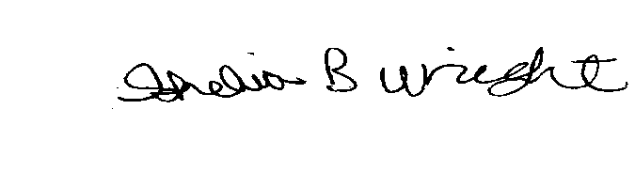
President, National Federation of the Blind of Missouri

Randy Carmack
By Eugene Coulter

Dear Jernigan Committee,

I am honored to nominate Mr. Randy Carmack for the 2026 Kenneth Jernigan Award. Although there are many outstanding candidates, Mr. Carmack’s exceptional dedication and leadership truly set him apart.

Mr. Carmack has been an invaluable member of both the local chapter and state affiliate, serving notably as treasurer for the Lewis and Clark Chapter. His exemplary contributions at the state level, particularly regarding the affiliate website, have made a lasting impact. Before the transition to our current website, Missouri’s affiliate site was recognized as one of the most comprehensive and up to date in the nation, thanks to Mr. Carmack’s tireless efforts. Even after stepping down as webmaster, he continued to enhance our online presence, overcoming challenges and generously training others as page managers for their respective chapters.

Additionally, Mr. Carmack has served as the Audio Guru for state conventions and board meetings, consistently ensuring flawless setup and operation of equipment. His commitment behind the scenes—transporting, assembling, and dismantling complex audio setups—exemplifies his professionalism. He was also instrumental in establishing the Archives, enabling me to manage them efficiently without needing extensive technical knowledge. This initiative allowed for the assignment of NFBMO.org email addresses. Furthermore, Mr. Carmack is responsible for bringing online forms for state convention and youth programs, streamlining our processes, and improving accessibility.

His leadership extends to his role as a distinguished member of the affiliate board of directors and as chairman of the public relations committee. Mr. Carmack actively participates in Jefferson City Seminars and consistently represents our affiliate at national conventions, embodying the spirit of service and advocacy.

Given the breadth of his contributions, I am certain there are many additional achievements that I have not fully captured. Please give Mr. Randy Carmack your highest consideration for the 2026 Kenneth Jernigan Award.

Editor’s note: Carol Coulter, editor and treasurer of the National Federation of the Blind of Missouri has moved. The new address is 4705 Cedar Rock Court, Columbia, MO 65203. This is a big part of why this addition is late and I send my deepest apologies.

The Belief Message
The National Federation of the Blind advances the lives of its members and all blind people in the United States. We know that blindness is not the characteristic that defines you or your future. Every day we raise the expectations of blind people, because low expectations create obstacles between blind people and our dreams. Our collective power, determination, and diversity achieve the aspirations of all blind people.

Board of Directors
National Federation of the Blind of Missouri

Officers:
Shelia Wright, President Jenny Carmack, First Vice President
Seyoon Choi, Second Vice President Tally Davis, Recording Secretary
Randy Carmack, Corresponding Secretary Carol Coulter, Treasurer

Board Members:
Eugene Coulter Dennis Miller Janice Grisham
Mark Harris Darrin Sherman Cory McMahon Nancy Aguilera President Emeritus, Gary Wunder

Chapter Presidents
Columbia Chapter, Cory McMahon, 314-610-1749
Jefferson City Chapter, Debbie Wunder, 573-874-1774
Springfield Chapter, Janice Grisham, 417-761-0253
Kansas City Chapter, Svetlana Ehlers, 816-769-9950
Lewis and Clark Chapter, St. Louis, Jenny Carmack, 314-239-9776
Mineral Area Chapter, Farmington, Roger Crome, 573-701-8409
Ivanhoe Chapter, Kansas City, Linda Black-White, 816-923-7074
Show Me Chapter, (at-large) meets via Zoom, Dennis Miller, 660-234-5351

Blind Missourian Editor, Carol Coulter
Proofreaders Daniel Garcia, Grace Warn, and Shelia Wright
Read by Elisabeth Coulter

FREE MATTER FOR THE

BLIND AND PHYSICALLY

HANDICAPPED

NFB of Missouri
4705 Cedar Rock Ct.
Columbia, MO 65203

