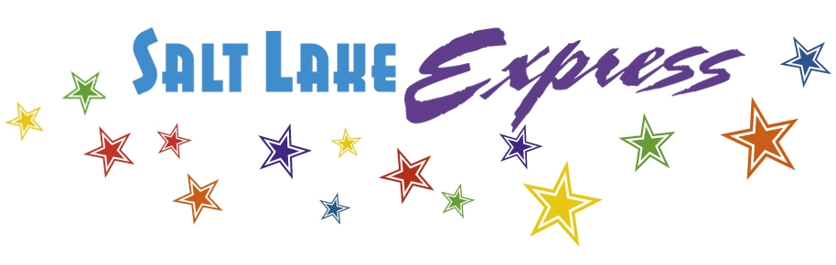
For Immediate Release: Contact:
February 18, 2014 Jacob Price, Operations Manager
208-317-8212
David Jacobs,
MDT Transit Section Supervisor
406-444-4265
Intercity Bus Service Restored to I-15 Corridor from Butte to Great Falls
Salt Lake Express to serve eight communities along corridor starting February 20th
Salt Lake Express announced today that they will begin intercity bus service between Butte, Helena, and Great Falls starting February 20th, serving eight communities on the I-15 corridor north of Butte that have been without service since last summer. The Montana Department of Transportation (MDT) and Salt Lake Express have been working on restoring the connection since that time, culminating in a signed contract last week. Funding comes from the Federal Transit Administration 5311(f) Intercity Bus Program, which is designed to connect rural communities with urban centers and with the National Bus Network.
Communities along I-15 north of Butte first lost service in March, 2013 when Federal Motor Carrier Safety Administration (FMCSA) inspectors shut down the Billings-based Rimrock Stages bus fleet. Salt Lake Express operated the route last summer, but ridership was not high enough for it to be financially viable, so service was terminated until a funding source could be found.
“This is a great additional connection for us,” said Tom Price, the owner of Salt Lake Express. “This will allow the people living in this corridor to have access to all the destinations we serve as well as into the National Bus Network which includes the continental U.S. This gives them more options for transportation. We are excited to partner with the Montana Department of Transportation on this project!” Price has won awards for his business. He was named Businessman of the Year by the Rexburg Chamber of Commerce and has led the Salt Lake Express administration team to success by his wisdom, perseverance and inspiration.
Stops on the new route will include Great Falls, Ulm Junction, Cascade, Craig Junction, Wolf Creek, Helena, Boulder, Basin, and Butte. This service will connect at the Butte Bus Transfer Center with the Salt Lake Express bus to Rexburg, Idaho Falls, Pocatello, and Salt Lake City via
MORE >>>
I-15; and the Jefferson Lines I-90 eastbound and westbound routes to Missoula, Bozeman, Billings, and points beyond. Buses will run on the following schedule:
- Great Falls to Butte southbound via I-15: Great Falls 3:15pm; Helena 5:45pm; arriving in Butte at 6:15pm.
- Butte to Great Falls northbound via I-15: Butte 6:45pm; Helena 8:00pm; arriving in Great Falls at 9:45pm.
Salt Lake Express’s goal is to reach all rural and urban communities with their own connections as well as coordinating with numerous other providers throughout the state in these regions they serve. This goal of connectivity is shared by Montana Transportation Department. Salt Lake Express currently operates eight other routes in Utah, Idaho and Wyoming. All these routes connect to each other in a timely fashion with very few layovers and waiting time. Seamless connectivity throughout this region has been achieved as a result of an outstanding management team and includes the routes between the following communities and points in between:
- Salt Lake Express provides service from Rexburg, ID to Salt Lake City, UT (11 times daily)
- Salt Lake City, UT to Provo, UT (2 times daily)
- Idaho Falls, ID to Butte, MT (2 times daily)
- Rexburg, ID to West Yellowstone, MT (2 times daily)
- Rexburg, ID to Jackson, WY(2 times daily)
- Pocatello, ID to Boise, ID (2 times daily)
- Logan, UT to Salt Lake City, UT (11 times daily)
- Logan, UT to Rexburg, ID (5 times daily)
To see all Salt Lake Express schedules or make reservations visit www.SaltLakeExpress.com or call 1-800-356-9796.
###

