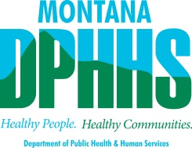
You are invited to a.......
Vocational Rehabilitation and Blind Services (VRBS)
Town Hall Meeting

To Discuss
Workforce innovation and Opportunity Act (WIOA)
Pre-Employment Training Services (PETS)
And other issues
When: Thursday October 29, 2015 from 1:30 to 3:30

Where: Billings
MSU-Billings, 1500 University Drive, College of Education Bldg., Room CE 160

There will be a call-in line available. Participants on the call-in line will have the opportunity to join in the discussion.
Call-in information is: Toll-free 1-877-668-4490 Access Code 801 691 027

Requests for accommodations should be made to:
Mike Hermanson: 406-444-3833 or mhermanson@mt.gov, by Oct. 15, 2015

Written comments can be sent to:
Mike Hermanson
Disability Employment and Transitions Division
P. O. Box 4210
Helena, MT 59604.
Or email: mhermanson@mt.gov.
You can also post comments at: http://www.dphhs.mt.gov/detd/index.shtml#publiccomment
Written and web comments deadline is November 25, 2015

