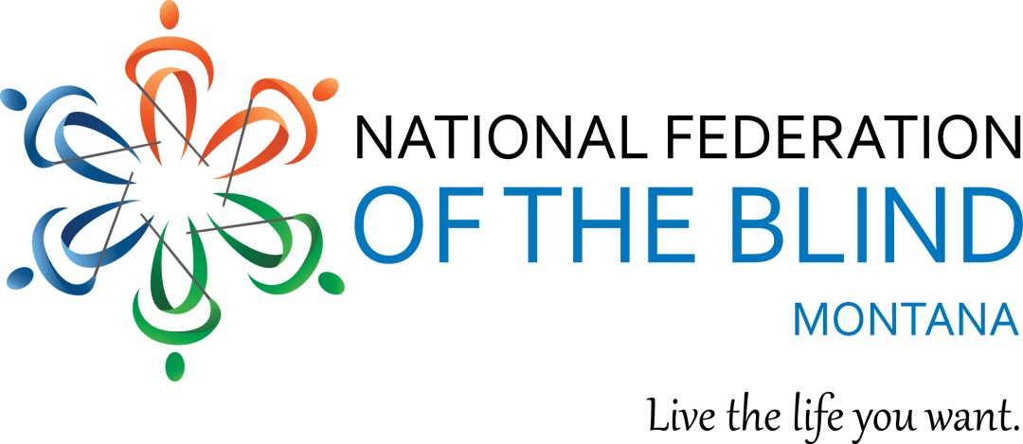
August 6, 2017

Dear Friend:

The National Federation of the Blind of Montana is hosting its fifth Annual State Convention on September 22-23, 2017, at the Bozeman Holiday Inn. We’re looking for items to use for door prizes and fund-raisers at the event. Can you help us?

As you may know, the National Federation of the Blind of Montana is a non-profit, private sector, 501 C(3) organization, which is a resource of knowledge, support, and encouragement for people who are blind and visually impaired in Montana. (Tax I.D. #46-1358514.) We are a state affiliate of the National Federation of the Blind, the oldest, largest, and most powerful consumer organization of blind people in the United States, which has grown to over fifty thousand members, and has affiliates in every state, as well as Washington, D.C. and Puerto Rico. We offer training and advocacy to blind people and parents of blind children, and work to remove legal, economic and societal barriers so that blind people can participate fully in employment, education, recreation, and all other aspects of community life. Our annual convention is one way we work toward achieving these goals.

Blind people from across Montana, parents of blind children, service providers, technology producers/distributors, inventors of products designed to enhance accessibility and independence for the blind, and representatives from rehabilitation service agencies, private agencies for the blind, and the Montana Talking Book Library attend our annual convention. We also award scholarships to deserving blind students in higher education.

Door prizes and surprises make this event even more exciting. Since we are financed by contributions from our members, friends and well-wishers, we hope you’ll be able to help us out with a gift CARD OR AN ITEM THAT we can use as a door prize or a fund-raiser.

Sincerely,

Joy Breslauer, President
National Federation of the Blind of Montana

