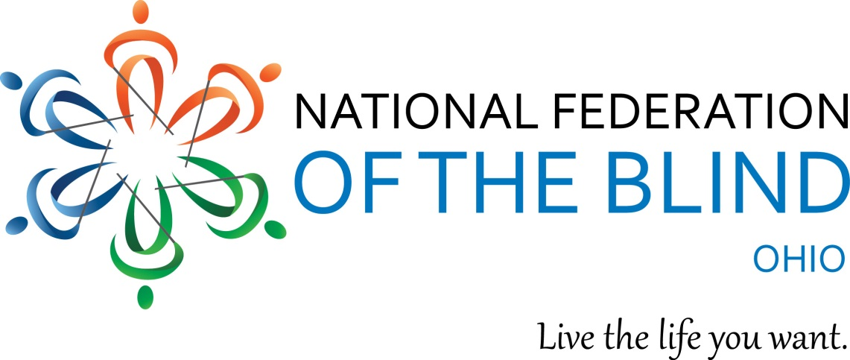

National Federation of the Blind of Ohio
2019 Scholarship Program

The National Federation of the Blind of Ohio is pleased to announce its 2019 scholarship program benefiting blind college students. This year we will offer scholarships to outstanding blind students who currently live in, or are attending college in, the state of Ohio during the 2019-2020 academic school year.

Scholarship winners will be required to attend the entire state convention of the National Federation of the Blind of Ohio and participate in all activities sponsored by the Ohio Association of Blind Students. In addition, scholarship winners will be required to meet with the Scholarship Committee during the state convention. The 2019 convention will take place November 1-3 at the DoubleTree by Hilton Columbus–Worthington, 75 Hutchinson Ave. Columbus, Ohio 43235.

Scholarship winners will be notified no later than August 1, 2019. All convention expenses will be provided for each scholarship winner, including transportation, hotel accommodations, and registration and banquet fees. For more information on the NFBO state convention, please visit http://www.nfbohio.org.

Applicants do not need to be members of the National Federation of the Blind of Ohio to apply for these scholarships. To be eligible for these scholarships, all applicants must:
- Be certified as being legally blind.
- Be a resident of the state of Ohio or be a full-time student at an Ohio college or university.
- Be pursuing a full-time postsecondary course of study during the 2019-2020 academic school year.
- Participate in the entire NFB of Ohio 2019 state convention and all scheduled scholarship activities.
- Submit all required application materials by June 1, 2019, no later than 11:59 p.m. EDT.

Application materials can be submitted electronically to Cassandra Jones at cassandra.jones02@gmail.com.

Please make sure all applications are complete. The National Federation of the Blind of Ohio's scholarship committee does not accept responsibility for incomplete applications. Each application will be reviewed by the committee, and candidates will be notified no later than August 1, 2019. All decisions made by the scholarship committee are final.

Questions can be directed to Cassandra Jones or Richard Payne, the NFBO state president, at the National Federation of the Blind of Ohio by email rchpay7@gmail.com or by phone, 937-396-5573.

National Federation of the Blind of Ohio Scholarship Application

Application must be submitted by June 1, 2019
Name: | Email:
Date of Birth: | Address:
Phone Number: | Cumulative GPA:
Major / Proposed Major: | Institution to be attended in Fall 2019:
Name of the state officer or chapter president who has interviewed you:
*Attachments required:
- Transcripts from all past post-secondary institutions attended through May 31, 2019 or high school transcripts if not yet attending college AND
- Three (3) letters of recommendation:
  - At least one of the first two letters needs to be from someone that can address your academic performance and achievements. The third letter should be from a leader of the National Federation of the Blind of Ohio. Please visit NFBohio.org or contact President Richard Payne at rchpay7@gmail.com to find an appropriate interviewer.

List all post-secondary institutions attended and cumulative grade point averages:
Institution | GPA

List all academic accomplishments and honors:
Honor / Accomplishment | Reason for Honor

List all community service activities you have participated in:
Organization | Community Service Activity

Please discuss how you learned about this scholarship program:

Personal Essay: Limit to 700 words maximum. Please address the following or similar questions:

In the following essay, please tell us about yourself. How have you dealt with your blindness? What are your educational and vocational goals? What makes you stand out from the crowd? What are your dreams and aspirations? What else would you like for us to know about you that is not covered in your application?

