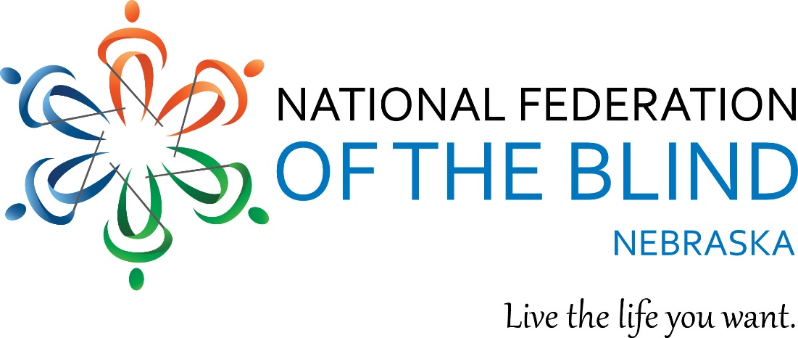
NFB of Nebraska 2018 State Convention
Live the Life You Want

Hello Nebraskans. Convention season is upon us, and the Nebraska state convention of the NFB is around the corner. Reserve your hotel room now and prepare for a weekend of Federation family and fun.
- When: Friday, October 5 to Sunday, October 7, 2018
- Where: Ramada Columbus River’s Edge Conference Center, 265 33rd Ave. Columbus, NE 68601

Call the hotel at (402) 564-1492 to reserve your room, and make sure to let them know you are with the NFB of Nebraska convention. The Ramada Columbus is offering the generous convention rate of $99.95/night, plus tax.
Our national rep is Patti Chang, and we will have sessions and presentations to help you live the best life possible, from One Touch to NFB technology to blind parents and much, much more. So, join us for NFBNs 2018 convention October 5 to 7 in Columbus, Nebraska as we continue to build the Federation.
Stay tuned for details on registration, and if you have questions or comments, email President Amy Buresh at president@ne.nfb.org.

