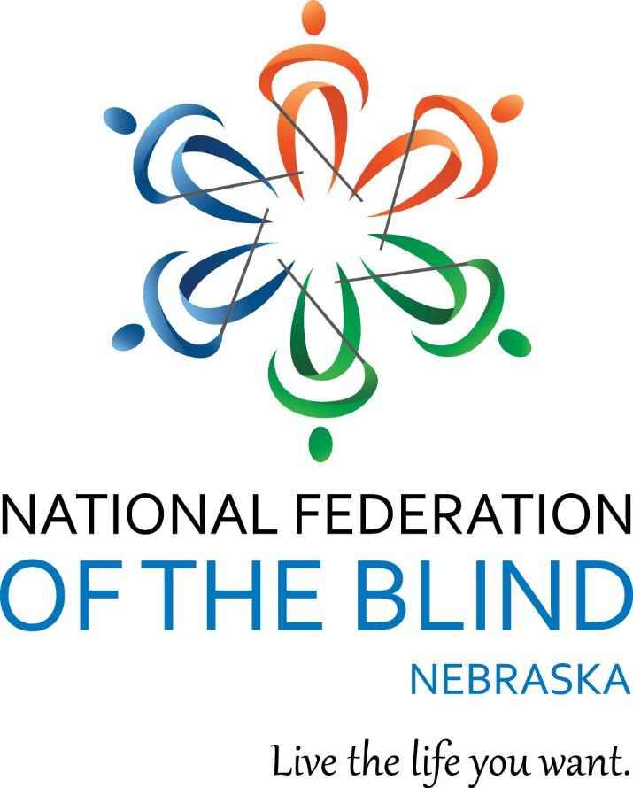

NATIONAL FEDERATION OF THE BLIND OF NEBRASKA

Live the Life You Want
55th Annual State Convention
Stronger Together
Our Rights. Our Responsibility. Our Resilience.
April 30 – May 3, 2026
Holiday Inn and Convention Center
110 2nd Avenue
Kearney, NE 68847

Welcome from the Officers and Board of Directors

Officers:
President, Jamie K. Richey, Lincoln, NE
First Vice President, Christine Boone, Lincoln, NE
Second Vice President, Bob Burns, Omaha, NE
Secretary, Linda Mentink, Columbus, NE
Treasurer, Cheryl Livingston, Lincoln, NE

Members of the Board of Directors:

Nancy Coffman, Lincoln, NE
Benjamin Grelk, Papillion, NE
Lucas Griess, Atkinson, NE
Leah Johnson, Omaha, NE
Geralyn K. Konruff, Chappell, NE
Karen Lemmon, Whitney, NE

Connect with the National Federation of the Blind of Nebraska!
Like on Facebook: @nebraskasblind
Follow on X: @nfbn
Subscribe on YouTube: @NFBNE
Visit Online: http://www.ne.nfb.org

BELIEF MESSAGE
The National Federation of the Blind advances the lives of its members and all blind people in the United States. We know that blindness is not the characteristic that defines you or your future. Every day we raise the expectations of blind people, because low expectations create obstacles between blind people and our dreams. Our collective power, determination, and diversity achieve the aspirations of all blind people.

CORE VALUES
• Believe in blind people
• Lead courageously
• Champion collective action
• Foster inclusion
• Dream big

PLEDGE
I pledge to participate actively in the efforts of the National Federation of the Blind to achieve equality, opportunity, and security for the blind; to support the policies and programs of the Federation; and to abide by its constitution.

We Wish to Extend Sincere Gratitude to this Year’s Convention Sponsors

Silver Level Sponsors

The Johnson Family

Richey’s Vending, LLC

Bronze Level Sponsors
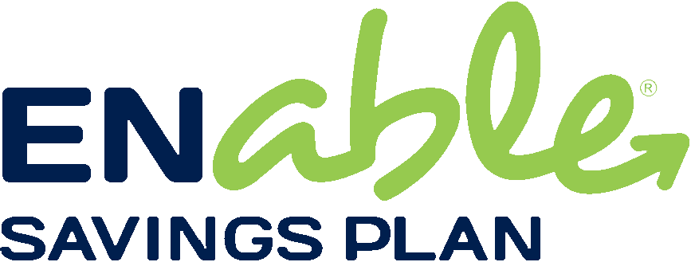

Enable Savings Plan
Enable is dedicated to helping individuals with disabilities reach their financial savings goals through checking accounts, savings accounts, and investment options. Since The Nebraska Treasurer’s Office implemented Nebraska’s ABLE Act plan a decade ago, Enable has grown to over five thousand accounts with more than $61 million in assets. For 2026, individuals, families, businesses, and organizations can contribute up to $20,000 per year to an Enable account. Contributions may also qualify for a Nebraska state tax deduction of up to $10,000 ($5,000 for married taxpayers filing separately). Enable plan options offer tax-free investment growth and tax-free withdrawals when used for qualified disability expenses such as housing, education, transportation, health care, and assistive technology. Enable accounts allow individuals — and their loved ones — to set aside funds for disability-related needs without jeopardizing eligibility for critical benefits.

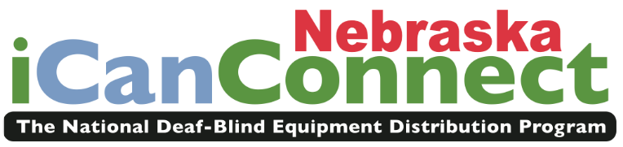
iCanConnect Nebraska
The National Deaf Blind Equipment Distribution Program
The iCanConnect Program administered through the Assistive Technology Partnership (ATP) helps individuals with combined vision and hearing loss stay connected through specialized communication equipment. For over 10 years, ATP has administered this national program in Nebraska, ensuring those with limited incomes can access phone, email, and internet services.


NanoPac, Inc.
Technology for Independence Since 1987
NanoPac has been serving the blind and low vision community in Nebraska for nearly 40 years. The company represents leading manufacturers of blindness technology and provides products that empower individuals to live independently. Every low vision, braille, and blindness technology product comes with lifetime support.

Next Steps Access, LLC
Based in Nebraska, Next Steps Access, LLC manufactures the DCane, a lightweight and flexible long white cane crafted for confident travel. Made by the blind and used by the blind, the DCane reflects quality craftsmanship and a commitment to independence.
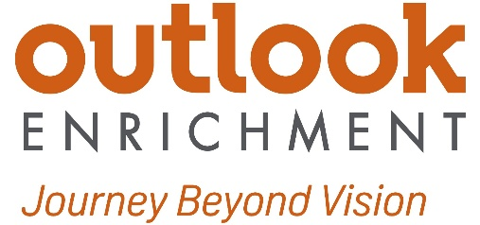

Outlook Enrichment
Journey Beyond Vision
For over 25 years, Outlook Enrichment has empowered individuals who are blind or who have low vision to live, work, and thrive with confidence. Through programs in adaptive technology, independent living, recreation and the arts, health and wellness, and work readiness, Outlook Enrichment supports independence and confidence. Join in building a more inclusive and accessible community!

The National Federation of the Blind of Nebraska Welcomes Our Honored Guests!

National Representative: Anil Lewis, Executive Director of Blindness Initiatives, National Federation of the Blind

Born in Atlanta, Georgia, Anil was diagnosed with retinitis pigmentosa at age nine but did not become totally blind until age twenty-five while completing his degree at Georgia State University. After losing his sight, he committed himself to mastering the alternative skills of blindness and used those skills to complete his Bachelor of Business Administration in Computer Information Systems in 1993. He later earned a Master of Public Administration with an emphasis in Policy Analysis and Program Evaluation. In 2002, he received the Kenneth Jernigan Memorial Scholarship, the highest scholarship awarded by the National Federation of the Blind and its most prestigious recognition of a blind scholar.
Anil first became involved with the National Federation of the Blind in 1995 after seeking guidance on Social Security work incentives and employment strategies. Attending his first national convention transformed his understanding of blindness and the power of collective action. He has often said that his success in helping blind people achieve meaningful employment came from incorporating Federation philosophy into his work.
Before joining the staff of the National Federation of the Blind Jernigan Institute in 2010, Anil worked as a Braille and assistive technology instructor, job placement specialist, disability consultant, and Client Assistance Program advocate. He managed employment initiatives during the 1996 Atlanta Olympic and Paralympic Games and developed programs focused on expanding competitive employment opportunities for people with disabilities.
Within the Federation, Anil served as president of the Atlanta Metropolitan Chapter and later as president of the National Federation of the Blind of Georgia. He was elected to the National Federation of the Blind Board of Directors in 2003 and served until 2010, when he joined the national staff. Over the years he has held key leadership roles, including Director of Advocacy and Policy and Director of Strategic Communications. He led the Federation’s efforts to repeal Section 14(c) of the Fair Labor Standards Act and coordinated communications for the Blind Driver Challenge™, demonstrating the Federation’s commitment to innovation, equality, and high expectations.
His leadership extends beyond the Federation. Anil has served on numerous state and national boards, including the Georgia Statewide Independent Living Council, the Maryland Statewide Rehabilitation Council, and the U.S. AbilityOne Commission, of which President Barack Obama appointed him. Across all of these roles, his focus has remained clear: policies that affect people with disabilities must be shaped by people with disabilities.
Today, as Executive Director of Blindness Initiatives for the National Federation of the Blind, Anil leads the creation, development, and replication of innovative programs across our nationwide network of affiliates, advancing education, employment, and independence for blind people throughout the country.
Anil often says that his proudest accomplishment is his son, Amari. Balancing the responsibilities of national leadership with the demands and joys of fatherhood has been one of his greatest challenges and greatest blessings. He believes his most important contribution has been encouraging blind people to believe in themselves and to understand that blindness does not define or limit their potential.
Anil previously joined us in Nebraska in 2006 and again in 2017. We are excited to welcome him back for his third Nebraska state convention.

Nikhil Dadlani, Secretary, National Association of Blind Students

Nikki is a recent graduate of the University of California, Berkeley, where he earned a degree in Political Science. Based in Millbrae, California, he is currently preparing for law school by studying for the LSAT and seeking opportunities to gain additional experience in the legal field.
Following the 2023 Washington Seminar, Nikki became deeply inspired by the National Association of Blind Students and its commitment to excellence, community, and continuous growth. He is passionate about helping ensure that blind students have access to the opportunities, resources, and support they need to succeed and looks forward to contributing to that work.
In his free time, Nikki enjoys keeping up with current events, reading Supreme Court cases, and exploring topics like the separation of powers. He also enjoys traveling and discovering new cities and neighborhoods.

Karen Anderson, Coordinator of Education Programs, National Federation of the Blind

Karen grew up in Omaha, Nebraska, and was introduced to the National Federation of the Blind of Nebraska through the Work and Gain Experience in the Summer (WAGES) program sponsored by the Nebraska Commission for the Blind and Visually Impaired. That early experience helped shape her belief in the power of high expectations and the importance of community.
She was recognized for her academic achievement and leadership as a recipient of the National Federation of the Blind of Nebraska state scholarship in 2006 and went on to receive a national Federation scholarship in 2007. These experiences further strengthened her commitment to the organized blind movement.
In 2015, Karen relocated to Baltimore, Maryland, to join the staff of the National Federation of the Blind. Through her leadership in national education initiatives, Karen works to expand access to braille literacy and ensure that blind students have the tools and skills needed to succeed academically and in life.
She remains actively involved in the Maryland affiliate and continues to contribute to the Federation’s mission at both the national and local levels.
In her free time, Karen enjoys knitting, reading, and spending time with her toy poodle, Rami.

Aaron Golub, Entrepreneur, Consultant, and International Speaker

Known for inspiring audiences to rethink limitations and create meaningful change, Aaron delivers high-impact presentations that challenge assumptions and drive personal and organizational growth. Through keynote presentations, workshops, and consulting, he works with organizations and teams to strengthen leadership, build resilience, and create lasting results. He has delivered presentations for Fortune 500 companies, professional sports organizations, and leading universities across the country.
Aaron made history as the first blind Division I athlete to play in a game, serving as a team captain at Tulane University before pursuing opportunities in the NFL as a free agent. His groundbreaking achievements on the football field brought national attention to his story, including features on major media outlets such as Good Morning America.
Since the age of seventeen, Aaron has traveled extensively, sharing his experiences and helping others reframe adversity as opportunity. His work focuses on building grit, determination, and intentional effort, empowering individuals to act, overcome challenges, and reach their full potential.
Rather than simply delivering a keynote, Aaron partners with organizations to create lasting impact, ensuring that ideas translate into meaningful growth and long-term success.
He often reminds audiences, “It’s less about the challenges you face and more about how prepared you are to conquer them.”

CONVENTION DETAILS

Registration
All convention attendees must register. Registration provides access to the convention room rate and eligibility for door prizes. If you are pre-registered, please visit the registration area to pick up your packet. If you have not yet registered, you may do so onsite for a $30.00 fee. Please note: Meal tickets will NOT be available for purchase onsite. Registration times will be strictly followed to ensure our members can fully participate in convention activities. Refer to the agenda for registration times and locations.

Information Table
Located Between Ballroom I and Ballroom II, the Information Table is your go-to spot for assistance. Federationists will be available to answer questions and provide guidance throughout the convention. This table will also serve as the lost and found, so be sure to check here for any misplaced items.

Assistive Listening Devices
An FM transmitter system is available for those who need assistance. Visit the information table for details.

Guide Dog Relief Areas
The dog relief areas are located in three grassy areas outside the hotel. Trash receptacles are available near each entrance.
Front Entrance: A grassy area is located straight out from the front entrance beyond the parking lot.
Entrance G, Near Loper Hall: When exiting, the sidewalk will immediately turn to the right. Turn right and the grassy area will be on your left.
South Side of the Hotel: Use Entrance B, located in the middle of the south wing of the hotel, or Entrance C on the southwest corner of the hotel. From either entrance, cross the parking lot to the curb. The grassy area will be just beyond the sidewalk.
Please be courteous and pick up any waste and dispose of it in the trash receptacles provided.

Door Prizes
A variety of door prizes will be drawn during each general session and at the banquet. Attendees must be registered for the convention to be eligible for a door prize and must be present to win. Drop off all door prize donations, clearly labeled in print and braille, in the registration area during the assigned registration times.

AGENDA

Thursday, April 30, 2026

6:00 - 8:00 p.m. Registration and Packet Pick-Up
Pre-Function Foyer
Cheryl Livingston, Coordinator, Registration Arrangements
7:00 - 10:00 p.m. Welcome Reception
Loper Hall North
Light Hors D’oeuvres and a cash bar will be available.

Friday, May 1, 2026

7:30 - 9:00 a.m. Registration and Packet Pick-Up
Pre-Function Foyer
Cheryl Livingston, Coordinator, Registration Arrangements
7:30 - 8:30 a.m. Greater At-Large Chapter Meeting
Stateroom D
This is the annual face-to-face meeting of the chapter. Chapter members are encouraged to attend, and guests are welcome!
Kimberly Scherbarth, President, National Federation of the Blind of Nebraska Greater At-Large Chapter

General Session I
Ballroom I

9:00 a.m. Call to Order
Jamie K. Richey, President, National Federation of the Blind of Nebraska, Lincoln, NE
9:05 a.m. Invocation
Nancy Coffman, Board Member, National Federation of the Blind of Nebraska, Lincoln, NE
9:10 a.m. Convention Logistics
Kimberly Scherbarth, President, Greater At-Large Chapter, Kearney, NE
9:20 a.m. Welcome to the Heart of Nebraska
Jonathan Nikkila, Mayor, City of Kearney, Kearney, NE

9:40 a.m. National Report
Anil Lewis, National Representative, National Federation of the Blind, Atlanta, GA
10:25 a.m. Fit Break
10:35 a.m. The Right to Read: Tailoring TBBS to Your Lifestyle
Gabe Kramer, Executive Director, Nebraska Library Commission Talking Book and Braille Service, Lincoln, NE
10:50 a.m. A Responsibility to Connect: Christian Record’s Global Mission
Dextor Thomas, President, Christian Record Services, Lincoln, NE
11:05 a.m. The Resilience of the Human Voice: News in a Digital World
Bekah Jerde, Executive Director, Radio Talking Book Service, Omaha, NE
11:20 a.m. Final Announcements

11:30 a.m. Adjourn
12:00 - 1:00 p.m. Luncheon and Keynote Address: Investing in Independence: Nebraska Enable Savings Plan
Loper Hall North
Shauna Paolini, Director, Nebraska Enable Savings Plan, Nebraska State Treasurer’s Office, Lincoln, NE

1:00 - 6:00 p.m. Exhibits
Ballroom II
Refer to the exhibitor section at the end of the agenda for a list of exhibitors and descriptions.
Note: Visit each exhibitor and have your card marked at each table for a chance to win cash prizes! Once completed, drop your card off at the Information Table. A drawing will take place on Sunday morning. You must be present to win.
1:00 - 2:00 p.m. Registration and Packet Pick-Up
Pre-Function Foyer
Cheryl Livingston, Coordinator, Registration Arrangements
1:15 - 3:00 p.m. Tapping Into It: Making the Most of Smart Devices
Stateroom D
Discover how everyday technology can support greater independence at home and on the go. This session will highlight useful apps and affordable tools, along with practical ways to get more out of the devices you already use. Participants will also learn about the WayAround® app and how to use WayTags included on convention name badges to access agenda information and more.
Peg Halverson, Facilitator
1:15 - 3:00 p.m. Harnessing Our Future: Building a Guide Dog Division
Stateroom E
Whether you currently travel with a guide dog, are considering one for the future, or simply want to support your fellow Federationists, this session is for you. Join us as we take the exciting step of forming our own division. We will discuss the rights of handlers, the responsibility of high-quality training, and the resilience required to navigate the world as a team. Come share your voice and help us build a community that is truly stronger together.
Maura Loberg, Facilitator
1:15 - 3:00 p.m. How to Get Benefits from Social Security, Go to Work, and Live to Tell About It
Stateroom F
Here is your opportunity to get answers to your questions about Social Security Disability Insurance (SSDI) and Supplemental Security Income (SSI). Sponsored by the Nebraska Commission for the Blind and Visually Impaired, this session will cover what each program is, who is eligible, financial limits, benefit amounts, and the medical benefits associated with SSDI and SSI. Learn how to apply, how work affects benefits, and how to use safety nets known as work incentives to help protect your benefits while working. Special attention will be given to rules and advantages specific to blind individuals. Time will also be provided for audience questions beyond the presentation content. A limited number of individual consultations are available by emailing convention@ne.nfb.org. Consultations will be held from 3:15 to 6:00 p.m.
Michael Dalto, Owner, High Note Consulting, LLC
3:15 - 5:00 p.m. Be Tactile
Stateroom D
Join our exclusive Be Tactile Breakout Session to explore the full Be Tactile Program and experience the Tactile Treasures Quarterly Kit firsthand. Create one of our elegant, textured cards during the session, using luxury materials and guided techniques. Plus, enjoy the exclusive opportunity to pre-order and take home the complete kit, which is available in limited quantities. Don’t miss this chance to craft, discover, and elevate your gifting with effortless sophistication!
Jeni Charlston, CEO, Kreative Keepsake
3:15 - 5:00 p.m. Stronger Together: Building Resilient Families
Stateroom E
Designed for blind parents and parents of blind children, this seminar blends hands-on problem solving with encouragement and resource sharing. Discover creative approaches to everyday parenting, normalize common challenges, and leave with actionable ideas, renewed confidence, and meaningful support.
Lesa Griess, Facilitator, National Federation of the Blind of Nebraska Parents Group
3:15 - 6:00 p.m. Individual Benefits Consultations
Stateroom F
Meet one-on-one with Michael Dalto to discuss Social Security Disability Insurance (SSDI) and Supplemental Security Income (SSI). Get personalized guidance on benefits, work, and available supports. A limited number of consultations are available. To schedule, email convention@ne.nfb.org in advance.
Michael Dalto, Owner, High Note Consulting, LLC

6:00 p.m. Dinner and Keynote: Our History, Our Strength: The Story of Blind Nebraskans
Loper Hall North
Peggy Chong, The Blind History Lady, Aurora, CO

7:00 p.m. National Federation of the Blind of Nebraska Board of Directors Meeting
Loper Hall North
Join the quarterly board meeting of the affiliate to learn about the latest updates, discuss key topics, and hear from board members on important initiatives. Everyone is welcome to attend.
7:30 p.m. Resolutions Committee
Loper Hall North
All attendees are encouraged to attend, as this is where you will learn about the resolutions for this year. Resolutions which are passed by the committee will then be voted on by the membership during general sessions of the convention. Resolutions are the birthplace of what becomes the policy and action of our affiliate.
Amy Buresh, Chair, Resolutions Committee
8:00 - 10:00 p.m. Trivia
Loper Hall North
Gather your team or join one on the spot for a fun and fast-paced trivia challenge! From NFB history to general knowledge and surprise questions, this exciting event will keep you on your toes. Come ready to compete, learn, and share some laughs—who will take home the trivia chocolate?
$5 per person per round; a cash bar will be available.
Jeff and Deb Altman, Facilitators

Saturday, May 2, 2026

7:00 - 7:30 a.m. Nominating Committee
Stateroom F
This is the only closed meeting within the National Federation of the Blind of Nebraska and consists of a delegate from each chapter and division.
Bob Burns, Chair, Nominating Committee
8:00 - 9:00 a.m. Registration and Packet Pick-Up
Pre-Function Foyer
Cheryl Livingston, Coordinator, Registration Arrangements
8:00 - 11:30 a.m. Exhibits
Ballroom II
Refer to the exhibitor section at the end of the agenda for a list of exhibitors and descriptions.
Note: Visit each exhibitor and have your card marked at each table for a chance to win cash prizes! Once completed, drop your card off at the Information Table. A drawing will take place on Sunday morning. You must be present to win.
8:00 - 9:45 a.m. Be Tactile
Stateroom D
Join our exclusive Be Tactile Breakout Session to explore the full Be Tactile Program and experience the Tactile Treasures Quarterly Kit firsthand. Create one of our elegant, textured cards during the session, using luxury materials and guided techniques. Plus, enjoy the exclusive opportunity to pre-order and take home the complete kit, which is available in limited quantities. Don’t miss this chance to craft, discover, and elevate your gifting with effortless sophistication!
Jeni Charlston, CEO, Kreative Keepsake
8:00 - 9:45 a.m. Crafting Your Own Professional Future: Blind Entrepreneurs Securing Success Through Self Employment
Stateroom E
Self-employment can open the door to independence, creativity, and new opportunities. In this session, hear from blind entrepreneurs who have successfully built their own businesses. Learn what qualifies as a small business, how to get started, and what steps are needed to turn an idea into a sustainable venture. Presenters will also share practical advice, lessons learned, and resources available to help blind individuals start and grow their own businesses. Whether you are exploring an idea or already thinking about launching a business, this session will provide valuable insight into the possibilities of self-employment.
Christine Boone, Facilitator

10:00 - 11:30 a.m. Senior Division Annual Business Meeting
Stateroom E
Join us for the Senior Division’s Annual Business Meeting, where we’ll discuss important updates, upcoming initiatives, and opportunities for involvement. This is your chance to connect with fellow seniors in the blind and low vision community. Be part of the conversation as we work together to strengthen our division and continue advocating for the needs of blind seniors.
Rev. Dr. Karen R. Moritz, President, National Federation of the Blind of Nebraska Senior Division

10:00 - 11:30 a.m. Nebraska Association of Blind Students Annual Business Meeting
Stateroom F
Whether you're a high school student preparing for college, an adult learner exploring a new path, a seasoned college attendee, or an educator working with blind and low vision students, this meeting is for you! Learn about the division and discover how you can get involved!
Lucas Griess, President, Nebraska Association of Blind Students
11:45 a.m. - 1:00 p.m. Luncheon and Keynote Address: Achieving Goals Through Adversity
Loper Hall North
Aaron Golub, Entrepreneur and Speaker, Los Angeles, CA
General Session II
Ballroom I

1:30 p.m. Call to Order
Jamie K. Richey, President, National Federation of the Blind of Nebraska, Lincoln, NE
1:35 p.m. Invocation
Nancy Oltman, Board Member, National Federation of the Blind of Nebraska Greater At-Large Chapter, Hastings, NE
1:40 p.m. Presidential Report
Jamie K. Richey, President, National Federation of the Blind of Nebraska, Lincoln, NE

2:00 p.m. Report from the National Association of Blind Students
Nikhil Dadlani, Secretary, National Association of Blind Students, Millbrae, CA
2:20 p.m. Presenting with Purpose: Our Experience, Our Perspective
Lucas Griess, President, Nebraska Association of Blind Students, Atkinson, NE; Benjamin Grelk, Vice President, Nebraska Association of Blind Students, Papillion, NE
2:40 p.m. Stronger Partnerships, Greater Possibilities: An Update from NCBVI
Carlos Servan, Executive Director, Nebraska Commission for the Blind and Visually Impaired, Lincoln, NE
3:10 p.m. Fit Break
3:20 p.m. Tools for Resilience: Technology that Expands Opportunity
Kevin Hughes, West Region Manager, HumanWare; Rachel Ramos, Blindness Technology Specialist, HumanWare
3:50 p.m. Real Access, Real Impact: SSPs in the DeafBlind Community
Leah Johnson, Board Member, National Federation of the Blind of Nebraska, Omaha, NE
4:10 p.m. Investing in the Federation: Our Shared Responsibility
Bob Burns, Second Vice President, National Federation of the Blind of Nebraska, Omaha, NE

4:30 p.m. Nebraska Roots, National Resilience: A Journey of Growth and Opportunity
Karen Anderson, Board Member, National Federation of the Blind of Maryland Greater Baltimore Chapter, Baltimore, MD
4:55 p.m. Reports and Resolutions
5:00 p.m. Adjourn
6:00 p.m. Portrait Studio
Loper Hall Foyer
Dress your best and say cheese! We will be taking current photos for archival purposes. Don’t miss the chance to have your picture taken before the banquet!
Sandy Wright, Photographer
6:00 p.m. Cocktail Reception
Loper Hall North
Kick off the evening with great company and a refreshing cocktail! Get a sneak peek at the exciting auction items, purchase a duck for the Lucky Ducky game, and enjoy a relaxed atmosphere with friends before the banquet begins.
7:00 p.m. Annual National Federation of the Blind of Nebraska Banquet
Loper Hall North
Shane Buresh, Master of Ceremonies, Lincoln, NE

Invocation: Linda Mentink, Secretary, National Federation of the Blind of Nebraska, Columbus, NE

Keynote Address: Anil Lewis, National Representative, National Federation of the Blind, Atlanta, GA
Awards Presentation: Cheryl Livingston, Chair, Awards and Assistance Committee, Lincoln, NE
Scholarship Presentation: Bob Burns, Chair, Scholarship Committee, Omaha, NE
Get on the PAC Plan!
9:00 - 11:00 p.m. Annual Auction
Loper Hall North
Join us for an exciting evening of bidding, laughter, and friendly competition as we auction off a variety of unique, hand-crafted, and valuable items. Proceeds support the ongoing work of the National Federation of the Blind of Nebraska. A cash bar will be available.

Pre-Authorized Contribution (PAC) Program Form
This program allows you to contribute to the National Federation of the Blind through recurring monthly donations. These donations can be made via direct withdrawals from your checking account or charges to your credit card. To start a new monthly donation or update your existing PAC plan, please scan the QR Code below.
For questions, please contact: PAC@nfb.org

Thank you for your generosity and support!

PAC QR
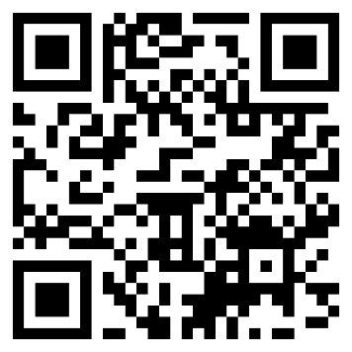

Sunday, May 3, 2026

7:30 - 8:30 a.m. Non-Denominational Devotions
Stateroom D
Start your day with reflection and inspiration at our Non-Denominational Devotions. This welcoming session offers a time for prayer, encouragement, and shared wisdom, open to all who wish to attend.
Linda Mentink and Kimberly Scherbarth, Facilitators
General Session III
Ballroom I

9:00 a.m. Call to Order
Jamie K. Richey, President, National Federation of the Blind of Nebraska, Lincoln, NE
9:05 a.m. Invocation
Rev. Dr. Karen R. Moritz, President, National Federation of the Blind of Nebraska Senior Division, Omaha, NE
9:10 a.m. Stronger Together: Building the Next Generation of Braille Readers
Lesa Griess, Coordinator, National Federation of the Blind Braille Enrichment for Literacy and Learning® Academy in Nebraska, Atkinson, NE; Karen Anderson, Coordinator of Education Programs, National Federation of the Blind, Baltimore, MD
9:40 a.m. Minutes of the 2025 National Federation of the Blind of Nebraska Business Meeting
Linda Mentink, Secretary, National Federation of the Blind of Nebraska, Columbus, NE
9:50 a.m. 2025 Annual Treasurer's Report
Cheryl Livingston, Treasurer, National Federation of the Blind of Nebraska, Lincoln, NE
10:00 a.m. Roll Call of Chapters, Divisions, and Groups
A. Greater At-Large Chapter
B. Lincoln Chapter
C. Omaha Chapter
D. Nebraska Association of Blind Students
E. Senior Division
F. Guide Dog Group
G. Parents Group
10:35 a.m. Fit Break
10:45 a.m. Constitution Committee Report
Linda Mentink, Chair, Constitution Committee, Columbus, NE
11:00 a.m. Resolutions Committee Report
Amy Buresh, Chair, Resolutions Committee, Lincoln, NE
11:10 a.m. PAC Program Report
Barbara Loos, Chair, Pre-Authorized Contribution Program Committee, Lincoln, NE
11:15 a.m. Scholarship Awards
Bob Burns, Chair, Scholarship Committee, Omaha, NE
11:25 a.m. Nominating Committee Report
Bob Burns, Chair, Nominating Committee, Omaha, NE
11:30 a.m. Election of Officers
11:50 a.m. Final Remarks
Anil Lewis, National Representative, National Federation of the Blind, Atlanta, GA
12:00 p.m. Adjourn

2026 Convention Exhibitors
The following exhibitors and organizations will be available throughout the convention. Be sure to stop by, connect, and explore the many resources and opportunities they offer.
An index card with your name in print and braille can be found in your registration packet. Have each exhibitor you visit mark your card. If you visit all exhibitors, return the card to the information table to be placed in a cash drawing on Sunday. You must be present to win. Please note: Affiliate chapters and divisions will be selling throughout the weekend and are not part of the drawing.

Bus Across Nebraska – Black Hills Regional Ski for Light (BHSFL)
Bus Across Nebraska coordinates transportation for individuals attending the annual Black Hills Regional Ski for Light event in Deadwood, South Dakota. This effort makes it possible for individuals who are blind or who have low vision to take part in a week-long program focused on recreation, community, and personal growth.
Contact: Ward Kinney, Coordinator
(402) 630-3640
whkinney@gmail.com
www.busacrossneb.org

Christian Record Services, Inc.
Free programs and resources are available for individuals who are blind or who have low vision. Offerings include a library of books and materials in braille, large print, and audio formats, as well as Bibles and Bible lessons. Live call-in programs are hosted each week through PhoneFaith, and scholarships are available for camp adventures and undergraduate students.
Contact: Dextor Thomas, President
(402) 488-0981
info@christianrecord.org
www.christianrecord.org

Enable Savings Plan – Bronze Level Sponsor
Enable is dedicated to helping individuals with disabilities reach their financial goals through savings and investment options. The Enable Savings Plan is a qualified ABLE program sponsored by the State of Nebraska, allowing individuals to save for disability-related expenses while maintaining eligibility for important benefits like SSI and Medicaid. Accounts offer tax-free growth and tax-free withdrawals when used for qualified expenses such as housing, education, transportation, health care, and assistive technology.
Contact: Shauna Paolini, Director
(844) ENABLE4
Shauna.paolini@nebraska.gov
www.enablesavings.com

iCanConnect Nebraska – Bronze Level Sponsor
The iCanConnect Program administered through the Assistive Technology Partnership (ATP) helps individuals with combined vision and hearing loss stay connected through specialized communication equipment. For over 10 years, ATP has administered this national program in Nebraska, ensuring those with limited incomes can access phone, email, and internet services.
Contact: Brooke Harrie, Coordinator
(402) 679-4271
Brooke.harrie@nebraska.gov
www.icanconnect.org

Kelly’s Art
Kelly Coleman, a blind artist, creates both tactile and standard landscape paintings, offering visually engaging and textured artwork for all audiences.
Contact: Kelly Coleman, Blind Artist
(402) 432-1877
colemankelly268@gmail.com

NanoPac, Inc. – Bronze Level Sponsor
NanoPac has been serving the blind and low vision community in Nebraska for nearly 40 years. The company represents leading manufacturers of blindness technology and provides products that empower individuals to live independently. Every low vision, braille, and blindness technology product comes with lifetime support.
Contact: Patrick J. Fischer, Regional Representative
(402) 699-4357
patrick@nanopac.com
www.nanopac.com

Nebraska Center for the Education of Children Who Are Blind or Visually Impaired (NCECBVI)
NCECBVI serves children from infancy through age 21. The program offers the expertise and specialized skills of the center’s staff to serve students who are blind or who have low vision in residential, day, and outreach settings. Services are provided to local school districts, students, families, teachers, and other support staff.
Contact: Audrey Graves, Director of Programs
(402) 873-5513
agraves@esu4.net
www.ncecbvi.org

Nebraska Commission for the Deaf and Hard of Hearing (NCDHH)
NCDHH is an agency that is committed to access for all. It serves people living in Nebraska with hearing loss through a variety of programs. NCDHH also provides education, youth and family services, training, and advocacy.
Contact: Aaron Rothenberger, Outreach Liaison
(800) 545-6244
ncdhh@nebraska.gov
www.ncdhh.nebraska.gov

Nebraska Library Commission – Talking Book and Braille Service (TBBS)
TBBS provides free access to audiobooks, audio magazines, and braille materials for individuals who are blind or who have low vision, or who have physical or print disabilities that limit the use of regular print. As part of the National Library Service (NLS) network, TBBS offers materials by mail and digital downloads through BARD online and BARD Mobile.
Contact: Miranda Shreves, Marketing and Outreach Coordinator
(402) 471-4038
miranda.shreves@nebraska.gov
www.nlc.nebraska.gov/tbbs

Nebraska Secretary of State – Elections Division
The Elections Division ensures the integrity of elections in Nebraska by overseeing election laws, managing election procedures, maintaining election tabulation equipment and ballot-marking devices, and administering the state voter registration system. Stop by to try out the ExpressVote machine and get answers to your general voting questions.
Contact: Beckie Cromer, Elections Coordinator
(402) 471-6148
sos.elect@nebraska.gov
www.sos.nebraska.gov

Next Steps Access, LLC – Bronze Level Sponsor
Based in Nebraska, Next Steps Access, LLC manufactures the DCane, a lightweight and flexible long white cane crafted for confident travel. Made by the blind and used by the blind, the DCane reflects quality craftsmanship and a commitment to independence.
Contact: Jamie K. Richey, Owner
(308) 520-9024
NextStepsAccess@gmail.com

Outlook Enrichment – Bronze Level Sponsor
For over 25 years, Outlook Enrichment has empowered individuals who are blind or who have low vision to live, work, and thrive with confidence. Through programs in adaptive technology, independent living, recreation and the arts, health and wellness, and work readiness, Outlook Enrichment supports independence and confidence. Join in building a more inclusive and accessible community!
Contact: Nina Rongisch, Director of Fund Development
(531) 365-5342
nrongisch@outlooken.org
www.outlooken.org

Radio Talking Book Service (RTBS)
RTBS connects individuals who are blind or who have low vision, or who are print disabled, with access to news, information, arts, and culture through the human voice and technology with three programs: Radio Talking Book Network (RTBN), Nebraska’s only radio reading service; Listening Link, an educational reading service; and Audio Description.
Contact: Bekah Jerde, Executive Director
(402) 572-3003
info@rtbs.org
www.rtbs.org

Vanda Pharmaceuticals, Inc.
Non-24-Hour Sleep-Wake Disorder (Non-24) is a chronic condition that disrupts the body's natural sleep cycle. It affects up to 70% of people who are blind, many of whom may not even be aware they have it. Symptoms include difficulty falling asleep, staying asleep, excessive daytime sleepiness, and waking up feeling groggy or unrested.
Contact: Vicki Preddy, Nurse Educator
(202) 578-9060
Vicki.preddy@vandapharma.com
www.vandapharma.com
Nebraska Association of Blind Students
A variety of snacks and drinks are available for purchase, helping to keep attendees energized throughout the day.
Contact: Lucas Griess, President
(402) 925-8538
students@ne.nfb.org
www.ne.nfb.org/students
National Federation of the Blind of Nebraska Greater At-Large Chapter
Purchase a stylish Braille bracelet, available in a variety of colors and sayings, for just $5. Or try your luck with our 50/50 raffle. Tickets are $5 or 6 for $20. The winner will be drawn during the banquet, and you do not need to be present to win.
Contact: Kimberly Scherbarth, President
(308) 224-1134
greater-at-large@ne.nfb.org
www.ne.nfb.org/greater-at-large

National Federation of the Blind of Nebraska Lincoln Chapter
Score some delicious Baker’s Chocolates for just $6 a bag! Thirteen different flavors are available: Scooters, milk mocha, milk chocolate, milk mint, milk raspberry, milk peanut butter, milk coconut, milk caramel, dark chocolate, dark mint, dark cherry, dark orange, and dark sea salt caramel.
Contact: Nancy Coffman, President
(402) 450-7469
lincoln@ne.nfb.org
www.ne.nfb.org/lincoln

National Federation of the Blind of Nebraska Omaha Chapter
Need some cold hard cash? Get your chance to win $250 in our cash raffle! Tickets are $5 or 5 for $20. The winner will be drawn during the banquet—no need to be present to win!
Contact: Bob Burns, President
(402) 210-5750
omaha@ne.nfb.org
www.ne.nfb.org/omaha

National Federation of the Blind of Nebraska Senior Division
Take part in an exciting raffle featuring two Omaha Steaks packages, each valued at $175. These premium packages make a perfect gift or a great addition to your own table. Raffle tickets are available for $5 or 5 for $20. Don’t miss your chance to support the division and win a delicious prize.
Contact: Karen Moritz, President
(402) 570-7827
seniors@ne.nfb.org
www.ne.nfb.org/seniors

