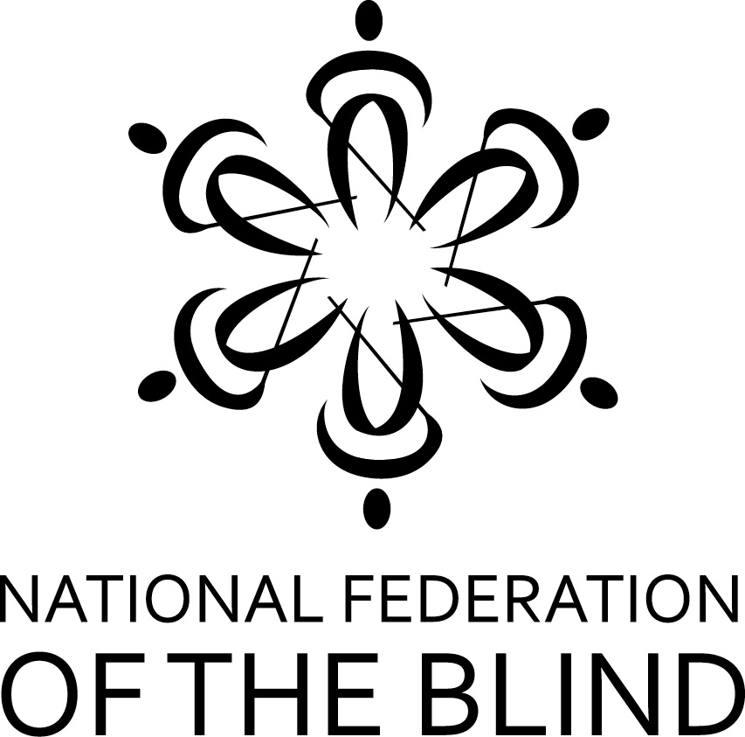

THE NEW Great Lakes BRAL Contest IS HERE!

The National Federations of the Blind of Minnesota, Wisconsin, Illinois, Michigan, and Ohio have joined together to offer the first annual Great Lakes regional Braille Readers Are Leaders contest for kids, grades K-12. Contestants compete to read the most Braille pages, going against other kids in similar grades across all five states. The contest runs for 7 weeks, encouraging kids to be proud of their Braille reading ability and to work to improve their skills -- while possibly winning prizes in the process.

A thumbnail sketch of the contest:
• A certifying official (parent, teacher, etc.) should fill out and submit a registration form. This can be done as early as November 1, 2016, and as late as January 20, 2017.
• Kids enter in one of five grade categories: K-1, 2-3, 4-5, 6-8, & 9-12.
• Record Braille pages read between December 1, 2016, and January 20, 2017, on a reading log.
• The certifying official should submit the reading log form by February 1, 2017.
• Prizes in each grade category are: first, $25; second, $15; third, $10.
• Every contestant, whether a winner or not, will receive a goodie bag at the end of the contest.
• To get the complete contest rules, registration form, and the reading log form, visit the website, http://www.nfbofillinois.org, then go to link “Great Lakes BRAL Contest.”
• Both the registration form and the reading log form should be submitted by email as attachments to dkent5817@att.net. Please put BRAL in the subject line.

If you have questions, contact the contest administrator:
Deborah Stein
Email: dkent5817@att.com. Please put BRAL in the subject line.
phone number: 773-203-1394

