National Federation of the Blind of Idaho
Dana Ard, President
1320 E. Washington
Boise, ID 83712
Ph.: (208) 345-3906
danalynard@q.com
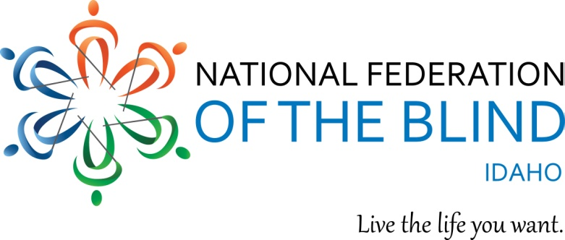
You are invited to the National Federation of the Blind of Idaho State Convention
March 23-25 at the Wyndham Garden Hotel 3300 S. Vista Avenue, Boise ID 83705.
Convention Hotel rates are $83.00 per night for singles, doubles triples and quads. A $30.00 charge will be added to credit and debit cards at the time of check in to cover incidentals. This charge will be removed at check out if there are no incidentals.

The Convention theme is “Transforming our Dreams into Reality.”

Convention registration is $15.00 and will allow you to participate in the Thursday night reception to honor our 2017 scholarship winners, general sessions, the Friday blindness product and services expo, senior seminar, student seminar, classes introducing the iPhone, parents of blind children seminar, and activities for blind children, an open mic event and much more. See attached registration for costs for the Friday board dinner, and Saturday evening banquet featuring our NFB National President, Mark Riccobono, as our keynote speaker.

We guarantee that you will have fun:
- Meeting and talking with other people who are blind and visually impaired who share your interests.
- Learning tips and tricks from other seniors at the free senior seminar.
- Learning about new products for people who are blind or visually impaired at the free product and service expo.
- Meeting NFB student leaders and other blind and visually impaired high school and college students.
- Discussing student problems with other blind students and find solutions.
- Attending free classes on such topics as using the iPhone and enjoying social media.
- Getting the latest medical information and treatment for non24 sleep disorder, which often affects blind people who do not see light.
- Have fun at our Friday night open mic talent show.
- Learning from educational and inspirational speakers such as our NFB National President, Mark Riccobono, employed persons who are blind, blind students attending NFB training centers, presentations by our BELL Academy students, presenters on public transportation, and so much more.

The convention will begin at 8:30 Friday morning. The blindness product and services expo will begin Friday at noon, and the senior and student seminars will take place Friday afternoon from 2:00—4:00 and 3:30—5:00 respectively. The Saturday session will begin at 8:45, and the banquet will begin at 6:30 P.M.

Please complete and send the attached registration form including your meal selections and required funds. Meals need to be ordered a week in advance of the event. Enjoy this dynamic event, meet others who are blind and visually impaired, and learn to transform your dreams into reality. If you have further questions, please contact Dana Ard, President, National Federation of the Blind of Idaho 208-345-3906, or danalynard@q.com.

