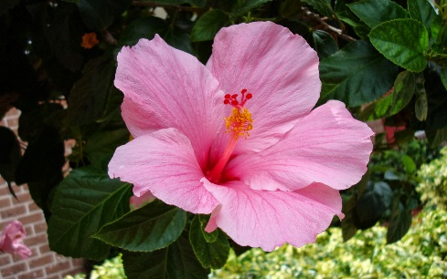ALOHA!

THE 2017 HOST COMMITTEE INVITES YOU TO OUR NFB LUAU PARTY
Admission: $10
Location: Panzecola F-3 and F-4 level 1
Cash bar
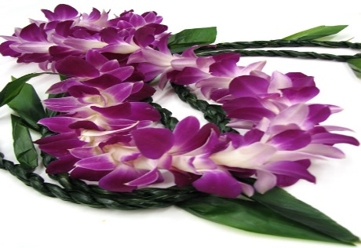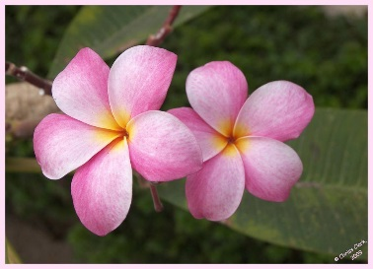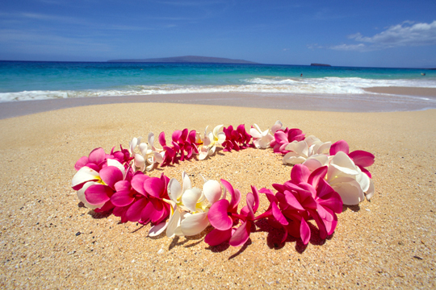
Join us on Thursday, July 13 from 8-midnight to enjoy some delicious island hors d’oeuvres and desserts, dance to Hawaiian music, sip on tasteful drinks, and immerse yourself in the beloved culture of Hawaii!
- Say hello to our King and Queen of the Luau, President Riccobono and First Lady Riccobono!
- Dress in your Hawaii fashion
You won’t want to miss a night to remember with your Federation family!
Kathryn Webster | President, National Student Division
Nani Fife | President, NFB of Hawaii

