National Federation of the Blind of Utah
Annual Convention

April 19-21, 2018
Salt Lake City, Utah

If not us, then who?
If not now, then when?
The time is now!
- John E. Lewis

Salt Lake City Sheraton
50 West 500 South, Salt Lake City, UT 84101
Register at: www.nfbutah.org

If you are using social media during our convention:
#NFBU18
Mission Statement
In the National Federation of the Blind the blind and interested sighted persons come together to create programs to improve the quality of life of the blind; to provide a means of collective action for parents of blind children; to promote the vocational, cultural, and social advancement of the blind; to achieve the integration of the blind into society on a basis of equality with the sighted; and to take action which will improve the overall condition and standard of living of the blind. We work toward the removal of legal, economic, and social barriers to full participation by blind people in all aspects of community life. The NFB is the blind speaking for ourselves.

The National Federation of the Blind Pledge
I pledge to participate actively in the efforts of the National Federation of the Blind to achieve equality, opportunity, and security for the blind; to support the programs and policies of the Federation; and to abide by its constitution.

Door Prizes
Door prizes can be donated to Jennifer Kennedy. You must be present when your name is called to win a door prize.

Guide Dogs
Parking for guide dogs is located on the north side of the hotel, across from the Alta room. There is an atrium located there for guide dog use; there are trash cans with bags next to each one. Please be courteous and pick up after your dog AT ALL TIMES.

Hotel Layout
All meeting rooms are on the east side of the hotel on the main floor. When you come in the front doors of the hotel, turn right and head to the conference side/east side of the hotel. The restaurant is located on the northeast side of the lobby and a Starbucks is in the southwest corner of the lobby.

National Federation of the Blind of Utah
Board of Directors 2018

Affiliate President
Everette Bacon, baconev@yahoo.com

First Vice President
Cheralyn Creer, cheralyn.creer@yahoo.com

Second Vice President
Karl Smith, karl@axistech.net

Secretary
Barbie Elliott, barbieelliott@msn.com

Treasurer
Mark Turley, blindsquid@yahoo.com

Board Members
Willie Black, judicialcorner@yahoo.com

Jennifer Kennedy, msjenniferkennedy@gmail.com

Sachin Pavithran, sachin.pavithran@gmail.com

Deja Powell, deja.powell@gmail.com

Ian Reed, ianr11@gmail.com

NFB of Utah Chapters and Divisions Presidents

Weber/Davis Chapter
Willie Black, judicialcorner@yahoo.com

Salt Lake Chapter
Deja Powell, deja.powell@gmail.com

Utah Valley Chapter
Laura Vincent, ldvincent54@gmail.com

Red Rocks Chapter
Myrna Bell, mbell6492@gmail.com

Utah at-Large Chapter
Coordinator: Jennifer Kennedy, msjenniferkennedy@gmail.com

Student Division
Chelsea Peahl, chelsea.peahl@hotmail.com

Parents Division
Contact: Tara Purcel, tarapursel@gmail.com

Spanish Division
Ulvia Guadarrama, lindauvis@gmail.com

Project STRIVE, Transition Program
Cheralyn Creer, cheralyn.creer@yahoo.com

Utah BELL Academy
Wendy Bybee, wkbybee@gmail.com

National Association of Blind Students
Edward Shaham
Additional Convention Details

Convention Chairperson:
Deja Powell, deja.powell@gmail.com

Registration Chairperson:
Laura Hathaway, hedwigsmom@gmail.com

Door Prize Chairperson:
Jennifer Kennedy, msjenniferkennedy@gmail.com

Auction Chairperson:
Daniel Ashman, djashman2007@gmail.com

Vendor Fair Chairperson:
Willie Black, judicialcorner@yahoo.com

Resolutions Chairperson:
Karl Smith, karl.axistech@gmail.com

Scholarship Chairperson:
Deja Powell, deja.powell@gmail.com

Nominating Committee Chairperson
Cheralyn Creer, cheralyn.creer@yahoo.com

Taffy for a Trip Program
You have a chance to WIN two roundtrip airline vouchers for anywhere JetBlue flies. Taffy is $10 a piece, and comes with a ticket for the drawing. Must purchase by Saturday, April 21st at 12:00 pm. Winner will be announced at the banquet, but you do NOT have to be present to win. Contact Jennifer Kennedy for details (phone: 330-465-6245; Email: msjenniferkennedy@gmail.com); or your chapter president.

NFB of Utah Welcomes our Honored Guests

NFB National Representative: Ms. Ever Lee Hairston
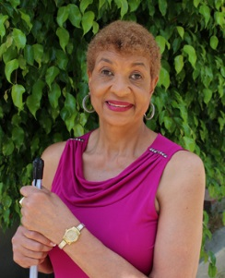
Ever Lee Hairston serves on the Board of Directors for the National Federation of the Blind. The third of seven children, she is a product of the segregated South. After her failing eyesight kept her from realizing her dream of becoming a nurse, she began working as a teacher. At the age of twenty-nine, facing total blindness, with a failed marriage, a child to raise alone, and uncertainty about future employment, ever changed her attitude and changed her life. After attending the Louisiana Center for the Blind, the North Carolina Central University graduate began integrating blindness skills into her everyday life. A resident of California, she continues to devote tireless hours mentoring and advocating for the blind.

NFBU Special Guest: Cary Supalo
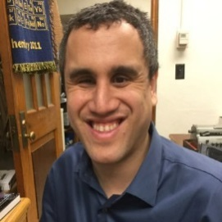
Cary Supalo is the president and founder of Independence Science: a small assistive technology and accessibility consulting firm based out of the Purdue Research Park in West Lafayette, Indiana. He also serves as chair of the chemistry subcommittee of the Braille Authority of North America (BANA) and also serve on the chemists with disabilities committee for the American Chemical Society.

NFBU Special Guest: Congressman Chris Stewart
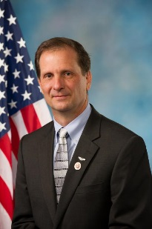
Chris Stewart is the Congressman from Utah's Second Congressional District. Chris is one of ten children and grew up on a dairy farm in Cache Valley. He graduated from Utah State University, where he earned his degree in economics. He served for fourteen years as a pilot in the Air Force, flying both rescue helicopters and the B-1B bomber. He holds three world speed records, including the world’s record for the fastest non-stop flight around the world.

2018 NFB of Utah Convention Agenda

All general sessions (beside breakout sessions) will be held in the Capitol Reef Ballroom.

Thursday April 19, 2018

6:30-8:00 pm: Welcome & Sponsor’s Pizza Dinner
Location: Zion Ballroom
*FREE to registered convention attendees.

8:00-9:00 pm: Early Registration Available
Location: Canyons Lobby (right outside main ballrooms)
Avoid longer lines by coming to our early bird registration.
Registration Fee: $10.
Meal: Varies
Affiliate Membership Dues: $1

8:00-11:00 pm: NFB Utah Spanish Division Game Night
Location: Zion Ballroom
The Spanish Division is hosting a game night. We will have lots of fun games. This is something you don’t want to miss!

8:00-9:30 pm: Resolutions Committee Meeting
Location: Deer Valley
Resolutions Chairperson: Karl Smith
Come learn about the resolutions that will be presented at this year’s convention. All are welcome.

Friday April 20, 2018

7:00-9:00 am: Convention Registration
Location: Canyons Lobby
Your name will NOT be included in the door prize drawings until you have registered. Please try to arrive early to prevent long lines. Registration: $10
Affiliate Membership dues: $1

7:45-8:45 am: Board of Directors Breakfast
Location: Capitol Reef Ballroom
Invocation: Karl Smith, 2nd Vice President of the NFB of Utah
Moderator: Everette Bacon, affiliate president
Come hear from the board of Directors of the NFB of Utah, and various venders who will be present at this year’s convention.

Friday Morning General Session
Capitol Reef Ballroom

9:00 am: Call to Order and Welcome Ceremony
Everette Bacon, President of the NFB of Utah, Member of our National Board of Directors

Color Guard

National Anthem: Special Guest

Invocation: Jerry Nealey, MA, NOMC; Outreach Specialist at DSBVI; Weber/Davis Chapter Member

NFB Pledge: Ian Reed, NFB of Utah Board of Directors, member Red Rock’s Chapter

Special Guest Performance: Sun Water Singers, featuring Preston Rock and Daryl Reese (Both Salt Lake chapter members) of the Navajo Tribe.

9:30 am: A Mayor’s Welcome, Mayor Ben McAdams, Salt Lake County mayor and candidate for U.S. Congress.

9:50 AM: National Report, Ever Lee Hairston, NFB National board of Directors; civil rights advocate; President of the NFB of California.

10:20am: State of the State, Everette Bacon, President of the NFB of Utah; board member of the National Federation of the Blind

10:50 am: Why I’m a Federationist: From the Beach to the Mountains, Yadiel Sotomayor, NOMC, cane travel instructor at DSBVI; Salt Lake chapter member.

11:10 am: Technology Yesterday, Today and for the Future, Kevin Hughes, Sales Director for the Western Region at Humanware.

11:20 am: Blindness Rehabilitation in Utah: History and Change
Steve Winn, Director of the Utah Division of Services for the Blind and Visually Impaired.
Sarah Brenna, Director of the Utah State Office of Rehabilitation.

11:35 am: Blindness Skills and College, a Match made in Heaven,
Adam Rushforth, Coordinator of Training and Adjustments Services at DSBVI, Utah Valley chapter member.

11:50 am: Support and Sponsorship: Growing with the Federation, Vanda Pharmaceuticals and Aira, LLC

12:00 pm: Adjourn

Live the Life You Want Luncheon
12:00-1:30 pm
Location: Capitol Reef Ballroom
Invocation: Zachary Ledford, Project STRIVE
Sponsors Address: Diamond Sponsor, Second Sight

The 7th Annual NFB of Utah Descriptive Fashion Show:
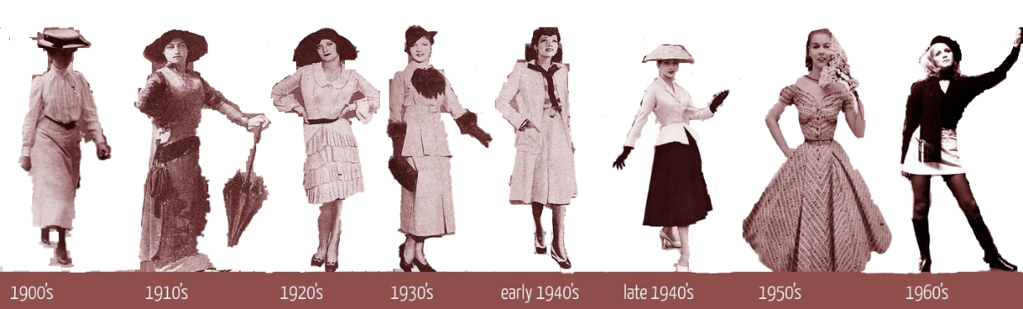
Fashion Through History: Icons of Fashion

Friday Afternoon Session

1:45 pm: Education is the most Powerful Weapon Which you can Use to Change the World: Presentation of the 2018 NFBU Scholarship Finalists, Deja Powell, chairperson of the NFBU scholarship committee.

2:00 pm: Science Without Sight: It’s Completely Possible, Dr. Cary Supalo, President and Founder of Independence Science.

2:20pm: Making State Parks Friendly to the Blind, Monica Stamm, graphic design and interpretive media specialist at Utah State Parks and Recreation.

2:35 pm: Why I’m a Federationist: Flute from the Heart, Tara Briggs, musician and blind mother, instructor for NFBU Project STRIVE, Salt Lake chapter member.

2:50 pm: A History of Civil Rights Advocacy: Disability Law Center, Lindsay Boerens, Disability Employment Rights Activist at the Utah Disability Law Center.

3:05 pm: Blind Princesses Do Exist, Mia Walker, 11-year-old blind actress, lead in “Princess Academy” at the Timpanogos Valley Theater.

3:25 pm: Making Theatre Accessible in Utah at the Eccles, Sarah Pierce, Director of the Salt Lake County Center for the Arts.

3:40 pm: NFB Newsline: Civic Right Starts with Access to News,
Michael Harris, Utah State Library for the Blind representative; Salt Lake Chapter member.
Jerry Nealey, NOMC, Weber/Davis Chapter member

3:55 pm: Adjourn

Friday Evening
Dinner on your own—hotel restaurant is open. Several activities will be going on this evening (refer to agenda below).

4:00-7:00 pm: NFBU 2018 Vendor Fair
Location: Canyons Lobby
*Refer to full vendor list at the end of the agenda.

4:00-7:00 pm: Auction Preview and Silent Bidding
Location: North Star
Here is your chance to come preview items for Saturday’s auction. One hundred percent of funds raised through the annual auction are used for funding a summer braille enrichment program for elementary school children, and collegiate scholarships.

8:00-11:00 pm: Songs and Sundaes Presented by NFBU
Project STRIVE
Location: Zion Ballroom
Everyone is welcome to come sing with us and enjoy ice cream at this fun, annual event. Come meet STRIVERS, learn about our program, or just come hang out and witness the amazing/terrible singers we have in Utah.

Saturday April 21, 2018

7:30 am: Convention Registration
Location: Canyons Lobby
Registration: $10
Affiliate Membership Dues: $1

7:45 am: NFBU Chapter Breakfast,
Location: Capitol Reef Ballroom
Moderator: Willie Black, President of the Weber/Davis chapter.
Invocation: Aaron Timm, Logan, Utah

Come enjoy breakfast and hear from all the chapters, divisions, clubs, and groups of the NFB of Utah.
Willie Black, Weber/Davis
Deja Powell, Salt Lake City
Laura Vincent, Utah Valley
Myrna Bell, Red Rocks
Jennifer Kennedy, Utah At-Large Chapter
Ulvia Guadarrama, Spanish Division
Chelsea Peahl, UABS
Edward Shaham, NABS
…any other chapters or divisions of the NFB.

Saturday Morning Breakout Sessions
Location: Review list of breakout sessions for individual locations.

9:00-10:00 am: “A” Breakout Sessions

Breakout 1A: Science without Sight
Location: Alta Room
Moderator: Cary Supalo
Learn about the skills needed to be a blind scientist. Learn how to make STEM accessible for blind students. And hear techniques and tips for improving the science experience for the blind.

Breakout 2A: NFB History and Philosophy
Location: Sundance Room
Moderators: Ron Gardner and Ever Lee Hairston
Come enjoy an open discussion about the NFB philosophy, what we work for, and various programs of the organization.

Breakout 3A: Spanish Division Meeting: Start Where You Are, Use What You Have, and Do What You Can.”
Location: Solitude Room
Moderators: Ulvia Guadarrama and Laura Vincent
Take part of our Spanish Division so that together we can help in changing common myths and misconceptions of blindness within other cultures. The Spanish Division will be holding its elections. Come hear from our National Federation of the Blind Translation Committee and talk about our upcoming events and how to grow our division.

Breakout 4A: Humanware
Location: Powder Mountain Room
Moderator: Representative from Humanware technology.
Kevin Hughes,

10:10-11:00 am: “B” Breakout Sessions

Breakout 1B: The Past Guides us to a Brighter Future:
Parents Division
Location: Solitude Room
Moderators: Everette Bacon, President; Patricia Renfranz, Parent of a Blind Child
Parenting comes with unique challenges, come interact with other parents of blind children, blind parents, and well, any parent! Enjoy open and honest dialogue about what it’s like to truly be a parent of a blind child, or parent as a blind person.

Breakout 2B: Jujitsu and Martial Arts
Location: Deer Valley Room
Moderators: Dr. Ned Lindholm and Nathan Ostergaard
Join this hands-on sessions to learn the basics of Jujitsu from two advanced instructors. Come ready to learn new moves.

Breakout 3B: Aira
Location: Snowbird Room
Moderator: Representative from Aira

Breakout 4B: Vanda Pharmaceuticals
Location: Alta Room
Moderator: Representative from Vanda Pharmaceuticals

Breakout 5B: Second Sight
Location: North Star room
Moderator: Representative from Second Sight

11:00 am-Noon: “C “Breakout Sessions

Breakout 1C: Family, Friends, and Spouses of the Blind
Location: Solitude Room
Moderators: Lucas Atkinson, Dr. Angela Peters, and Kerri Conley
This is a panel for spouses, siblings, parents, partners, teachers, or anyone who has a loved one who is blind. Come have an open discussion about issues related to blindness from the sighted person’s perspective. This interactive session is a favorite of many convention attendees. SIGHTED PEOPLE ONLY, please!

Breakout 2C: Jujitsu and Martial Arts
Location: Dear Valley Room
Moderators: Dr. Ned Lindholm and Nathan Ostergaard
Join this hands-on sessions to learn the basics of Jujitsu from two advanced instructors. Come ready to learn new moves.

Breakout 3C: NFBU Student Division Meeting
Location: Brighton Room
Moderator: Chelsea Peahl,
Are you a student or looking at becoming a student? If so, come join us! Meet fellow students from our state and see what UABS has been up to this year, hear more about AIRA technology, and hear from our special guest, Sayeed NABS Board of Directors, of the National Association of Blind Students. Also, elections for positions on the UABS board will be held during this meeting. We hope to see you there!

Breakout 4C: Vanda Pharmaceuticals
Location: Alta Room
Moderator: Representative from Vanda Pharmaceuticals

Breakout 5C: Second Sight
Location: North Star Room
Moderator: Representative from Second Sight

Noon-1:30 pm: Lunch

Food and Fundraising Luncheon
Noon-1:30 pm
Location: Capitol Reef Ballroom
Invocation: Amelia Creer, Weber/Davis Chapter

2018 NFBU Annual Auction
*100 percent of proceeds go to the NFB of Utah and its many programs.
Auctioneer: Daniel Ashman, Salt Lake chapter member

Saturday Afternoon General Session
Location: Capitol Reef Ballroom

1:45 pm: Accessibility and Disability Rights in the Capitol City, Moana Uluave-Hafoka, Ed.M, Policy advisor and community outreach for diversity and human rights at Salt Lake City Corporation.

2:00 pm: Braille, Canes, and Growing Brains: Utah Bell Academy, Wendy Bybee, director Utah Bell Academy;
Panel: Staff and participants of the 2017 Utah Bell Academy.

2:20 pm: A Groundbreaking and Historic Program in Transition Services: Project STRIVE, Cheralyn Creer, Director Project STRIVE, First Vice President NFB of Utah, Weber/Davis chapter member.
Panel: Staff and participants of NFBU Project STRIVE.

3:00 pm: Leadership is the Legislature, Representative Chris Stewart, United States House of Representatives 2nd District of Utah.

3:15 pm: Civil Rights and Advocacy: Washington Seminar Report
Dr. Sachin Pavithran, Presidential Appointee to the US Access Board, NFB Utah board of directors, Program Director of Disability Policy at Utah State University.
Dr. Ned Lindholm, Salt Lake chapter member, professor at Salt Lake Community College.
Myrna Bell, President Red Rocks Chapter

3:40 pm: Equal Access Across the Board: Deaf Blind Services in Utah, Laura Benge, COMS, Rocky Mountain Regional Representative at the Helen Keller National Center for Deaf-Blind Youths & Adults.

3:50 pm: Money Funds the Movement: NFBU Treasurer’s Report, Mark Turley, Treasurer of the NFB of Utah, Salt Lake chapter member.

4:05 pm: 2018 NFBU Resolutions, Karl Smith, NFB of Utah Resolutions Chair, 2nd Vice President NFB of Utah, owner AXIS technology.

4:30 pm: NFB of Utah Board Elections, Cheralyn Creer, Nominating Committee Chair, Weber/Davis chapter member.

5:00 pm: Adjourn

You are cordially invited to the National Federation of the Blind of Utah’s 2018 Banquet

Waves of the Movement,
It’s our Time to Rise!

The Twenty-First Day of April Two Thousand and Eighteen
at Six-Thirty in the Evening

Master of Ceremonies:
Mr. Everette Bacon
Invocation:
Mr. James Bybee
Honored Guest Speaker
Mr. Robert Spendlove, Utah State Legislature
Banquet Address:
Ms.Ever Lee Harriston
PAC Plan Presentation:
Mr. Kirt Manwaring
Presentation of NFB of Utah Scholarship Winners:
Mrs. Deja M. Powell
Diamond Auction Items
Mr. Daniel Ashman
Special Awards
Mr. Everette Bacon

2018 NFB of Utah Vendors

Ability 1st Utah
AIRA
Auction Pre-Look Table
AXIS Technology
Corey Noyse
Deaf/Blind Advocacy Group
Disability Law Center of Utah
Dr. Cary Supalo
En-vision America
Guiding Eyes
Humanware
JW.org
Mary Kay Cosmetics
Moran Eye Center
Rocky Mountain Low Vision
Second Sight
Sprint
Traci McDonald, author
Uber
Utah Assistive Technology Foundation
Utah Division of Services for the Blind and Visually Impaired
Vanda Pharmaceuticals
Willie B's Café

The NFB of Utah wishes to thank the following
2018 convention sponsors, without you we couldn’t put on such a wonderful convention.
Thank You!

Diamond Sponsor
$3,000 donation
Second Sight

Titanium Sponsors
$2,000+ Donation
Vanda Pharmaceuticals

Gold Sponsor
$1,000 Donation
Uber

Gold Sponsor
Silver Sponsor
Willie B’s Café

Silver Sponsors
Humanware
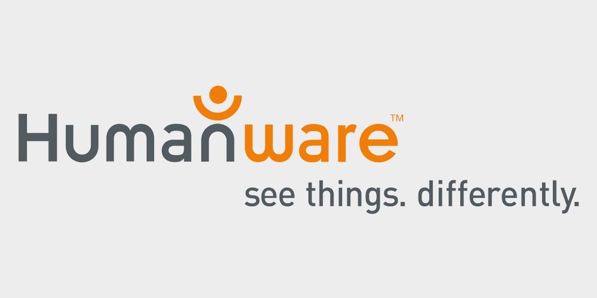

The NFB of Utah Also Wishes to Thank…

The staff at the Sheraton for making our convention run so smoothly, providing unprecedented hotel rates, and being so easy to work with.

All the members who have gone out to collect items for door prizes and auction items, and who support our organization through fundraising throughout the year.

All guests, sponsors, and vendors who traveled from all over the country to attend our convention, you helped make it unique and we hope you’ll come back to Utah again…and again.

Dr. Angela Longboat and the Lions Club of Utah for their generous donation to our scholarship program.

All those who helped behind the scenes with registration, organizing auctions and door prized, coordinating vendors, recruiting sponsors, planning meals, working with the hotel, preparing speeches, and recruiting new members to attend.

Ms. Janice Spencer, who always makes the most perfect centerpieces to fit our theme for banquet night every year. Your talent does not go unnoticed.

Save the date!
Dates: June 4 - June 15 2018
NFB of Utah BELL ACADEMY

Banking on Blindness Skills

The National Federation of the Blind (NFB) Braille Enrichment for Literacy and Learning (BELL) Academy helps blind and low-vision children, ages four through twelve, develop the literacy skills that will empower them to achieve their academic goals and live the life they want. This year, with the assistance of our Wells Fargo partners, we provide opportunities to develop financial literacy skills as well. In addition to Braille instruction, the program provides instruction in other nonvisual blindness skills through fun, hands-on learning. To learn more about NFB BELL Academy and to apply please visit https://nfb.org/bell-academy.

- Where: Utah Schools for the Deaf and Blind Salt Lake
Campus, 1655 E. 3300 S. Salt Lake City, UT 84106
- Time: Monday - Friday 8:45 AM-3:15 PM
- Register: https://www.nfb.org/bell-academy
- Questions: Contact Wendy Bybee: 801-910-2542 e-mail:
    - wkbybee@gmail.com

Please be sure to complete the permission and release forms with your application.

