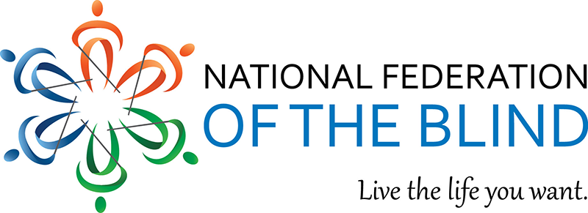

Hello everyone,
Please join the National Federation of the Blind Greek and Masonic Group for their White Cane Safety Day program Held on Tuesday, October 17th at 8 PM Eastern Standard Time. The group will discuss the significance of White Cane Safety Day and there will be a panel discussion on inclusive participation in Greek and Masonic organizations. To join the program, please review the zoom information below. Thanks and I hope to see you there!!!
Join Zoom Meeting
https://nfb-org.zoom.us/j/8204086286
Meeting ID: 820 408 6286
One tap mobile
+13017158592,,8204086286# US (Washington DC)
+16469313860,,8204086286# US
Dial by your location
• +1 301 715 8592 US (Washington DC)
• +1 646 931 3860 US
• +1 305 224 1968 US
• +1 309 205 3325 US
• +1 312 626 6799 US (Chicago)
• +1 646 876 9923 US (New York)
• +1 689 278 1000 US
• +1 719 359 4580 US
• +1 253 205 0468 US
• +1 253 215 8782 US (Tacoma)
• +1 346 248 7799 US (Houston)
• +1 360 209 5623 US
• +1 386 347 5053 US
• +1 408 638 0968 US (San Jose)
• +1 507 473 4847 US
• +1 564 217 2000 US
• +1 669 444 9171 US
• +1 669 900 6833 US (San Jose)
Meeting ID: 820 408 6286

