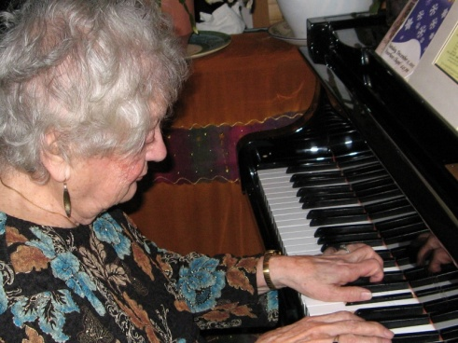 **NANCY CASTELLANO**

*Loving Mother, Grandmother,*

*Great-grandmother, Pianist*

Nancy Castellano passed away peacefully on January 11, 2017, after a brief illness.

Born on September 21, 1919 to Lorenzo and Maria Florio in Hoboken, NJ, Nancy graduated from A.J. Demarest High School and went on to work in business. Her true love, however, was music. She joined the Coro d’Italia in New York City in 1936 where she sang and served as accompanist and where she met the other love of her life, John Castellano. Nancy and John spent 44 happy years together singing and dancing and raising their three children.

Nancy was predeceased by her dear husband John, her siblings Chancie, Yolanda, and Larry, and her son-in-law Walter Stasiak. At age 97, she was the last one standing. Surviving are her beloved children Barbara Stasiak, Carol Castellano and her husband William Cucco, and John Philip and his wife Marisa; dear niece Donna Florio and her husband Richard MacKay; cherished grandchildren Adam Stasiak and his wife Melanie, David Stasiak and his wife Alexandria, Serena Cucco, and John Cucco and his wife Alysia D’Urso; and treasured great-grandchildren Lucas and Emilia.

She will be fondly remembered and deeply missed by everyone who had the good fortune to converse with her, taste her delicious cooking, or hear her beautiful music.

Friends and family are invited to a celebration of Nancy’s life at   
the Morristown Unitarian Fellowship, 21 Normandy Heights Rd., Morristown, on Monday, Jan. 16 from 2-3 PM., followed by visitation at Madison Memorial Home, 159 Main St., Madison, from 4-7 PM. A funeral Mass will be celebrated at St. Thomas More Church, Madison Ave., Convent Station, on Tuesday, Jan. 17 at 10 AM.

Donations in Nancy’s memory would be greatly appreciated to D’Italia Programs, 20 Erie Pl., Nutley, NJ 07110, or Parents of Blind Children-NJ, 23 Alexander Ave., Madison, NJ 07940.