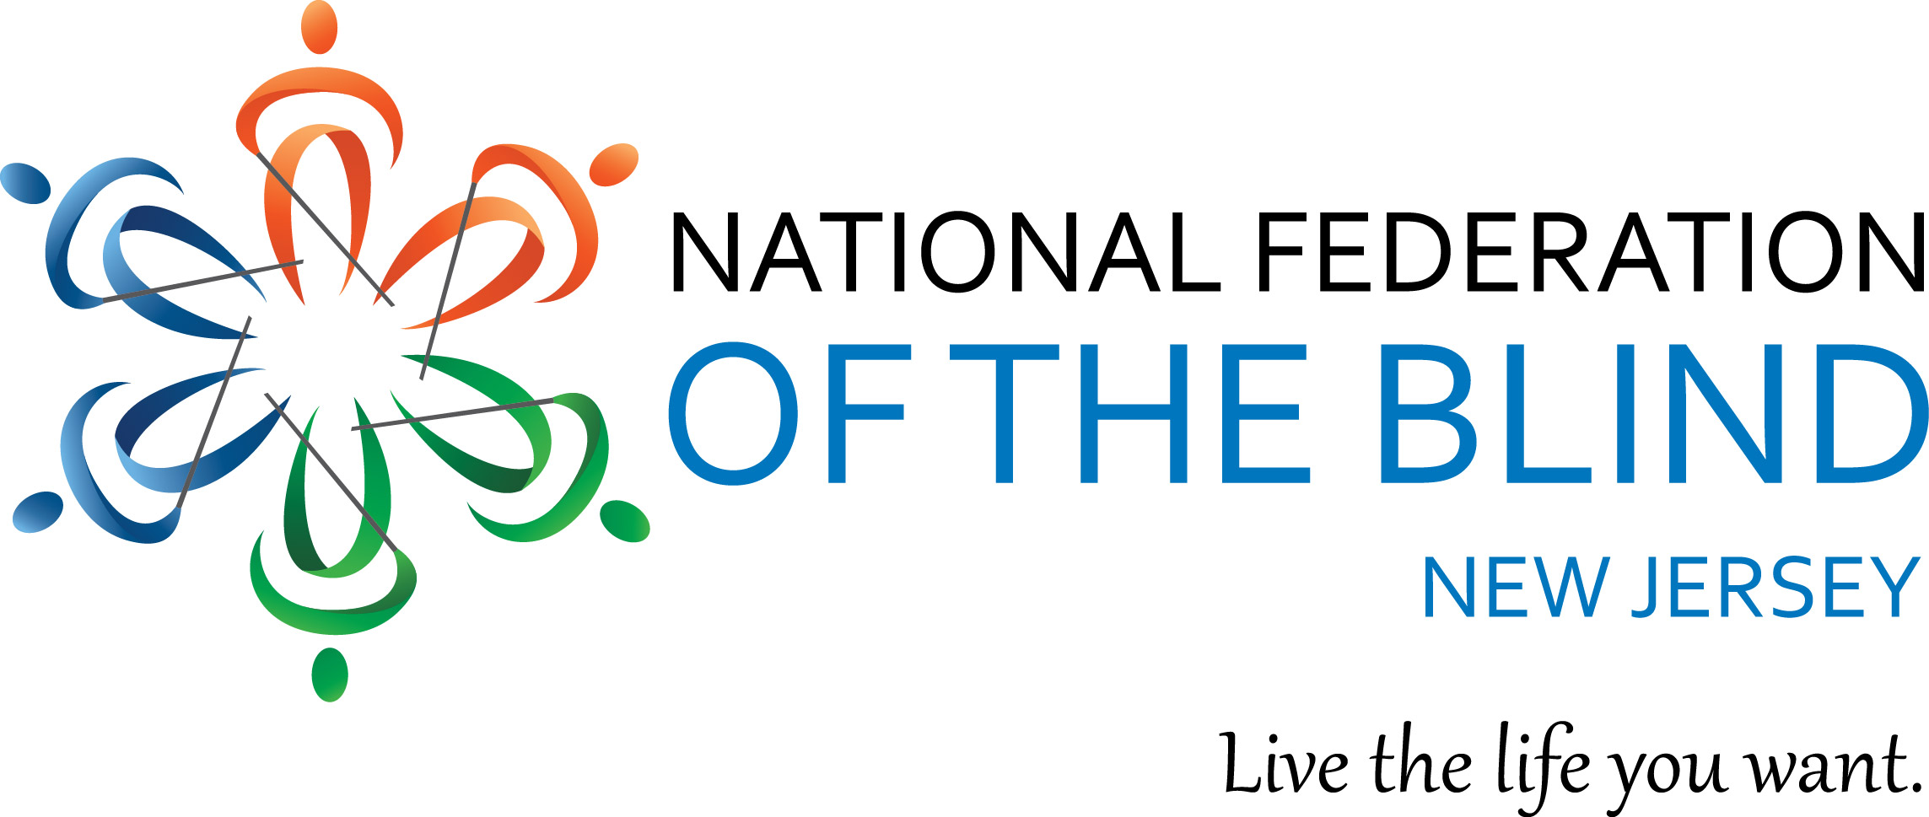

September 4, 2017

Dear Friend:

The National Federation of the Blind of New Jersey will be hosting it's 41st Annual State Convention, “Live The Life You Want; Let’s Make It Happen,” November 9 - 12, 2017, at the Holiday Inn in Manahawkin, NJ. We’re looking for items to use for door prizes and fund-raisers at the event. Can you help us out?

As you may know, the National Federation of the Blind is a non-profit, private sector resource of knowledge, support and encouragement for people who are blind (Federal 501(c)(3) ID #22-2716500). Take a look at our website: www.nfbnj.org

We offer training and advocacy to blind people and parents of blind children, and work to remove legal, economic and societal barriers so that blind people can participate fully in employment, education, recreation and all other aspects of community life. Our annual convention is one way we work toward achieving these goals.

Hundreds of blind people, parents of blind children, service providers, technology producers/distributors, inventors of products designed to enhance accessibility and independence, and representatives from rehabilitation services, agencies, private agencies for the blind and the New Jersey Talking Book and Braille Center attend our annual convention. At our convention, we also award scholarships to deserving young blind scholars.

Door prizes and surprises make this event even more exciting. Because we are financed only by contributions from our members, friends and well-wishers, we hope you’ll be able to help us out with a gift we can use as a door prize or fund-raiser item. Your tax deductible contribution(s) checks should be made payable to National Federation of the Blind of New Jersey.

Mail to:
Jane Degenshein, Chair of Auction/Donations of the NFBNJ
14 Elmwood Avenue
West Orange, NJ 07052

If more convenient, call 973 736 5785 or email us at jdegen16@comcast.net and we’ll arrange for the item to be picked up. We’ll look forward to hearing from you soon.

Sincerely,

Jane Degenshein
Chair of Auction/Donations of the NFBNJ

