Important Information for SNAP
Recipients about your February Benefits

Due to the federal government shutdown, you will be receiving your February Supplemental Nutrition Assistance Program (SNAP) benefits early. If you received a SNAP benefit in January and were scheduled to receive SNAP in February, your February benefits will be available on your
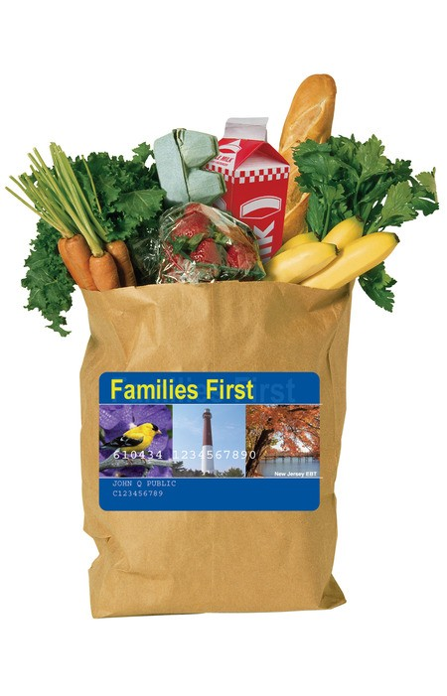

Families First card on
January 17

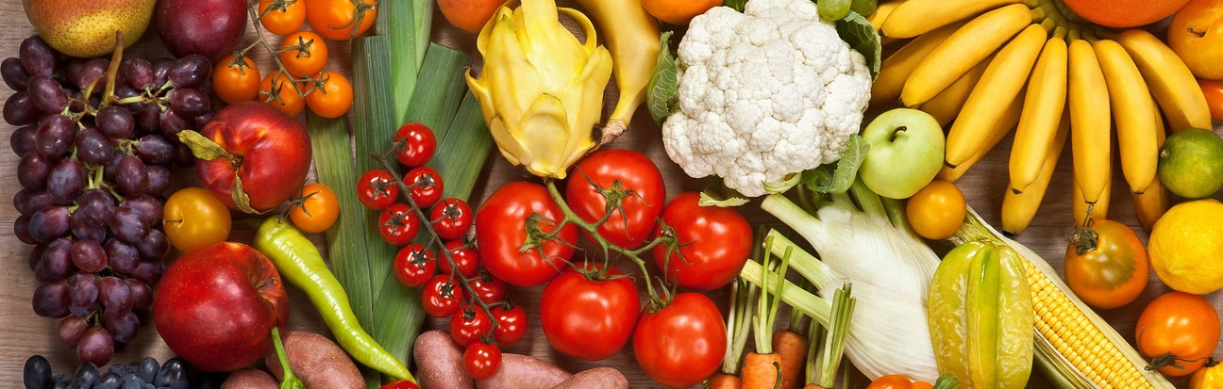

This is your benefit for the entire month
of February, so please budget with that in mind

February cash assistance benefits for Work First New Jersey (WFNJ) Temporary Assistance for Needy Families (TANF) and General Assistance (GA) will be available on your Families First card on your regular date

For ongoing updates on how the federal shutdown may
impact your SNAP benefits, visit NJSNAP.gov.

NJ Department of Human Services
Phil Murphy, Governor l Sheila Oliver, Lt. Governor l Carole Johnson, Commissioner This institution is an equal opportunity provider.

