**FALL 2019**

**The Sounding Board**

**The Publication of the National Federation of the Blind of New Jersey**

**In This Issue**

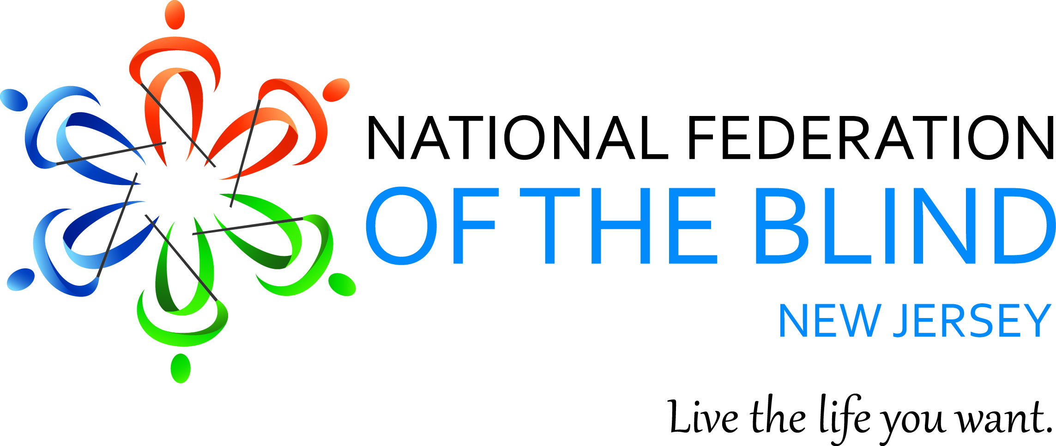

**Mary Jo Partyka**

*Highlights New Jersey’s 6th BELL Program*

**Bernice Davis, Aaliyah Dent & Amy Albin**

*Reflect on the 2019 National Convention*

**Annemarie Cooke**

*Tells about a European travel adventure*

**Sherel Beslanovitz**

*Shares the story of DeafBlind Paralympian Alice Eaddy*

**& New Jersey’s Blindness**

**Awareness Month Proclamation**

**Live the Life You Want**

**THE SOUNDING BOARD**

**Fall 2019**

*Katherine Gabry, Editor*

*Co-Editors: Annemarie Cooke, Mark Gasaway, Jerilyn Higgins & Mary Jo Partyka*

Published by e-mail and on the Web through Newsline by

**The National Federation of the Blind of New Jersey**

[**www.nfbnj.org**](http://www.nfbnj.org)

Joseph Ruffalo, President

State Affiliate Office 254 Spruce Street Bloomfield, NJ 07003

Email: nfbnj1@verizon.net

Articles should be submitted to the State Affiliate Office at [**nfbnj1@verizon.net**](mailto:nfbnj1@verizon.net)

and to the editor at **specialk38@aol.com.**

Advertising rates are $25 for a half page and $40 for a full page.

Ads should be sent to [**specialk38@aol.com**](mailto:specialk38@aol.com)**.**

**The editorial staff reserves the right to edit all articles and advertising**

**for space and/or clarity considerations.**

***Please Note: The deadline for the Spring issue is March 15, 2020.***

Donations should be made payable to the

**National Federation of the Blind of New Jersey**

and sent to the State Affiliate office.

To subscribe via Newsline: Jane Degenshein 973-736-5785 or Jdegen16@comcast.net

**DREAM MAKERS CIRCLE**

You can help build a future of opportunity for the blind by becoming a member of our Dream Makers Circle. It is easier than you think. You can visit your bank and convert an account to a P.O.D. (payable on death) bank account which is payable after your passing to the National Federation of the Blind or one of our affiliates. Your legacy gift to the National Federation of the Blind or the National Federation of the Blind of New Jersey can be made in the form of a will or living trust, an income generating gift, or by naming us as the beneficiary of a retirement plan, IRA, pension or a life insurance policy. You can designate a specific amount, a percentage, or list the NFB as one of several beneficiaries. For additional information, please contact Patti Chang at 410-659-9314, extension 2422 or at [pchang@nfb.org](mailto:pchang@nfb.org).

**Mission Statement**

The National Federation of the Blind of New Jersey, Inc. is an organization of blind and interested sighted people who plan and carry out programs; work to improve the quality of life of the blind; provide a means of collective action for parents of blind children; promote the vocational, cultural and social advancement of the blind; achieve the integration of the blind into society on a basis of equality with the sighted; and take action that will improve the overall condition and standard of living of the blind.

***The National Federation of the Blind knows that blindness is not the characteristic that defines you or your future. Every day we raise the expectations of blind people because low expectations create obstacles between blind people and our dreams. You can live the life you want; blindness is not what holds you back.***

**The National Federation of the Blind Pledge**

I pledge to participate actively in the efforts of the National Federation of the Blind to achieve equality, opportunity and security for the blind; to support the programs and policies of the Federation; and to abide by its constitution.

***The Sounding Board***

*The Sounding Board* is the magazine of the National Federation of the Blind of New Jersey. It is publishedtwice a year. Through *The Sounding Board*, we aspire to provide a source of hope, inspiration, pride and camaraderie through the personal stories featured in our publication.

Hundreds of readers receive our publication via email and *Newsline*. *The Sounding Board* is also available for download in its entirety from our website at www.nfbnj.org. We encourage our readers to share *The Sounding Board* with family members, teachers, professionals, neighbors, friends and any other interested parties. We estimate our circulation to be in the thousands, as readers from across the country regularly report that *The Sounding Board* influences their lives.

Seventeen people contributed to this issue by sharing stories, editing, interviewing and proofreading. It is truly a collaborative effort. We hope you enjoy the fruits of our labor.

**TABLE OF CONTENTS**

Presidential Message, by Joe Ruffalo 5

The National Federation of the Blind: My Favorite Charity? By Rick Fox 6

The Impact of the 2019 National Convention – series of three articles 7 – 10

The 2019 NFB National Convention – a Thought-Provoking Experience, by Bernice Davis 7

My First (of Hopefully Many) NFB National Conventions, by Aaliyah Dent 8

The 2019 National Convention: A Life-Changing Experience, by Amy Albin 9

Highlights from New Jersey’s 6th Bell Program, by Mary Jo Partyka 11

The Nature of Independence while in Another Country, by Annemarie Cooke 13

Why Get Involved? by Chris Franz 14

October is Blindness Awareness Month, New Jersey’s Proclamation 15

White Cane Awareness Day: A Symbol of Independence, by Marc Maurer 15

NFBNJ Volunteering Opportunities 17

Inspiration Corner: Alice Eaddy, Paralympic Athlete, by Sherel Beslanovitz 18

What’s Eye2Eye? by John Dehmer 19

How to Properly Charge a Phone Battery, by Simon Jary 20

Tech Tip: Getting Help for Your iDevice, by Jane Degenshein 21

Recipes 22 – 23

Jerilyn’s Healthy Snack Choices 22

Ruff’s Puffs 22

NFBNJ Contact Info 24

**PRESIDENTIAL MESSAGE**

**Greetings Fellow Federationists,**

For me, the arrival of autumn ushers in welcome changes. Warm summer sunshine transforms to cool, energizing crispness and the onset of brightly colored leaves. Lazy summer days at the beach morph into the activities of the school year and plans for the upcoming holiday season. In the National Federation of the Blind of New Jersey, fall presents us with renewed excitement as we prepare for our state convention where we continue to provide the philosophy and the expectation for each of us to live the life we want. This year’s convention – *Lead The Life You Want: We Got This* – will be held at the Delta by Marriott Hotel in Woodbridge, November 7 – 10.  Information has been distributed and is available on the state website at [www.nfbnj.org](http://www.nfbnj.org). Try to make an effort to attend as the convention features presentations, breakout sessions, an exhibit room, fellowship, great food and an opportunity to change what it means to be blind.

The chapters and divisions of the NFBNJ continue our mission of raising expectations. Meetings continue to provide growth in each member. Activities and outreach programs continue to provide the gift of the Federation to others. Scholarships continue to provide financial support to the next generation of members to achieve their goals and objectives. The fun and fund raising opportunities and the grants received continue to support the programs and projects of the NFB and the NFBNJ. Special thanks to Ellen Sullivan and all who have contributed time, effort and resources to the fundraising opportunities at Boscov’s department stores, Barnes & Noble and a number of grocery stores.

Last spring, the NFBNJ and Bloomfield UNICO partnered in hosting a comedy and musical entertainment fun and fund raiser night at the Knights of Columbus in Belleville. Proceeds benefited the Joe and Rose Ruffalo Memorial Scholarship Fund. Save the date for the second annual comedy and musical entertainment event scheduled for Saturday, March 28 at the Knights of Columbus in Belleville. Stay tuned for details!

Each issue of *The Sounding Board* provides information, personal stories and group activities to continue to inspire the growth in each of us. Thanks to all who share their stories in this issue. We – or someone we care about – may have lost eyesight, but we will never lose our vision.

On a special note:  I want to personally thank all who offered prayers and positive words to encourage me with my sudden medical emergency and with my 30-day stay in the hospital.  I feel stronger each day, and I’m getting back to “normal.” I continue to learn what is needed to live the life I want.

  Sincerely,

Joe Ruffalo, President

National Federation of the Blind of New Jersey

**GUEST EDITORIAL BY RICK FOX**

**The National Federation of the Blind: My Favorite Charity?**

**Editor's Note:** *Rick Fox is president of the NFBNJ’s Northern Chapter. He discovered the NFB decades ago while a student at Brown University in Providence, RI. One day, while exploring downtown Providence with a mobility instructor, a priest from a local cathedral noticed them and told Rick about a blindness group that met monthly in a conference room at the cathedral. The rest, as they say, is history.*

At a recent large family gathering, one of my nieces asked me the name of my favorite charity. Taken aback, I answered, “The National Federation of the Blind.” I didn’t have the time to tell her that the NFB was much more than a charity to me, that its members and philosophy helped me truly accept my blindness, raise my expectations for myself, and drew me into a community that feels like a second family to me.

A year in college had changed me from a cocky kid who thought he could do anything into a person who was depressed, lacked confidence and thought negatively about almost everything. That’s when I met the National Federation of the Blind.

The organization was founded in 1940 by a small group of blind people who felt that only people who were blind could and should lead the blind from a position of almost guaranteed idleness, helplessness and poverty, to a position of equality with their sighted neighbors. The very idea that this might be possible was, in that day, controversial.

The first, and most important lesson I began to learn from my NFB mentors was: *It is respectable to be blind.* As I pondered this message, I realized that I viewed my disability as a badge of inferiority. I have learned that this is common among people with disabilities, and other marginalized minorities. The idea that I, Rick Fox, blindness and all, could claim the same dignity and self-respect as other human beings, was, to say the least, liberating and revolutionary. All that shame and self-loathing could now be put to use in positive ways.

The second lesson was: *Keep your expectations high; don’t abandon your dreams because of your disability*. My NFB mentors gave me constant encouragement. One totally blind New York City resident spent a day with me in the subways and crazy, noisy streets of Manhattan. I decided I really could live and work in New York when he led me across 116th Street and Broadway. I’m proud to say I have built a 35-year career in the technology field, beginning in New York City.

Lesson #3: *Only a blind person can teach another blind person lessons 1 and 2.*

Lesson #4: *If we have taught you life-transforming lessons, pass them on to others by continuing the work of the NFB.* Over most of my adult life, I have tried to do this by mentoring others, educating the public regarding the capabilities of blind people, working with governmental and private agencies doing work with people who are blind to improve their services, and lobbying our legislators to pass laws conducive to equal participation of blind people in our society. One of our current issues is the abolition of subminimum wage payments to people with disabilities. Yes, corporations and nonprofits alike are allowed to pay people with disabilities less than the minimum wage!

Though I cringe at the remembrance of my painful period of depression and self-doubt, I am a more mature and compassionate person having gone through it. As a “wounded healer,” I believe I am a more effective and authentic mentor to others.

**THE IMPACT OF THE 2019 NATIONAL CONVENTION**

**Editor’s Note:***The next three articles are first-timers’ personal impact stories related to the National Federation of the Blind’s 2019 national convention in Las Vegas. Bernice Davis, Aaliyah A. Dent and Amy Albin share how the convention impacted them in the moments there and what it means for them in the future.*

**The 2019 NFB National Convention – A Thought Provoking Experience**

**By Dr. Bernice Davis, PsyD., Executive Director, CBVI**

While mapping out the logistics for my travel to the National Federation of the Blind’s national convention, I was invigorated by the prospect of sharing the experience with old friends while making new ones. I also thought about the distinction of being a stakeholder of an organization with such a long history of empowering people who are blind and proactively working to enlighten the world on the value that blind people bring to every aspect of society.

As I continue the process of immersion into the role of Executive Director of the New Jersey Commission for the Blind and Visually Impaired (CBVI), I find I am more and more inspired by the powerful ingredients of community and inclusion. I believe that these formidable elements must be recognized and embraced by anyone with an interest in ensuring that people who are blind and visually impaired have the opportunity to live the life they want.

Although significant, these thoughts could not compare to the phenomenal experience of the convention; the vast array of workshops offered was topped only by the diversity of topics and attendees. The hustle and bustle of trying to make it from one great workshop to the next, the side conversations, people helping each other with the logistics, the light and positive energy felt throughout – I found it all tremendously uplifting. However, more importantly it solidified the magnitude of the cultural experience of blindness and visual impairment and the significance of “a sense of belonging.” The workshops were reflective of NFB’s recognition and appreciation of the needs and lifestyles of people with diverse perspectives but the unquestionable spirit of community was compelling.

As I give thoughtful reflection on my experience at the NFB national convention and CBVI, I am proud of the paralleled history shared in partnership with the NFBNJ under the dedicated and tireless leadership of Joe Ruffalo. I am also proud that like NFB, the Commission has and will continue to demonstrate a strong commitment to diversity in the blind and visually impaired community, with the understanding that our collaborative goals truly go beyond unilateral efforts of providing services in the areas of employment, education and independent living. We are stakeholders in the total quality of life of our consumers and therefore, maintain an interest in full community inclusion as well as the social and civil rights of blind people, because it is all connected.

**My First (of Hopefully Many) NFB National Conventions**

**By Dr. Aaliyah A. Dent, MSW, LSW, CBVI Northern Regional Office Manager**

I must begin by thanking NFBNJ President Joe Ruffalo for both extending an invitation and encouraging me to attend this year’s National Federation of the Blind’s national convention in Las Vegas. I truly appreciated the chance to network with many members of the NFB during such an auspicious and informative event. Being introduced to President Riccobono and the hospitality shown to me and my NJ Commission for the Blind and Visually Impaired colleagues was much appreciated.

I admit that I was not prepared for the tremendous number of people in attendance. The over 3,000 attendees representing such a wide array of diverse perspectives was impressive, to say the least. In particular, I enjoyed interacting with the many young adults who visited CBVI’s table during the job fair. Their interest in our organization, as well as pursuing employment opportunities, was invigorating.

Since joining CBVI in 2018, I have actively pursued opportunities to expand my awareness and knowledge base about blindness and vision loss. For me, the NFB national convention was a massive one-stop learning center with people from all over the country, including service providers, vendors and representatives from organizations, as well as a plethora of companies that manufacture and market assistive technology. Most important was the sharing of concerns and ideas about how to bring about positive change, for example, things that should be considered when hiring someone who is blind or visually impaired. All of this useful information will be shared with my CBVI colleagues and in particular the Northern Regional Service Center staff.

In closing, President Riccobono’s speech encompassed client choice, equality, treating people with dignity and respect, and promoting self-worth. As I reflect on my experience, I cannot help but think about how my own personal beliefs, social work values and ethics are closely aligned with what I witnessed at the convention.

There is a lot of important work to do as related to ensuring 100 percent equality in all realms of life for all people. I look forward to working with NFBNJ to make that a reality for CBVI consumers.

**THE 2019 NATIONAL CONVENTION: A LIFE-CHANGING EXPERIENCE**

**By 2019 NFB Scholarship Finalist Amy Albin**

**Editor’s Note:** *Amy Albin, a junior at Montclair State University majoring in psychology, was a 2019 national scholarship finalist at this year’s convention. As such, she also is receiving a state scholarship at the NFBNJ state convention in November.*

I’m immensely honored to be part of the 2019 Scholarship Class of the National Federation of the Blind. Through this opportunity to attend a National Federation of the Blind national convention, I established relationships with successful mentors. I also learned a great deal about the policies of the NFB.

A major component of the Scholarship Program is that each finalist has the privilege of working with a different mentor each day. I am extremely thankful for all the time the mentors put in to making this a great experience for me!

For example, Dr. Arielle Silverman is a psychologist, which I aspire to be. I follow her blog, Disability Wisdom, and I hope to emulate her by always being an advocate for people with disabilities. This could be in my official career or volunteering, such as working with the NFB.

Tom Page and I are both musicians, so that was something we could both talk about. He also helped me by explaining what he did as part of the Resolutions Committee, and by suggesting ways for me to improve my orientation and mobility skills.

I appreciate that Denice Brown took the time to meet with me and have a deep conversation, even on a day when we were both very busy. Carla McQuillan and Everette Bacon were both people I’d met before because they were National Representatives at New Jersey state conventions. It was great to meet them on a more personal level and sit together during general sessions. Finally, Merry Schoch was my mentor during a complicated spatial activity involving the Dots candy. We worked together as a team to figure it out!

The mentorship component of the Scholarship Program was invaluable because it ensured that I was not alone during convention, and it allowed me abundant networking opportunities.

In addition to the new contacts I made, participating fully in the convention has launched my involvement in legislative activities. It started on the day in General Session when President Riccobono told us to call our federal legislators about the Access Technology Affordability Act. My previous habit, though I’m ashamed to admit it, was to read the legislative alerts but not take action, thinking that “someone else” would do it. But at lunch that day, I made the phone call. Since then, I’ve decided that each individual, through his or her own advocacy and through sharing with others, can make a significant difference in legislation. After leaving convention, I continued to call and e-mail about all our important bills and began educating people in my social circle about the legislation. I joined the Legislative Advocacy Committee of the National Association of Blind Students.

On August 19, I attended a town hall meeting with Representative Mikie Sherrill, and spoke publicly about the Transformation to Competitive Employment Act, the Access Technology Affordability Act, and the Greater Accessibility and Independence through Nonvisual Access Technology Act. I will continue to make NFB legislation a major priority in my life. In addition, I encourage all of the readers of *The Sounding Board*, in other words, you personally, to call and e-mail your representatives and senators about these three important bills. Don’t make the mistake I used to make. Don’t wait for another person to do it for you.

Being an NFB 2019 Scholarship Finalist has afforded me many opportunities to meet successful Federationists and ask questions. I have taken the knowledge I gained at convention to play an integral role in advocating for legislation to build the Federation so we can live the lives we want. Once again, thank you, NFB!

National Federation of the Blind of New Jersey



**43rd ANNUAL STATE CONVENTION**

*Live the Life You Want: We Got This*

**November 7 – 10, 2019**

Hosted by the Northern Chapter, the Senior Division & the Technology Division

Delta by Marriott Hotel (formerly the Renaissance Woodbridge Hotel)

515 US Highway 1 South ⚫ Iselin, New Jersey 08830 ⚫ Access Link accessible

More information and registration form available at:

<https://www.nfbnj.org/state-convention/>

*Please consider bringing non-perishable food items to donate to the Puerto Rican Association for Human Development, Inc., and personal items to donate to a nonprofit to assist those in need.*

**Get involved. Stay involved. Make a difference!**

**Highlights from New Jersey’s 6th BELL Academy**

**By Mary Jo Partyka**

**Editor’s Note:** *Mary Jo Partyka is a lifelong Braille user. She is currently chairman of the NFBNJ Braille Committee and president of the Capital Chapter.*

The NFBNJ sponsored its sixth BELL (Braille Enrichment for Literacy and Learning) Academy July 22 through August 2, 2019 at the Puerto Rican Association for Human Development (PRAHD) in Perth Amboy.  In planning year’s program, the BELL team requested a more private space than we had in the past. As a result, PRAHD provided us with a little greenhouse, which was small, but provided the space and the privacy conducive to a good learning environment for staff and students alike.

The BELL Academy is an intensive two-week summer experience which provides children between the ages of four and 12 who lacked exposure to Braille and nonvisual life skills with concentrated instruction in these areas.  This learning occurs through the students’ participation in fun, hands-on activities which will help them become more independent and self-sufficient.  Thirty-five NFB Affiliates offered a BELL Academy this past summer. The New Jersey program had six students.

This year’s BELL Academy was planned and coordinated by our BELL team: State Affiliate President Joe Ruffalo, BELL coordinator Mary Jo Partyka, head teacher Sylvia Reid, assistant teachers Joanna Mallard and Jonathan Zobek, NFBNJ Sports and Recreation Division President Linda Melendez, and Ellen Sullivan, the person who kept us on track and kept everything in order.  State Affiliate volunteers played an active role in the program, as well. Rosa Santiago and Alba Milla helped the students learn Braille. For the third year in a row, Rick Fox and Debbie Bloomer spent  half a day  at  BELL during which they talked with the students,  read them a story, and taught them how to play a new game called Quibbler, and brought prizes for the winners of the game.

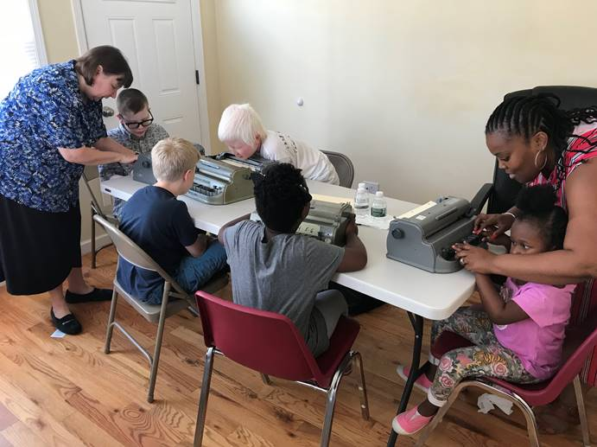

In addition to learning Braille and activities of daily living, each day, the students were encouraged to do something at home to enhance their independence, such as a new chore or engaging in self-care activities. When their teacher asked what they had done independently at home, they usually thought of something, and they were encouraged to ring their bells to celebrate their achievements. The children also engaged in problem-solving situations during which they considered how they would handle something they found challenging.

The students engaged in some new experiences this year. On the first day of each BELL Program, the students celebrate Louis Braille’s birthday. This year’s birthday celebration was inspired by a lesson the BELL coordinators learned while in training at the National Center. The students were encouraged to use their white canes, learning shades and sense of touch to approach a piñata, tactually examine it and the stick that would be used to hit the piñata, and then, in turn, use the stick to try to break the piñata. Cries of “AWESOME!” were common. To further their mobility training, four sessions of travel instruction were provided for each student by Donna Panero, a certified orientation and mobility instructor from CBVI. The students also learned to use tactile sketchpads on which they could draw letters, diagrams or geometric figures. Because they could touch and feel these drawings, the representations were more meaningful to them. All BELL Academies received sketchpads donated by the American Action Fund.

The students also went on two field trips. The first was to the Perth Amboy police station where they were able to touch some police equipment and experience sitting in a police car and on a motorcycle. Those who knew Braille were encouraged to read the Braille signs in the police station to the rest of the group. The second trip was to the Keansburg Amusement Park and was sponsored by the NFBNJ’s Sports & Recreation Division. While the students, parents and siblings were invited to participate in this field trip, each student was assigned a blind mentor who spent the day with them. The students were given money to order their food, and they placed the orders themselves and had to make change in some instances. The students also went on the rides independently. This was a great experience for the students, and a day they will remember for a long time because they realized they could do some new things independently.

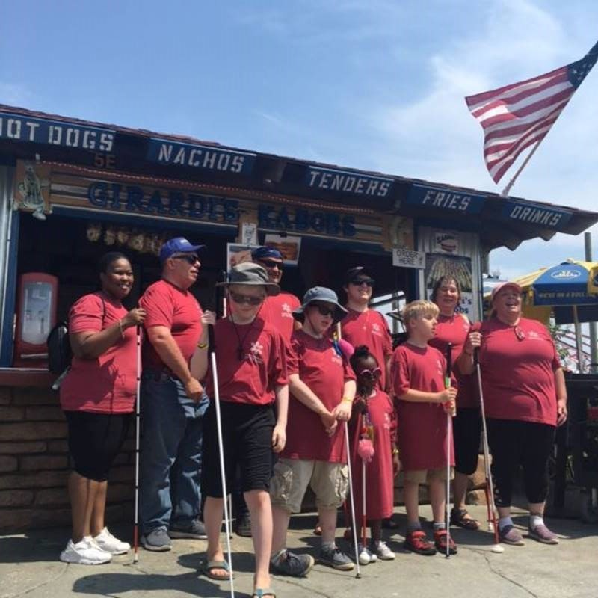

There was a high level of commitment between the BELL Academy staff and the parents of the BELL students. The parents were invited to participate in two planning conference calls before the program started and were apprised of all activities which took place during BELL.

The BELL students participated in a graduation ceremony and after they marched into the classroom, each discussed a different facet of the program. Joanna Mallard taught the children to do the Cha-cha Slide, and they sang a song called Six Dots of Braille to the tune of the Beatles “Eight Days a Week.”

The BELL Academy would not have been possible without financial support from the Allergan Foundation, as well as the Chester and Bloomfield Lions Clubs, and from the State Affiliate chapters and divisions which helped us work this magic once again. Thank you for your generous support!

**The Nature of Independence While in Another Country**

**By Annemarie Cooke**

One of Kenneth Jernigan’s most memorable essays is “The Nature of Independence.” In this work, he notes that independence for us blind folks doesn’t necessarily mean having to struggle through everything by oneself; the nature of true independence is knowing when to ask for assistance.

Nothing proved this for me like a trip my husband Doug and I took to Scotland and England this past August. Because the day we planned to travel from Edinburgh, Scotland to London was on a bank holiday weekend, we learned a few months ahead of time that the railroad track would be under renovation, and the station we had planned as our destination would be closed. No real big deal…except that a no-transfer express train would now be a series of short hops – four of them – on different trains operated by different rail companies (trains were privatized in the UK years ago).

I had vouchers for the tickets which had to be printed at the station. Luckily, we did this when we first arrived in Scotland, as the process took about 45 minutes. I had noticed while browsing for rail schedules that all the companies offered assistance for passengers who have disabilities. Even for seasoned travelers, it can be maddening to find the correct track and determine whether one is assigned to a specific car and seat or whether it’s open seating.

Adding to the potential stress of the day was the unusually high temperatures predicted for the week – 90 degrees F and higher in a land in which air conditioning hardly ever is needed so there usually isn’t any.

On our appointed travel day, a Sunday morning, we searched high and low for the reception desk we had been told to visit. The security cameras must have finally revealed a blind woman with a white cane and sighted guy looking confused and increasingly cranky as the hour grew later because suddenly a station employee in uniform arrived, iPad in hand. He had been waiting for us, he said (who knew?). He guided us to the correct platform, and said he’d be back closer to train arrival time. He did, got us situated and said someone would meet us at the next station. Like clockwork, that happened! And it happened at the next two stations, too.

When we finally made it to Chatham, the stop past London, which was our destination, the station staff member, possibly bored by the dearth of other passengers, walked us two blocks to the cab stand and waited until a cab arrived and we safely were en route to our hotel.

On the way back to London several days later, our reservations still were live in the system and a uniformed staff member greeted us, got us seated and away we went to central London. Upon arrival, the crowd brought to mind Times Square on New Year’s Eve (we’ve seen it only on TV). Which exit would get us to the street we knew would take us to our hotel?

So I called AIRA (short calls are free!). The call cut out as we walked through the teeming waiting area, but the AIRA agent was able to guide us to a coffee shop on a corner outside (I could smell the aroma!) and to our sought-after street crossing.

Bottom line: Travel can stress blind and sighted folks alike; travel arrangements and seating can be different than in the US; when it’s super-hot weather, one can lose patience faster.

So, follow Kenneth Jernigan’s advice and make use of assistance, especially when traveling. You’ll waste less time and energy and arrive at your destination sooner and in a calmer frame of mind.

**WHY GET INVOLVED?**

**By Chris Franz**

**Editor’s Note**: Why get involved? *showcases our members living the lives they want and how that raises the expectations of others around them. Chris Franz is a member of the At Large Chapter, as well as the Technology and Senior Divisions. Here is her story.*

I am vision Impaired and have cerebral palsy. When I was going to school most of my teachers gave me coloring books and crayons and M&Ms to keep me quiet. Teachers told me I couldn’t learn anything.

I met a wonderful lady named Jane Degenshein in 2006 who introduced me to her brother Joe Ruffalo. Jane and Joe encouraged me to learn other techniques so I could do more by myself. After that, I went to the Joseph Kohn Training Center (JKTC) in New Brunswick to learn daily living skills to prepare me for an independent life on my own.

With Jane and Joe’s excitement and encouragement, I moved out of a group home and into my first apartment alone over 10 years ago. I went to my first state convention in 2009. I believed in the NFB philosophy and became more and more independent as the years went by. I learned a lot from different people in the Federation, such as how to act on a conference call, and how each one can teach one. I became more confident with so many friends of mine in the Federation.

I joined the Senior Division when it started in 2011, the Technology Division in 2013, and the At Large Chapter since it was established in 2009. I am grateful for all of you in the NFB who continue to assist me to be the best I can be.

Many of you have made me more confident, and this makes me much happier. I want to say to those new members that there are people who believe in you here in our NFB family, just like I found, and it has helped me to live the life I want and need, and you can be the best you can be here with our NFB family, too.

**OCTOBER IS BLINDNESS AWARENESS MONTH**

**Proclamation Received from the State of New Jersey Executive Department**

*Governor Phil Murphy and Lieutenant Governor Sheila Oliver signed the following:*

*Whereas*, the State of New Jersey became a trailblazer in 1910, with the establishment of the Commission for the Blind and Visually Impaired (CBVI), one of the nation’s first state agencies dedicated exclusively to the unique educational, vocational and day-to-day life needs of people who are blind or visually impaired; and

*Whereas*, it is estimated that over 259,000 New Jersey residents live with blindness or severe vision loss; and

*Whereas*,  the mission of the CBVI is to promote and provide services in the areas of education, employment, independence and eye health through informed choice and partnership with persons who are blind or visually impaired, their families and the community; and

*Whereas*, CBVI has always recognized the importance of providing services that facilitate access to opportunities that will enable people with vision loss to obtain their fullest measure of self-reliance and improved quality of life and is also actively involved in  ensuring their treatment as individuals with dignity and worth who are fully integrated into their community; and

*Whereas*, CBVI continues to work in partnership with consumers and all individuals and organizations that share their goal to prepare for the promise of the future while promoting the vast reservoir of talent and ability represented by people who are blind or visually impaired; and

*Now, therefore,* I, Phil Murphy, Governor of the State of New Jersey, do hereby proclaim that October 2019 be declared Blindness Awareness Month.

**White Cane Awareness Day: A Symbol of Independence**

**By Marc Maurer**

***Reprinted with permission from the National Federation of the Blind***

**Editor’s Note:** *Every state in the Union has a White Cane Law. New Jersey’s law is summarized in the Driver’s Manual as follows: “Vehicles must give the right-of-way when any of the following crosses any highway or intersection: blind persons who use a predominantly white or metallic cane, blind persons accompanied by a guide dog, or a guide dog instructor engaged in instructing a guide dog. A motorist must stop when he/she sees a person with a white or metallic “colored” cane or with a guide dog. All motorists must comply with this law (N.J.S.A. 39:4-37.1).*

In February of 1978 a young blind lady said, “I encounter people all of the time who bless me, extol my independence, call me brave and courageous, and thoroughly miss the boat as to what the real significance of the white cane is.”

The National Federation of the Blind in convention assembled on the 6th day of July, 1963, called upon the governors of the 50 states to proclaim October 15 of each year as White Cane Safety Day in each of our 50 states. On October 6, 1964, a joint resolution of the Congress, HR 753, was signed into law authorizing the President of the United States to proclaim October 15 of each year as “White Cane Safety Day.” This resolution said:

*“Resolved by the Senate and House of Representatives…, that the President is hereby authorized to issue annually a proclamation designating October 15 as White Cane Safety Day and calling upon the people of the United States to observe such a day with appropriate ceremonies and activities.”*

Within hours of the passage of the congressional joint resolution authorizing the president to proclaim October 15 as White Cane Safety Day, then President Lyndon B. Johnson recognized the importance of the white cane as a staff of independence for blind people. In the first Presidential White Cane Proclamation, President Johnson commended the blind for the growing spirit of independence and the increased determination to be self-reliant that the organized blind had shown. The Presidential Proclamation said:

*“The white cane in our society has become one of the symbols of a blind person’s ability to come and go on his own. Its use has promoted courtesy and special consideration to the blind on our streets and highways. To make our people more fully aware of the meaning of the white cane and of the need for motorists to exercise special care for the blind persons who carry it, Congress, by a joint resolution approved as of October 6, 1964, has authorized the President to proclaim October 15 of each year as White Cane Safety Day.*

*“Now, therefore, I, Lyndon B. Johnson, President of the United States of America, do hereby proclaim October 15, 1964 as White Cane Safety Day.”*

With those stirring words President Johnson issued the first White Cane Proclamation which was the culmination of a long and serious effort on the part of the National Federation of the Blind to gain recognition for the growing independence and self-sufficiency of blind people in America, and also to gain recognition of the white cane as the symbol of that independence and that self-reliance.

The first of the state laws regarding the right of blind people to travel independently with the white cane was passed in 1930. In 1966, Dr. Jacobus tenBroek, the founder of the National Federation of the Blind, drafted the Model White Cane Law. This model act – which has become known as the Civil Rights Bill for the Blind, the Disabled and the Otherwise Physically Handicapped – contains a provision designating October 15 as White Cane Safety Day. Today there is a variant of the White Cane Law on the statute books of every state in the nation.

From 1963 (and even before) when the National Federation of the Blind sought to have White Cane Safety Day proclaimed as a recognition of the rights of blind persons, to 1978 when a blind pedestrian met with misunderstanding regarding the true meaning of the white cane, is but a short time in the life of a movement. In 1963, a comparatively small number of blind people had achieved sufficient independence to travel alone on the busy highways of our nation.

In 1978 that number has not simply increased but multiplied a hundredfold. The process began in the beginning of the organized blind movement and continues today. There was a time when it was unusual to see a blind person on the street, to find a blind person working in an office, or to see a blind person operating machinery in a factory. This is still all too uncommon. But it happens more often and the symbol of this independence is the white cane. The blind are able to go, to move, to be and to compete with all others in society. The means by which this is done is that simple tool, the white cane. With the growing use of the white cane is an added element – the wish and the will to be free – the unquenchable spirit and the inextinguishable determination

to be independent. With these our lives are changed, and the prospects for blind people become bright. That is what White Cane Safety Day is all about. That is what we do in the National Federation of the Blind.

# National Federation of the Blind of New Jersey

# Volunteering Opportunities

Volunteers are an invaluable part of our team as we work to spread our positive message about blindness and the abilities of blind people.

**Volunteer opportunities include:**

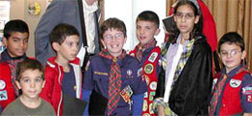

* Reading, driving
* Fundraising
* Helping with mailings
* Registration at our events
* And more!

To volunteer to support our efforts, please contact President Joe Ruffalo at [nfbnj1@verizon.net](mailto:nfbnj1@verizon.net) or 973-743-0075. Include your contact information, the town and county where you reside, and what your volunteer interests are.

**THANK YOU FOR YOUR CONSIDERATION IN MAKING A DIFFERENCE!Inspiration Corner: Alice Eaddy, Paralympic Athlete**

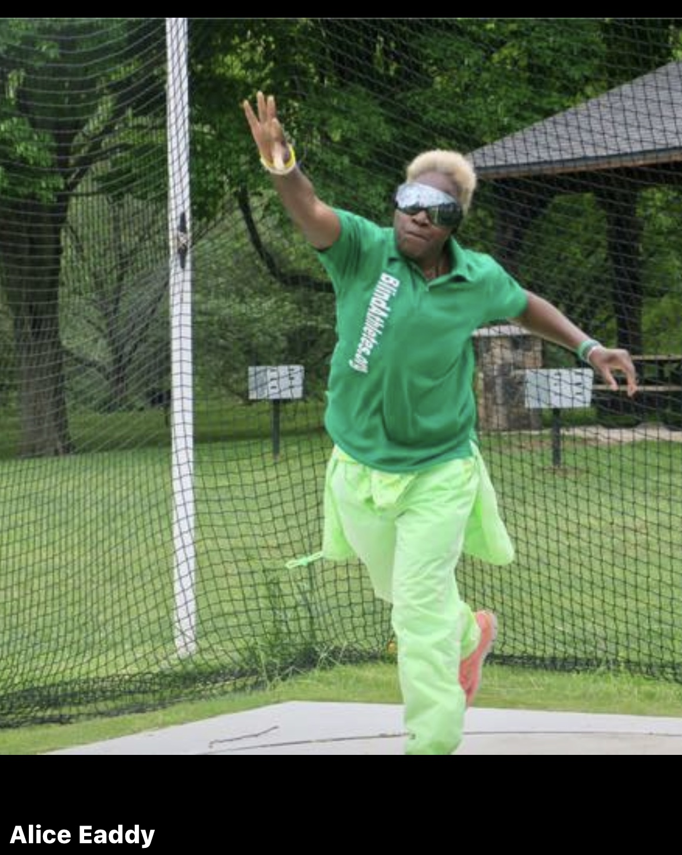

**By Sherel Beslanovitz**

***Reprinted with permission from* DBCANNJ Fall 2019 News**

Neither thunder nor lightning can stop Alice Eaddy on race day! Alice, in the photo at right, hurling the shotput, is a national track and field competitor on the Blind Athletes Inc. team, and she’s deafblind. Alice summarizes her athleticism in this way: “I’m definitely a unique, national level competitor. I don’t go at my sports endeavors halfway. I compete to … be reasonably, and realistically, competitive. I’m not just a competitor, I give track and field everything I’ve got.” Alice thrives as an athlete and encourages other deafblind people to participate in track and field sports.

Alice especially enjoys the camaraderie on the field, and she always makes an effort to communicate with her competitors who accept her competitive spirit without knowledge of the duality of her deafblindness. To foster those exchanges at every meet, she brings communication cards and a dry erase marker, as well as her mobility cane and her guide dog, Wanda. She enjoys the check-in process and meet and greet events, as they’re good times to get to know people. “Sometimes I’m in groups with youngsters under 12, and I’ve learned the value of a good knock knock joke to pass the time of slow moving events,” Alice adds.

In the 2019 Great Lakes Games in Chicago, Alice won first place in her age group in the 4K, shot put, javelin, discus throw, and the 100-, 200- and 400-meter runs. She used a guide runner for the 200- and 400-meter runs. In 2018, Alice participated and medaled in the Philadelphia Marathon Rothman Orthopaedics 8K where her completion time for the Race-Walk was 1 hour, 17 minutes and 48 seconds, placing her 44th in her age group of almost 2,000 athletes. The photo at left shows Alice and her guide dog Wanda at the 2018 Arizona World Para Athletics Grand Prix - Desert Challenge Games, where she won gold in the javelin and bronze in the 400-meter run. Alice has high expectations for herself, and she doesn’t quit. When her coaches give her a target pace to shoot for, she tries to nail it every time.



Alice has a cochlear implant and a hearing aid, but bad weather often precludes her from using them. Even if she is wearing them, Alice can’t hear the start gun, so an official alerts her to begin by tapping on her left shoulder, and there is also an official at the finish line. These accommodations ensure she starts and finishes with the group. Alice sums up her sports participation by saying, “I know that I’m a role model for the DeafBlind Community. My participation allows the public to see that people who have differing abilities do not let them get in the way of living their lives. It makes me proud of how I can put myself out there and GO FOR IT!!!”

**WHAT’S EYE2EYE?**

**By John Dehmer**

**Editor’s Note:** *Operating through Rutgers University, Eye2Eye is the first Reciprocal Peer Support program for people with vision loss in the United States. It has received designation for providing “National Best Practice in Peer Support” by the Department of Defense Center for Excellence (2011), has been featured in*The New York Times*, and has received an award from the American Psychiatric Association (2018). Services include peer support, clinical assessment, information dissemination, referrals and outreach. Eye2Eye is open Monday through Friday, 8 a.m. to 3 p.m., with longer hours coming soon. Call 833-932-3931. Find out more at*[*ubhc.rutgers.edu/eye2eye*](http://ubhc.rutgers.edu/eye2eye)*. Below, longtime NFBNJ member John Dehmer shares his thoughts on the new program.*

I’ve worked in support group development for more than 30 years, so my interest was piqued when I saw a job announcement for yet another new program. “Eye2Eye?” I wondered. “What makes this program different?” The answer is ***accessibility***.

The single thing that has always been missing from support groups is that they do not connect to the individuals who are not able to attend, nor do they connect with the families who don’t know how to obtain services for their loved ones. Further, there are no clearinghouses that provide comprehensive information, referrals and people to talk with who have personal experience with vision loss who can assist with and understand the personal concerns and issues related to adjusting to vision loss.

After accepting a position as a peer support counselor at Eye2Eye, I’ve personally experienced the uniqueness of Eye2Eye, and I’m proud to be part of this new endeavor. Eye2Eye is an easily accessible, community-centered, peer-supported, phone-based resource that assists people coping with the adjustment to vision loss. The Reciprocal Peer Support model of emotional support and information sharing focuses on developing a strong connection with the caller and goal setting with a focus on overall wellness and quality of life. A caller can schedule as many sessions as he or she wants to receive assistance, including referrals to agencies that provide other necessary services.

Eye2Eye is open to anyone who is blind or visually impaired in New Jersey and New York City; our hope is to eventually become nationwide. Through a grant provided by the Lavelle Fund for the Blind, the program has five peer support counselors and a clinician, all of whom are visually impaired or blind themselves. The clinician also provides information, suggestions and guidance on how to resolve personal situations and live the life you were meant to live. We are eager to work with clinical providers so that we can form effective referral networks to best serve people with blindness and visual impairment.

Eye2Eye is directed by Steven Silverstein, Ph.D., a clinical psychologist and vision researcher, and Cherie Castellano, MSW, the National Peer Support Call Center Program Director. The Reciprocal Peer Support model was developed by Ms. Castellano.

**HOW TO PROPERLY CHARGE A PHONE BATTERY**

**By Simon Jary – Published on the Web 26 April 2019**

*Submitted by Jane Degenshein, President, NFBNJ Technology Division*

Why is it that your phone's battery seems to get worse over time? At first it might have power to spare as you snuggle into bed at the end of the night, but as time goes on you find your battery is just half-full by lunchtime. Partly it’s because your use of the phone – the apps you install, the junk you collect, the customizations you make, and the more and more notifications you receive – puts more strain on the battery.

But the other thing to consider is that phone batteries do degrade over time, which means they are increasingly incapable of holding the same amount of power. While they should have a lifespan of between three and five years, or between 500 and 1,000 charging cycles, a 5-year-old phone battery is never going to keep going as long as a brand-new battery.

However, armed with our tips for best battery care practice, you can maintain your smartphone battery health much longer.

**When should I charge my phone?**

The golden rule is to keep your battery topped up somewhere between 50 percent and 90 percent most of the time. So top it up when it drops below 50 percent, but unplug it before it hits 100 percent. For this reason you might want to reconsider leaving it plugged in overnight.

Giving your phone a full recharge is not fatal for a phone battery, and it seems almost counter-intuitive not to do so, but giving it a full recharge every time you charge it will shorten its lifespan. Likewise, at the other end of the scale, avoid allowing your phone battery to get below 20 percent.

**Should I charge my phone battery to 100%?**

No, or at least not every time you charge it. Experts recommend that you do a full zero to 100 percent battery recharge (a “charge cycle”) once a month. This recalibrates the battery, which is a bit like restarting your computer.

**Should I charge my phone overnight?**

Not as a rule, since you want to avoid charging it to 100 percent too often, and won't want to have to keep one eye open for when that time is near. However, most modern smartphones are clever enough to stop charging when full, so there isn't a huge risk in leaving your phone charging overnight. If you are leaving it plugged in for a long period of time, removing the case can prevent it from overheating.

**Will fast-charging damage my phone?**

Most new smartphones support fast-charging, yet often come with a lower-spec charger in the box. The most common fast-charging standard is Qualcomm's Quick Charge, but phone makers often have their own alternative (which is often faster still). These phones have special code usually located in a chip known as the Power Management IC (PMIC) that communicates with the charger you are using and requests that it send power at a higher voltage.

While fast-charging itself will not harm your phone's battery, which is built to support it, the heat generated from that charging likely will affect its lifespan. So a quick top-up with a fast charger is unlikely to hurt your phone, but prolonged and regular fast-charging might mean the battery doesn't last quite as long as it would were you to use a slower charger. So it’s on you to balance the advantages of faster charging with the convenience of quickly topping up your phone before you dash out the door.

In the same way that phone batteries don’t like extreme heat, they also don't like the cold. So it goes without saying that you should avoid leaving your phone in a hot car, on the beach, next to the oven, out in the snow or, even, in the freezer.

**Can I use any phone charger?**

Where possible use the charger that came with your phone, as it is sure to have the correct rating. Or make sure that a third-party charger is approved by your phone’s manufacturer. Cheap alternatives from Amazon or eBay may harm your phone, and there have been several reported cases of cheap chargers actually catching fire. That said, your phone should draw only the power that it needs from a USB charger.

**Battery memory effect: Fact or fiction?**

The battery memory effect concerns batteries that are regularly charged between 20 percent and 80 percent and suggests that the phone might somehow “forget” that extra 40 percent you routinely ignore. Lithium batteries do not suffer the battery memory effect, though older nickel-based (NiMH and NiCd) batteries do.

**Storing battery tips**

Don’t leave a lithium battery lying around too long at 0 percent. If you're not using it for a while, leave it with around 50 percent charge. You’ll find the battery will drain between 5 – 10 percent each month, and if you let it discharge completely it might become incapable of holding a charge at all.

**TECH TIP: GETTING HELP FOR YOUR iDEVICE**

**By Jane Degenshein**

**Editor’s Note:** *Jane is the president of the Technology Division of the NFBNJ, as well as a State Affiliate board member, president of the Affiliate’s Senior Division and NFBNJ Newsline coordinator. She is also the facilitator of ECHO (Eyes Closed Hearts Open).*

If you have an iDevice that you need help with, or maybe you just want to know more about how to use it, try the iDevice group. I have been subscribed to this wonderful ios device listserv for several years and have had Denny Huff and Matt Vollbrecht on our Technology Division conference calls, too. For help with your device, send an email message to:  [iDevices+subscribe@groups.io](mailto:iDevices+subscribe@groups.io)s.

*Due to popular demand, our RECIPES column returns!*

**RECIPES**

**JERILYN’S HEALTHY SNACK CHOICES**

Jerilyn Higgins, a longtime NFBNJ member, is enjoying her new residence in Florida.  We’re hopeful that Jerilyn will return to New Jersey as we miss her, especially her desserts. Jerilyn provided the following healthy snack choices during a BELL Academy program a few years ago:

1. Fruit and cheese skewer: Use any fruit – grapes, watermelon, tangerine, blueberries, strawberries – and layer with mozzarella string cheese cut into 4 chunks
2. Homemade granola or trail mix using nuts, dried fruit, pumpkin seeds, shredded coconut, pretzels
3. Carrot and celery sticks with hummus or homemade ranch dressing using yogurt
4. Peanut butter on celery or apple slices with raisins or chia seeds on top
5. Pinwheels: Roll and slice a whole wheat wrap filled with peanut butter, bananas and chia seeds
6. Cucumber cups: Use a round melon baller to scoop out the flesh, then fill with yogurt or taziki or hummus
7. Caprese skewers: Use grape tomatoes, mozzarella and fresh basil
8. Fruit smoothie made with yogurt, almond milk and any kind of fruit
9. Banana chocolate ice cream using frozen bananas and cocoa powder
10. Homemade pickle chips using cucumber slices and a pre-made pickling liquid using some honey to offset the sour
11. Yogurt parfait using fruit, granola or oats, nuts, seeds, shredded coconut
12. Air popped popcorn using a brown bag in the microwave - top with parmesan cheese or nutritional yeast
13. Watermelon pizza using triangular sliced watermelon wedges, topped with feta and mint, or yogurt, berries and chia seeds
14. Guacamole or hummus with whole wheat pita chips
15. Grilled chicken nuggets with a homemade honey mustard sauce (honey, mustard and plain fat free yogurt)
16. Pineapple cut outs using fun shaped cookie cutters
17. Melon balls (honeydew, cantaloupe or watermelon) with fresh mint

**RUFF’S PUFFS**

Our second recipe is submitted by Joe Ruffalo. Joe owned and operated a baking business for seven years. Ruff’s Puffs is one of his – and many others’ – favorites. This recipe makes a dozen large cream puffs. Double the ingredients for double the pleasure!

**Ingredients:**

1 cup water

1 stick butter or margarine

1 cup all-purpose flour

4 large eggs

1 box of instant pudding

1-1/2 cups milk

1/2 cup sour cream

**Method:**

1. In a one-quart saucepan combine 1 cup water and 1 stick butter. Place saucepan on low heat, bringing the water and butter to a rolling boil.
2. Turn off heat and add 1 cup flour, stirring with wooden spoon until the mixture is thick and there are no lumps (approximately three to five minutes). When the batter is perfect, the wooden spoon will stand straight up in it.
3. Place batter in a large mixing bowl. Add 4 large eggs, one at a time, stirring constantly to insure that the batter remains stiff. When all four eggs have been worked in and you are satisfied with the stiffness of the batter, you are ready to make the Ruff's Puffs shells.
4. Grease the cookie sheet, if it does not have a nonstick surface or are not already well seasoned. Use a quarter-cup to measure the batter. Pack the batter into the cup so that you have no air pockets. Smooth the surface of the batter with the reverse side of a butter knife, allowing excess batter to fall back into the mixing bowl. Place the batter on the cookie sheet by sliding the butter knife around the inside of the measuring cup to loosen it. If the resulting puff is not round, shape it with your hands. Leave one to two inches of space around each puff.
5. Place sheet in preheated 375-degree oven for 35 to 40 minutes or until the smell of the puffs tells you that they are golden brown. Half way through the cooking process, rotate the cookie sheet 180 degrees to insure even baking. Be very certain that the puffs are done; they will fall when removed from the pans if they are not thoroughly baked and a bit crisp to the touch.
6. When done, gently remove puffs from cookie sheet and allow to cool on a rack or plate. Do not cut puffs until they are room temperature.
7. While puffs are cooling, in a large metal mixing bowl make the cream filling. Use one package vanilla or chocolate instant pudding. Once the instant pudding is in the mixing bowl, add 1 and 1/2 cups milk, any kind – whole milk adds a calorie or two but makes the filling noticeably richer. Then add a half cup of sour cream. Using an electric mixer on low speed, mix filling for approximately two minutes, then increase speed to high for about 30 seconds. Allow to stand at room temperature for approximately 10 minutes. If you prefer to mix the cream by hand, use an egg beater for about three to five minutes or until the cream thickens.
8. Use a sharp knife to cut puffs before filling them. Cut the puffs horizontally about three-quarters of the way through, approximately in the middle. This should expose a hollow space in the center. If not, pull out enough of the soft center to make your own hollow for filling. Using a tablespoon, begin filling the puffs with the cream and then close them again. Place in the refrigerator and enjoy the cleanup. Double the recipe, and you will double the calories.
9. Enjoy the Ruff's Puffs and watch your waistline grow.

**NFBNJ CONTACT INFORMATION**

**National Federation of the Blind National Office**

*President* Mark Riccobono 410-659-9314 [officeofthepresident@nfb.org](mailto:officeofthepresident@nfb.org)

**NFB State Affiliate**

*President* Joseph Ruffalo 973-743-0075 [nfbnj1@verizon.net](mailto:nfbnj1@verizon.net)

*1st Vice President* Linda Melendez 732-421-7063 [lindamelendez220@gmail.com](mailto:lindamelendez220@gmail.com)

*2nd Vice President* Mary Jo Partyka 609-888-5459 [choirnfb@gmail.com](mailto:choirnfb@gmail.com)

*Secretary* Ellen Sullivan 302-658-2268 [ems553@comcast.net](mailto:ems553@comcast.net)

*Treasurer* Andrew Rees 732-659-6002 [amrees567@gmail.com](mailto:amrees567@gmail.com)

*Board Members* Annemarie Cooke 609-859-4084 [aec732@gmail.com](mailto:aec732@gmail.com)

Linda DeBerardinis 856-735-5559 [ljdeber3@comcast.net](mailto:ljdeber3@comcast.net)

Jane Degenshein 973-736-5785 [jdegen16@comcast.net](mailto:jdegen16@comcast.net) Mary Fernandez 732-857-7004 [mary.fernandez@duke.edu](mailto:mary.fernandez@duke.edu)

Veronica Gaspa 434-989-1868 vee.gaspa@gmail.com

Zoraida Krell 201-439-0120 [krellbz@gmail.com](mailto:krellbz@gmail.com)

**NFBNJ Chapters – Meeting dates, times & available at** [**www.nfbnj.org**](http://www.nfbnj.org)

*At Large* Joe Ruffalo 973-743-0075[Nfbnj1@verizon.net](mailto:Nfbnj1@verizon.net)

*Capital* Mary Jo Partyka 609-888-5459 [choirnfb@gmail.com](mailto:choirnfb@gmail.com)

*Central Jersey* Mac Biggers 801-916-9753 [macbiggers@yahoo.com](mailto:macbiggers@yahoo.com)

*Garden State* Ryan Stevens 856-520-0016 [RYSteve@comcast.net](mailto:RYSteve@comcast.net)

*Northeast* Dan Facchini 201-906-8655 [danfb@verizon.net](mailto:danfb@verizon.net)

*Northern* Rick Fox 973-743-6107 [richardfox1@comcast.net](mailto:richardfox1@comcast.net)

*South Jersey Shore* Phil Harrison 609-788-0890 [pbharrison39@comcast.net](mailto:pbharrison39@comcast.net)

**NFBNJ Divisions**

*Blind Students* Jonathan Zobek 609-216-0181 [jrzobek@gmail.com](mailto:jrzobek@gmail.com)

*Parents of Blind Children* Carol Castellano 973-377-0976 [blindchildren@verizon.net](mailto:blindchildren@verizon.net)

*Senior Blind* Jane Degenshein 973-736-5785 [Jdegen16@comcast.net](mailto:Jdegen16@comcast.net)

*Sports & Recreation* Linda Melendez 732-421-7063 [lindamelendez220@gmail.com](mailto:lindamelendez220@gmail.com)

*Technology* Jane Degenshein 973-736-5785 [Jdegen16@comcast.net](mailto:Jdegen16@comcast.net)

**Programs, Projects & Committees**

*Adopt Adaptive Equipment* Joe Ruffalo 973-743-0075 [Nfbnj1@verizon.net](mailto:Nfbnj1@verizon.net)

*BELL Academy* Mary Jo Partyka 609-888-5459 [choirnfb@gmail.com](mailto:choirnfb@gmail.com)

*Blind Children’s Resource Center* Carol Castellano 973-377-0976 [blindchildren@verizon.net](mailto:blindchildren@verizon.net)

*Blind Merchants* Dan Facchini 201-906-8655 [danfb@verizon.net](mailto:danfb@verizon.net)

*Blind Parents* Joanna Mallard 201-354-0098 [joannmallard@gmail.com](mailto:joannmallard@gmail.com)

*Braille Mentoring Program* Mary Jo Partyka 609-888-5459 [choirnfb@gmail.com](mailto:choirnfb@gmail.com)

*DeafBlind Committee* Andrew Rees 732-659-6002 [amrees567@gmail.com](mailto:amrees567@gmail.com)

*Diabetic Committee* Ed Godfrey 862-628-3657 [edgodfrey1957@gmail.com](mailto:edgodfrey1957@gmail.com)

*Fundraising/Grant Writing* Ellen Sullivan 302-658-2268 [ems553@comcast.net](mailto:ems553@comcast.net)

*GreenDrop* Linda DeBerardinis 856-735-5559 [Ljdeber3@comcast.net](mailto:Ljdeber3@comcast.net)

*Guide Dog Committee* Dan Facchini 201-906-8655 [danfb@verizon.net](mailto:danfb@verizon.net)

*HAVA: Help America* Ryan Stevens 856-520-0016 [RYSteve@comcast.net](mailto:RYSteve@comcast.net)

*Vote Act Liaisons* Anthony Lanzilotti 609-361-3038 [Tti777@gmail.com](mailto:Tti777@gmail.com)

Andrew Rees 732-659-6002 [amrees567@gmail.com](mailto:amrees567@gmail.com)

*KNFB Reader Liaison* Rick Fox 973-743-6107 [Richardfox1@comcast.net](mailto:Richardfox1@comcast.net)

*Legislative Director* Ryan Stevens 856-520-0016 [RYSteve@comcast.net](mailto:RYSteve@comcast.net)

Anthony Lanzilotti 609-361-3038 [Tti777@gmail.com](mailto:Tti777@gmail.com)

*Liability Insurance*  Phil Harrison 609-545-8575 [pbharrison39@comcast.net](mailto:pbharrison39@comcast.net)

*Membership Engagement* Linda Melendez 732-421-7063 [lindamelendez220@gmail.com](mailto:lindamelendez220@gmail.com)

*NFB-NEWSLINE®* Jane Degenshein 973-736-5785 [Jdegen16@comcast.net](mailto:Jdegen16@comcast.net)

*PAC Plan Coordinator* Mac Biggers 801-916-9753 [macbiggers@yahoo.com](mailto:macbiggers@yahoo.com)

*Parliamentarian* Ryan Stevens 856-520-0016 [RYSteve@comcast.net](mailto:RYSteve@comcast.net)

*Public Relations/Press Corps*  Annemarie Cooke 609-859-4084 [aec732@gmail.com](mailto:aec732@gmail.com)

Mary Jo Partyka 609-888-5459 [choirnfb@gmail.com](mailto:choirnfb@gmail.com)

*Resolutions Committee* Ryan Stevens 856-520-0016 [RYSteve@comcast.net](mailto:RYSteve@comcast.net)

*Scholarship Committee* Evangelia Stone 917-570-3166 EvangeliaStone@gmail.com

*Social Media Coordinator* Zoraida Krell 201-638-3418 [krellbz@gmail.com](mailto:krellbz@gmail.com)

*Sounding Board* Kathy Gabry 201-998-9427 [Specialk38@aol.com](mailto:Specialk38@aol.com)

Annemarie Cooke 609-859-4084 [aec732@gmail.com](mailto:aec732@gmail.com)

Mary Jo Partyka 609-888-5459 [choirnfb@gmail.com](mailto:choirnfb@gmail.com)

*Spanish Committee* Rose Santiago 201-892-6946 [rosa.santiago901@gmail.com](mailto:rosa.santiago901@gmail.com)

*Transit Committee* Linda Melendez 732-421-7063 [lindamelendez220@gmail.com](mailto:lindamelendez220@gmail.com)

*Vehicle Donation Program* Andrew Rees 732-659-6002 [amrees567@gmail.com](mailto:amrees567@gmail.com)

*Webmaster* Brian Mackey 610-750-6765[webmaster@nfbnj.org](mailto:Bmackey88@gmail.com)

*White Cane Committee* Jane Degenshein 973-736-5785 [Jdegen16@comcast.net](mailto:Jdegen16@comcast.net)

Ann Marie Harris 856-589-8747 Lovey1160@gmail.com

# Deadline for the Spring 2020 issue: March 15, 2020

***CHECK US OUT ON THE WEB AT***

[**www.nfbnj.org**](http://www.nfbnj.org)[**www.blindchildren.org**](http://www.blindchildren.org)

To receive *The Sounding Board* and other information via e-mail,

please contact Ellen Sullivan at [ems553@comcast.net](mailto:ems553@comcast.net)