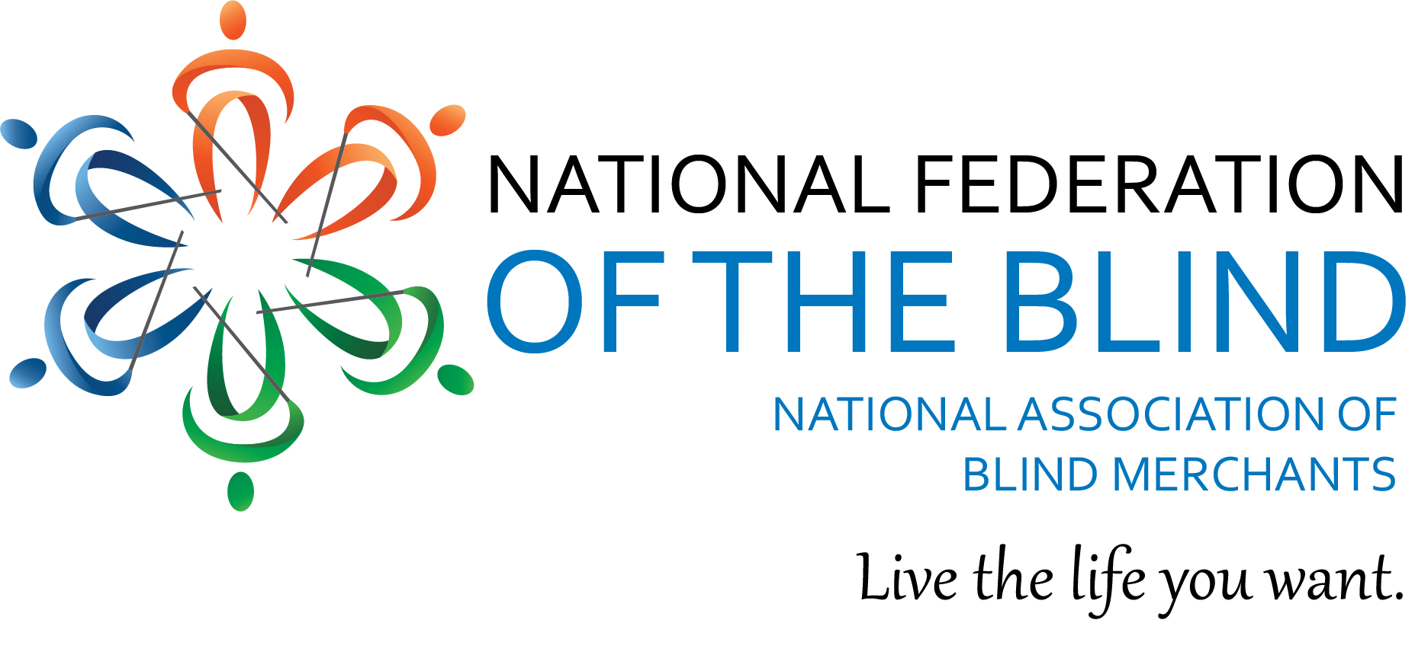

NABM To Host Call on SSDI and Unemployment

The National Association of Blind Merchants will be hosting a call to provide information about the CARES Act and the provision that allows blind entrepreneurs to qualify for unemployment benefits. Michael Dalto and Jim Gashel will discuss unemployment benefits and how they impact SSDI as well as other related issues.
The call is scheduled for Thursday, April 2nd, at 4:00 P.M. Eastern Time. To join, dial 877-394-5901 and the access code is 5478131. Please hit *6 when you join the call to mute yourself.

The National Federation of the Blind knows that blindness is not the characteristic that defines you or your future. Every day we raise the expectations of blind people, because low expectations create obstacles between blind people and our dreams. You can live the life you want; blindness is not what holds you back.

