Statewide Townhall on
Paratransit Transit Committee of the National Federation of the Blind

NJ TRANSIT

Office of Local Programs, Minibus Support and
Community Mobility
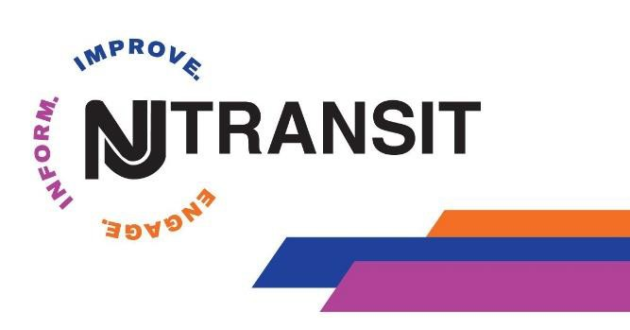
June 30, 2020

NJ TRANSIT Overview

NJ TRANSIT is the nation's largest statewide public transportation system providing more than 944,000 weekday trips.

251 bus routes (18,000 bus stops)
- Three light rail lines (62 light rail stations)
- 12 commuter rail lines (165 rail stations)
- Access Link paratransit service
- Pass through Federal and State Funds to State agencies,
Counties, municipalities and non-profits

Local Programs, Minibus Support and Community Transportation

- Administer approximately $49M annually in State and FTA grants and programs throughout New Jersey.
  - Casino Revenue Funding (SCDRTAP)
  - Section 5310 Enhanced Mobility of Senior and PWD
  - Section 5311 Rural Area Funding
- Designed to meet the needs of senior citizens, people with disabilities, rural and low income residents.
  - Can be used for operating, administration and capital expenses.
  - Over 100+ subrecipients throughout the State.

- Subrecipients must participate in the locally developed Coordinated Human Services Transportation Plans (CHSTP) to be included in grants. We participate in these plans and facilitate coordination amongst subrecipients who are non-profits, for profits and local governments to ensure no duplication of services with grant funds.

- We administer all grants in accordance with FTA and State regulations.

Pass through Programs

  - Senior Citizen, Disabled Residents Transportation Assistant Program (SCDRTAP) -Transportation for seniors and people with disabilities designated to the 21 counties for Administration, Operating and Capital projects. 85% of allocation goes to the 21 counties, 5% for NJT capital accessibility projects and 10% for NJT program Administration.
  - FTA Section 5310 – Enhanced mobility for seniors and individuals with disabilities is an annual competitive grant formula distribution funding by population (small urban, non-urban and UZAs). Eligible activities includes operating, capital and mobility management projects. NJT provides local 20% for capital projects (including mobility management). Requires local 50% match for operating projects. Currently there are 100+ Section S5310 subrecipients including counties, municipalities, State & non-profits agencies with 400 active S5310 vehicles.
  - FTA Section 5311/ 5311 innovation- Designated grant for rural areas of NJ general public transportation. There are 14 Section 5311 projects. S5311 innovation grant was implemented in 2015 as a initiative for agencies to develop deviated route services and/ or shared ride taxi service for rural areas of the state providing more options where public transit is limited.

Local Programs, Minibus Support and Community Transportation

21 County Coordinated Systems
- Modes of Service
  - Demand Response
  - Deviated Fixed Routes
  - Subscription Services
  - Feeder to Transit

Hours of Operations Differ by County
- Funding Sources (Rural Vs Urban)
- Citizens Advisory Committee Requirement
- Other Dial a Ride and Non-Profit Transportation Programs

INNOVATION and Future

- Road to Recovery
- Other initiatives

TNC Pilot Program
  - Accessible Service videos Travel Training Videos (in development)
  - Travel Training NJTIP @ Rutgers
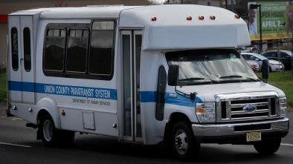
  - Mobile Application
  - Autonomous Vehicle

CONTACT INFORMATION
QUESTIONS, QUESTIONS, QUESTIONS

- Anna R. Magri
Director Local Programs, Minibus Support and Community Transportation
Amagri@njtransit.com
- Janelle Rivera
Manager of Local Programs
jrivera1@njtransit.com

7

County Community Transportation Contact information

Atlantic County Transportation | (609) 645-5910 | www.aclink.org
Bergen County Transportation | (201) 368-5955 | www.co.bergen.nj.us
Camden and Burlington Sen-Han Transit | (856) 456-3344 - Camden  (877) 603-5111 - Burlington | www.scucs.org
Burlington BURLINK | (609) 883-8891 | www.co.burlington.nj.us
Cape May Fare Free Transportation | (609) 889-3700 | www.capemaycountynj.gov
Cumberland Area Transit System CATS | (856) 691-7799 | www.co.cumberland.nj.us
Essex County Office On Aging | (973) 395-5858 OR  (973) 395-8418 | www.essex-countynj.org
Gloucester County Division of Transportation | (856) 686-8355 | www.co.gloucester.nj.us
Hudson County TRANSCEND | (201) 369-4320 (ext 4107) | www.hudsoncountynj.org
Hunterdon County, The Link | 800) 842-0531 | www.co.hunterdon.nj.us
Mercer T.R.A.D.E | (609) 530-1971 | www.mercercounty.org
Middlesex County Transportation, MCAT | (800) 221-3520 | www.co.middlesex.nj.us
Monmouth County SCAT | (732) 431-6480 | www.co.monmouth.nj.us
Morris County MAPS & Dial-a-Ride | (973) 829-8103 | www.co.morris.nj.us
Ocean County Ocean Ride | (877) 929-2082 OR  (732) 736-8989 | www.co.ocean.nj.us
Passaic County Paratransit | (973) 305-5756 | www.passaiccountynj.org
Salem County Transportation | (856) 339-8644 | www.salemcountynj.gov
Somerset County Transportation | (908) 231-7116  (800) 246-0527 | www.co.somerset.nj.us
Sussex County Transportation Skylands Ride | (973) 579-0480 | www.sussex.nj.us
Union County Transportation | (908) 241-8300 | www.ucnj.org
Warren County Transportation WCT | 908) 454-4044 OR Toll Free  1-866-594-4044 | www.co.warren.nj.us

