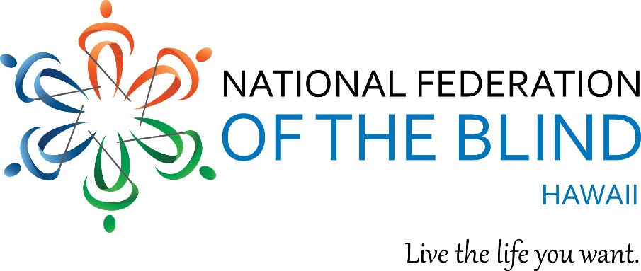

You are invited to attend our 2021 Annual State Convention

The National Federation of the Blind of Hawaii!

Friday May 14, 12:00 PM HST and Saturday May 15, 10:00 AM HST, 2021.

Anywhere and everywhere! Virtually via Zoom!

Our Theme is Mana Ohana,

Loosely translated, makes us stronger together!

All the fun you expect from an NFB of Hawaii conventions:

meet up with old friends,

meet new friends,

win door prizes,

get inspired again,

explore exhibits to learn about new devices for the blind,

learn how to live the life you want!

Save the dates and join us. Register now – it’s free! Its easy!

* Go to <https://hawaii.nfb.org/>
* Click on the link for [NFB of HI convention](https://hawaii.nfb.org/nfb-of-hi-convention).
* Then click on [Register Online Now](https://docs.google.com/forms/d/e/1FAIpQLSeuOs9qvaE28kQ4B6EhG89MMchT_HgUNwjo3LwgG8D_b-fgUg/viewform).
* Watch for more details to come.

You will receive the zoom link once you have registered.

For more information contact: Virgil Stinnett, NFB of Hawaii President.

Mobile: 808-722-4243

Email: nfbhpresident@gmail.com

Website: <https://hawaii.nfb.org/>