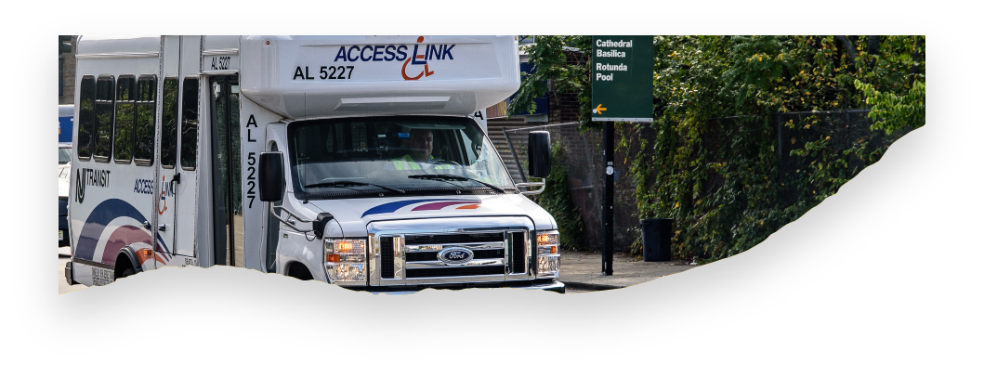

**Frequently Answered Questions (FAQ)**

**Access Link’s New Riders’ Choice Pilot Program**

**The Riders’ Choice Pilot Program may not be appropriate for everyone. You are encouraged to review the FAQ list and “opt in” if you would like to have your rides handled by one of our Transportation Network Company partners. Here are the answers to some common questions:**

**What is a Transportation Network Company (TNC)?**

A TNC is a corporation, partnership, sole proprietorship, or other entity that is registered as a business in the State of NJ or operates in the State and uses a digital network to connect a rider to a driver to provide a prearranged ride. Some examples of TNCs are LYFT and UBER.

**What if I do not want to participate in the pilot?**

If you do not want to enroll or “opt in” to the pilot, you do not have to do anything. All of your rides will continue to be handled by an Access Link driver in an Access Link vehicle. There is no need to call Access Link if you do not want to “opt in”.

**How do I sign up for this new ride option?**

You will need to fill out the [enrollment form](https://forms.office.com/g/czJ0pw2rhU) to “opt in” to the TNC Pilot Program. If you need help, call Customer Service for assistance. You also need to agree to share some information with the TNC, specifically your ride history and ride information (pick-up location, drop-off location, vehicle preference, date, time, duration, cost, contact information, etc.) The TNC will also need your approval to communicate with you via a telephone call, text message (SMS), or email about service, delays, marketing, newsletters, promotions, and surveys. All marketing material from the TNC will provide an opportunity to unsubscribe.

**Is the Riders’ Choice program based on where I live?** This ride option will be available to all Access Link riders. We will begin the pilot in our largest regions first and then expand the pilot program to the remaining regions.

**Am I still an Access Link customer?**

Yes. This new ride option is available to you as a certified Access Link rider. Your certification will not change.

**Will I be able to request that my Access Link rides only be handled by LYFT or UBER?**

No. After you make your Access Link reservation, your ride will be assigned to a LYFT or UBER driver if our software or scheduling team determines that your ride would be best handled by one of our TNC partners. You will not be able to make reservations with LYFT or UBER, under your Access Link ID.

**If I signed up but changed my mind, how do I opt-out of the pilot?**

You must unenroll from the pilot. Use this [form](https://forms.office.com/g/QgWagM7zuR) to have your client file updated. These are processed on a weekly basis. *If there an urgent need, contact Customer Service at [adaservices@njtransit.com](mailto:adaservices@njtransit.com) or 973-491-4224, option 5. On the weekends or at night, you can speak to the Service Monitors by calling 973-491-4224, option 3.

**What should I expect while using the TNC?**

You should expect a ride in a safe vehicle with a professional driver. The TNC driver will arrive within your window at the same price as your regular Access Link trip for now.

**Do I need to sign up for an app or create an account to ride with the TNC?**

No. You do not need to sign up for an app. If you already have an account with a TNC like LYFT or UBER, that account will need to be separate from the Access Link Rider’s Choice program, for now.

**Will customers using mobility devices be able to participate in the Riders’ Choice Program?**

Yes. When you enroll into the Riders’ Choice Pilot program, it allows Access Link service providers the ability, if needed, to move your ride to one of the program's TNC providers. At present, the TNC providers are LYFT and Uber. While our TNC partners do not offer ADA paratransit service, each provider has a fleet of vehicles, some of which may be wheelchair accessible. If you are traveling with a mobility device, our service provider's ability to move your ride to LYFT or UBER will be based on either TNC provider having a (WAV) wheelchair-accessible vehicle available in the area where you are traveling. While we cannot guarantee or predict that your ride will need to be moved to a TNC provider, we will always schedule your ride in an accessible vehicle that can accommodate your mobility device.

**Will I be able to travel with my service animal?**

Yes. Under the Access Link Riders’ Choice Pilot Program partnership, LYFT **and UBER drivers will transport Access Link customers with their service animals and are prohibited from refusing service. However,** service may be rightfully denied if your service animal is:

* Not under control
* Aggressive, disruptive, or posing a direct threat to the safety of others

**How will I know what vehicle is for me?**

Each TNC has distinct identifiers as pictured below. Also, prior to the vehicle arriving, the customer can confirm the trip provider. You will receive a text message letting you know your trip will be handled by a TNC provider, it will also include the estimated time of arrival and your driver’s name. If any changes occur, you will receive another notification such as a call or text message.

**Do I have to tip the driver?**

This is public transit. We ask that you do not tip the driver. If the service you receive is exceptional, submitting a commendation for the driver goes a long way. Contact our Customer Service department at [adaservices@njtrasit.com](mailto:adaservices@njtrasit.com) or call 973-491-4224 and select option 5.

**Who are the TNC’s that customers will be using?** Our Service providers have made agreements with [LYFT](https://www.lyft.com/) and [UBER](https://www.uber.com/). Click on the provider and it will take you their websites for more information.

**Are TNCs required to provide their drivers with information related to accessibility compliance?** Yes, TNCs must provide drivers with accessibility compliance information for persons with disabilities, including information about accommodating a rider with a disability.

**How much does it cost? How do I pay? Do they take cash?**

The fare is the same as the regular Access Link rides. Ideally, riders using TNC services will use EZ-Wallet. We are attempting to identify providers that will be able to take cash. If you need help signing up for EZ-Wallet, visit Access Link Online and read our brochure for more details on EZ-Wallet. You can also contact Customer Service at [adaservices@njtrasit.com](mailto:adaservices@njtrasit.com) or call 973-491-4224, select option 5.

**Will I be able to make last minute or same day reservations?**

No. This is for prearranged trips. You will still need to schedule rides from 1-7 days in advance using the web, mobile app, digital reservation form, or by speaking to an agent.

**Will there be video monitoring in the TNC vehicle?**

No. This is not a paratransit service. While some independent operators may have a video monitor system. They are not required to have a surveillance system in their vehicles.

**Is this safe? How do TNC’s screen their drivers?**

In New Jersey, the Motor Vehicle Commission has established safety and operating requirements for the companies and their drivers. For more information click [here](http://www.state.nj.us/mvc/pdf/business/tncfaq.pdf).

For detail on the specific TNC, please use the links below.

LYFT- [https://www.LYFT.com/safety](https://www.lyft.com/safety)

Uber <https://www.uber.com/us/en/safety/>

**Can I still share my ride with my PCA, family, or a companion?**

Yes. These rides will not be shared with other customers. You can still bring a Personal Care Attendant (PCA) and/or a Companion. You must inform the Reservationist at the time of booking. This can also be done on Access Link Online, the mobile app, and the digital reservation form.

**Will I be able to travel outside of the service area in a TNC?**

Not at this time. The TNC will only be providing trips within the service area that is ¾ of a mile from the local fixed route bus system.