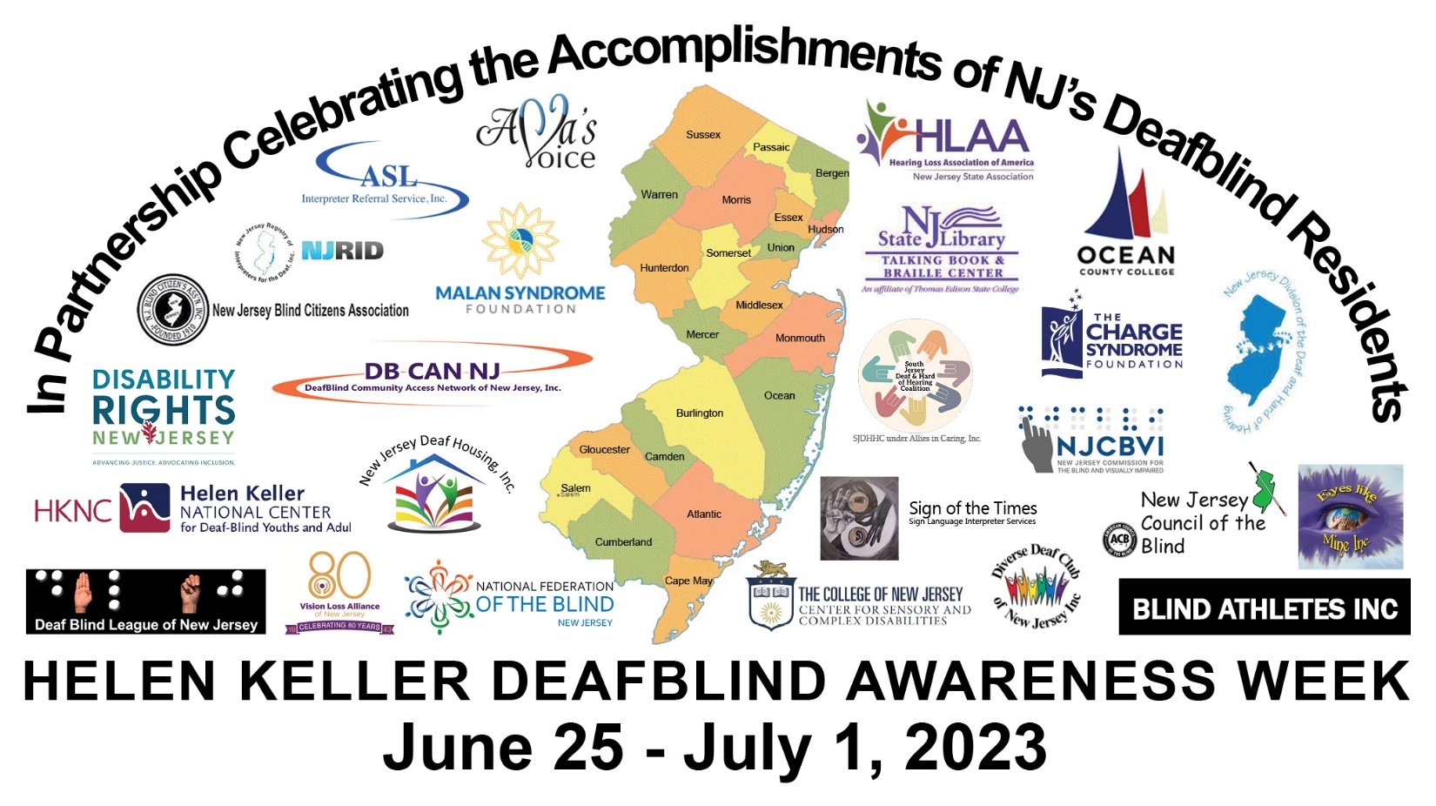
Graphic description: These words form an umbrella over 25 different logos: In Partnership Celebrating the Accomplishments of NJ’s Deafblind Residents. The 25 logos: ASL IRS, Ava’s Voice, Blind Athletes, Center for Sensory & Complex Disabilities, CHARGE Syndrome Foundation, DeafBlind Community Access Network of New Jersey, DeafBlind League of New Jersey, Disability Rights New Jersey, Diverse Deaf Club of New Jersey, Eyes Like Mine, Hearing Loss Association of America – New Jersey State Association, Helen Keller National Center, Malan Syndrome Foundation, National Federation of the Blind of New Jersey, New Jersey Blind Citizens Association, New Jersey Commission for the Blind and Visually Impaired, New Jersey Council of the Blind, New Jersey Deaf Housing, New Jersey Division of the Deaf and Hard of Hearing, New Jersey Registry of Interpreters of the Deaf, New Jersey State Library Talking Book and Braille Center, Ocean County College Sign Language Society, Sign of the Times Sign Language Interpreter Services, South Jersey Deaf & Hard of Hearing Coalition/Allies in Caring, Inc., Vision Loss Alliance of New Jersey. Under the logos, the text reads: Helen Keller Deafblind Awareness Week, June 25 – July 1, 2023

