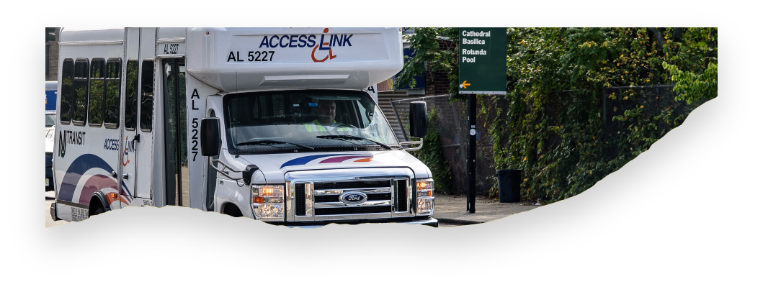

**COMING SOON! ACCESS LINK**

**APPOINTMENT TIME BOOKING**

**Access Link customers are needed to volunteer and test our new appointment time reservation feature!**

As a volunteer tester, you will be able to reserve rides by providing an appointment time. When you provide an appointment time, our computer system will calculate the best pick-up time or drop-off time for your ride. For example, you may need to be at work by 8:30 am. In this example, 8:30am would be your requested “drop-off appointment time”. Or you may need to be picked up from a friend’s house by 6:00 pm. In this example, your requested “pick-up appointment time” would be 6:00pm.

At this time, you will need to select either a drop -off time or a pick-up time. You will not be able to request both for the same ride.

If you are interested in volunteering to test this new feature, send your full name, Access Link ID number and an email address to [ktucker@njtransit.com](mailto:ktucker@njtransit.com). In appreciation of your support, you will receive a $20.00 EZ-Wallet credit after the testing has ended and you have shared your feedback.

If you are selected, you will receive follow-up instructions which will include further guidance.