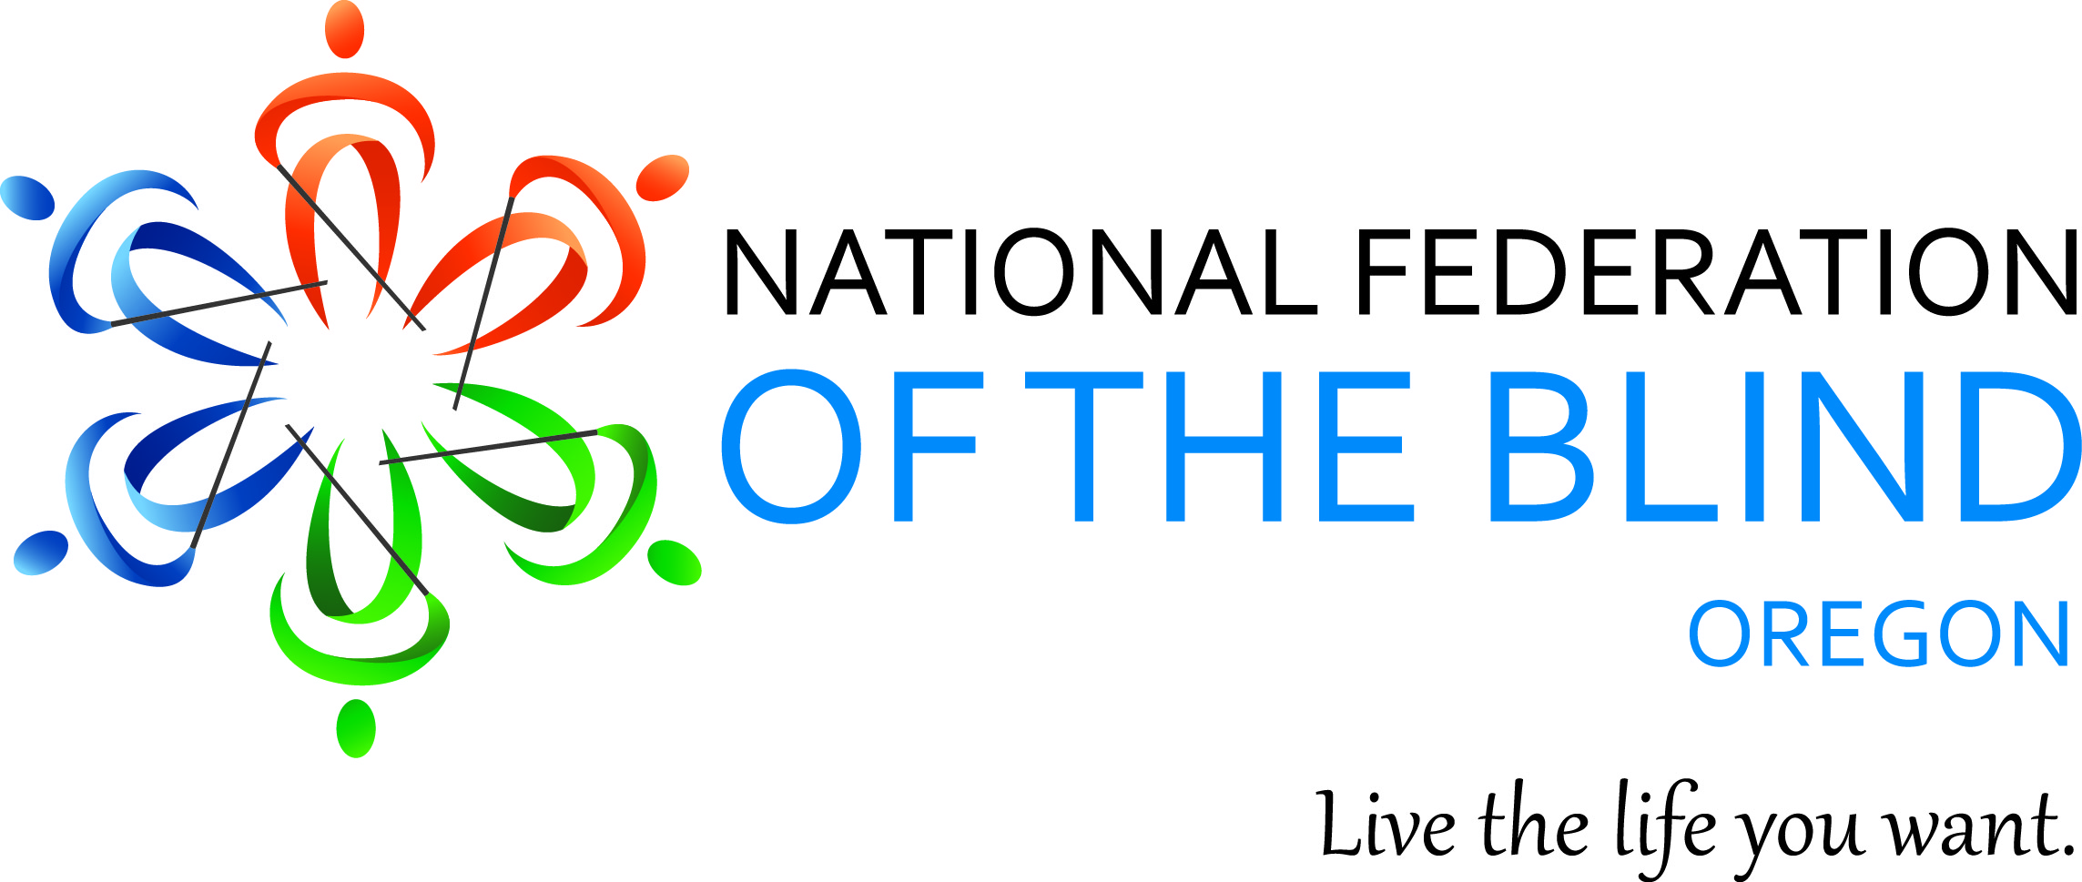
Annual State Convention
November 7th – 9th, 2014
Ramada Inn, Portland Airport
6221 NE 82nd Ave, Portland Oregon
Friday, November 7th
1:00-5:00 PM: Seminar for Parents of Blind Children, and I-Device Training workshop, and exhibitors.
6:00 PM: Auction: Start your holiday shopping early!! Join us for a live auction, food, and entertainment.
Saturday, November 8th,
9:00 AM -12:00 pm: General Sessions will feature State and National Reports, agency updates, and Member’s activities.
12:00 PM – 2:00 PM: LUNCHEON
2:00 PM – 5:00 PM Breakout sessions, including accessible phones and apps, starting your own business, the next generation of the NFB, and more!
6:30 PM: Banquet, Keynote Address: Patti Chang, Member of the National Federation of the Blind Board of Directors, and President of the National Federation of the Blind of Illinois.

Sunday November 9th:
9:00 AM – 11:30 AM: Business Meeting Elections
- Full Agenda to come.

