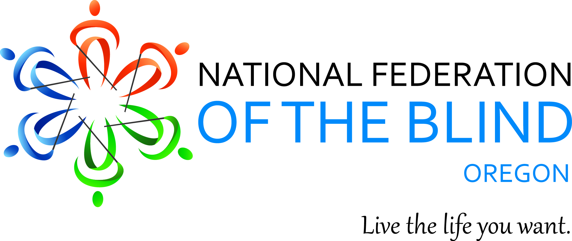

2014 NFBO Convention Registration:
Name: _______________________________________________________
Address: _____________________________________________________________
Phone: _______________________________________________________
Email: ________________________________________________________
Registration Fee: $10.00, before October 20th $ 20.00 after (Circle One)
Meals:
Friday: $________Saturday Lunch: $_______ Banquet: $ ________
Regular or Vegetarian (Please Circle one)
Meal Package: $ 50.00 ________
Total amount submitted with Registration: $ ____________
Hotel Room:
Friday 11/7/2014:_______ Saturday 11/08/2014________
Other Guests: ________________________________________________________________________________________________________________________

Payment Information:
Check_____ Credit Card: _____
Credit Card #__________________________________________________
Expiration: __________
3 Digit Code: ________
Name on Card: ________________________________________________
Address: _____________________________________________________________
_____________________________________________________________
Signature
Meals:
Friday Dinner 11/7: $15.00 Saturday 11/8: Lunch $ 18.00
Banquet 11/8: $27.00 Full Meal Package: $50.00
Hotel Room Rates are $55.00 per night (includes breakfast voucher)
Transportation: The hotel shuttle will pick up @ the airport and Max station @ the airport. Please call the hotel if you need a ride.
Registration Fees: $10.00 (by October 20th) $20.00 after October 20th
Send Registration form to:
NFB of Oregon
5005 Main Street
Springfield OR 97478 97478
541-653-9153
Fax#: 541-726-5527
Email: president@nfb-oregon.org

NOTE: To receive the special Convention Rate, Hotel reservations MUST, be made through the NFB of Oregon. You will then pay the Hotel directly upon arrival/check-in.

