The Dark Café
An Educational Fundraiser
Have you ever wondered what it is like to be blind? Find out how it is done with confidence and poise!

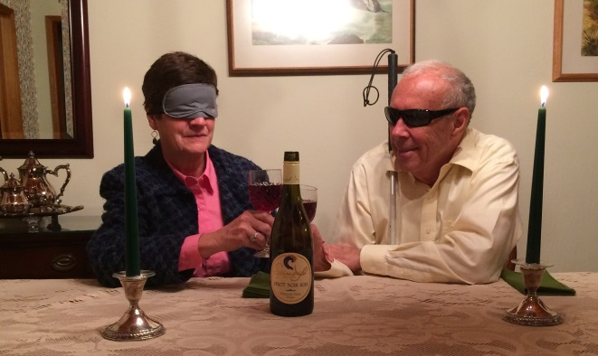

Before dinner, dawn your Sleep Shades and learn how to “do it in the dark”
- Basic Mobility Lesson
- Accessible Games and household items
- assistive technology
- braille instruction
Then, sit back and enjoy fine dining with: Choice of Entrée,
2 Glasses of wine, Dinner program, and Door prizes!
Saturday January 28, 2017
Time: 6-8 p.m. Cost: $75
Proceeds benefit the Linn-Benton Chapter of the National Federation of the Blind
National Support and Advocacy Group
To purchase tickets go to: www.nfb-oregon.org
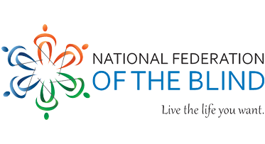
For more info about the event or help with blindness, contact:
Kristen Jocums, Linn-Benton Chapter President
P: 706-718-8055 E: kjocums@icloud.com

