Sponsor The Dark Café!!!
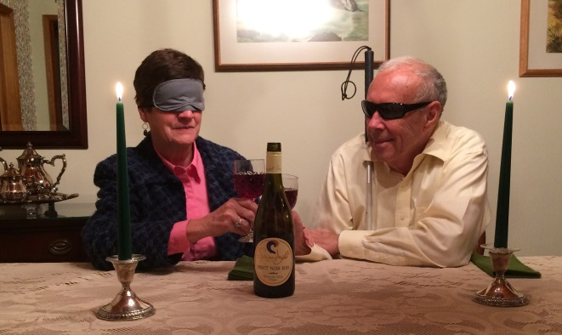

Want to help a great cause and benefit your business?
Become a Corporate Sponsor!

Bronze - $100 – List your business name on our video to be used in advertising future annual Dark café and other NFB activities, and in our program to be distributed the night of our 2017 event
Silver - $250 – 2 tickets to the Dark Café and list your business name on our video to be used in
advertising future annual Dark café and other NFB activities, and in our program to be distributed the night of our 2017 event

Gold - $500 – 4 tickets to the Dark Café and list your business name on our video to be used in
advertising future annual Dark café and other NFB activities, and in our program to be distributed the night of our 2017 event
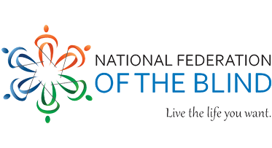

Contact Kristen Jocums at kjocums@icloud.com or 706-718-8055 for more information

