***Save the Date:***

***Dark Café 2018***

**A fun educational activity for the whole family!**

***Have you ever wondered what it is like to be blind? Bring your family and explore sports and daily activities as a blind person!***

***A picture containing tree, outdoor, ground, child

Description generated with very high confidence***

**Your Ticket Gets You:**

* [GoalBall](https://www.youtube.com/watch?v=0bZ51jzmbAQ) **(A sport developed by blind people for blind people)**
* **Basic White Cane Mobility Lesson**
* **Accessible Games and Household Items**
* **Assistive Technology**
* **Braille Instruction**
* **Question and Answer Session about Blindness**
* **Light Refreshments**

**Saturday, October 27th, 2018**

**First United Congregational Church of Christ, 4515 West Hills Rd. Corvallis, OR**

**Time: 1-2:30 (Early Session) or 3-4:30 p.m. (Late Session)**

**Proceeds benefit the Linn-Benton Chapter of the National Federation of the Blind**

**National Support and Advocacy Group**

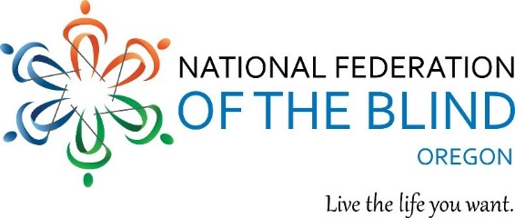

For more info about the event or help with blindness, contact:

Kristen Jocums, Linn-Benton Chapter President

P: 706-718-8055 E: [kjocums@icloud.com](mailto:kjocums@icloud.com)

W: [www.facebook.com/linnbentonchapter](http://www.facebook.com/linnbentonchapter)