# NFB Logo

# **2024 Dark Café: Lights Out Luau**

On April 28th, 2024, from 5:30pm – 7:30pm, the Linn-Benton chapter of the National Federation of the Blind of Oregon will be hosting a dark café fundraiser event: Lights Out Luau. This fun and educational evening will be a chance to experience dining without sight, while also learning about other adaptive techniques blind people use to navigate their world.

The NFB is a non-profit volunteer membership organization which believes that low expectations create obstacles between blind people and our dreams. Through a wide array of programs and services, the NFB seeks to break down barriers and raise awareness for blind equity. The Linn-Benton chapter works to further our mission in our local area of Oregon, as well as participating in activities and events on the state and national level.

Lights Out Luau ticket sales will run from February 10th to April 10th. For ticket sales or sponsorship details, visit: <https://www.nfb-oregon.org/home/chapters%20and%20divisions/linn-benton%20chapter/dark_cafe.php>

Keep informed on chapter happenings and event updates via the NFB Linn-Benton chapter Facebook page at [www.facebook.com/linnbentonchapter/](https://www.facebook.com/linnbentonchapter/) for more details to come!

If you would like to help support the Lights Out Luau fundraiser, please consider becoming a sponsor!

* **Silver Sponsorship**: $300
  + Includes two tickets to the luau and your business will be listed on print, electronic, and social media fundraiser materials.
* **Gold Sponsorship**: $600
  + Includes three tickets to the luau and your business will be listed on print, electronic, and social media fundraiser materials.
* **Platinum Sponsorship**: $1000
  + Includes four tickets to the luau and your business will be listed on print, electronic, and social media fundraiser materials.

For information on ticket sales or sponsorships, email:

[lightsoutluau@nfb-oregon.org](mailto:lightsoutluau@nfb-oregon.org)

Thank you for your support!

**Platinum Sponsors**

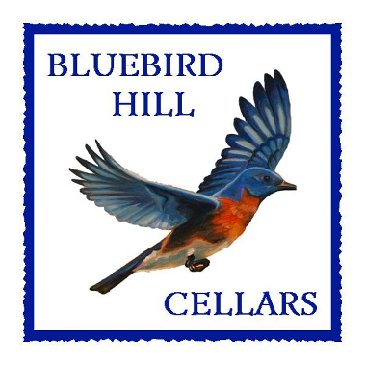 **Bluebird Hill Cellars**

25059 Larson Road  
 Monroe, OR 97456

(541) 424-2478

info@bluebirdhillcellars.wine

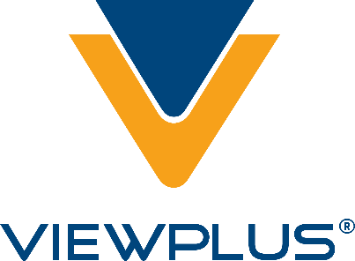 **ViewPlus Technologies Inc.**

1965 SW Airport Ave.  
 Corvallis, OR 97333

(541) 754-4002

sales@viewplus.com

**Silver Sponsors**

**Peaceful Family Solutions, LLC**

"Be the parent you are meant to be."  
Alternative dispute resolution for divorce and custody

Kristen Jocums, J.D.

(541) 286-4738

kristen@peacefulfamily.net

