Join Master Birder **Karin Lamberson**

for

Birding by Ear 2024

Hosted by the

**Linn-Benton Chapter of the**

**National Federation of the Blind of Oregon**

**Date: Saturday, May 11th 2024**

**Time: 9 am – 11 am**

**Where: OSU Campus Farms to the Covered Bridge**

(Pathway is paved and accessible for wheelchairs)

No special clothing or equipment required!

Download and practice with the Merlin app to

get a jump on the experience!

Questions about the event, to sign up for a ride or to

get information about vision loss, contact:

Kristen Jocums

[kjocums@icloud.com](mailto:kjocums@icloud.com)

706-718-8055

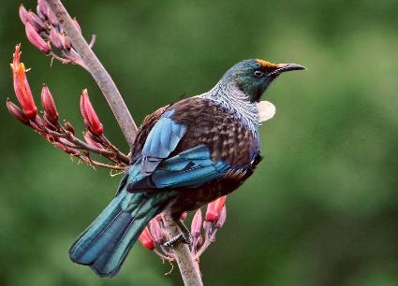

[This Photo](https://en.wikipedia.org/wiki/T%C5%AB%C4%AB) by Unknown Author is licensed under [CC BY-SA](https://creativecommons.org/licenses/by-sa/3.0/)