# NFB logo

# **2024 Dark Café: Lights Out Luau**

On April 28th, 2024, from 5:30pm – 7:30pm, the Linn-Benton chapter of the National Federation of the Blind of Oregon will be hosting a dark café fundraiser event: Lights Out Luau. This fun and educational evening will be a chance to experience dining without sight, while also learning about other adaptive techniques blind people use to navigate their world.

Thank you to members of our local Hawaiian community whom we consulted with for this event. Through their guidance, The Lights Out Luau is designed to be a culturally sensitive and accessible exposure to Hawaiian traditions. Activities will include an introduction to traditional hula, taught with accessible methods for blind people by Hawaiian dancers.

The NFB is a non-profit volunteer membership organization which believes that low expectations create obstacles between blind people and our dreams. Through a wide array of programs and services, the NFB seeks to break down barriers and raise awareness for blind equity. The Linn-Benton chapter works to further our mission in our local area of Oregon, as well as participating in activities and events on the state and national level.

Lights Out Luau ticket sales will run from February 10th to April 10th. For ticket sales or sponsorship details, visit: <https://www.nfb-oregon.org/home/chapters%20and%20divisions/linn-benton%20chapter/dark_cafe.php>

Keep informed on chapter happenings and event updates via the NFB Linn-Benton chapter Facebook page at [www.facebook.com/linnbentonchapter/](https://www.facebook.com/linnbentonchapter/) for more details to come!

If you would like to help support the Lights Out Luau fundraiser, please consider becoming a sponsor!

* **Silver Sponsorship**: $300
  + Includes two tickets to the luau and your business will be listed on print, electronic, and social media fundraiser materials.
* **Gold Sponsorship**: $600
  + Includes three tickets to the luau and your business will be listed on print, electronic, and social media fundraiser materials.
* **Platinum Sponsorship**: $1000
  + Includes four tickets to the luau and your business will be listed on print, electronic, and social media fundraiser materials.

For information on ticket sales or sponsorships, email:

[lightsoutluau@nfb-oregon.org](mailto:lightsoutluau@nfb-oregon.org)

Thank you for your support!

**Sponsors**

**Platinum Sponsors**

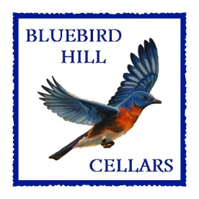 **Bluebird Hill Cellars**

25059 Larson Road  
Monroe, OR 97456  
541-424-2478  
info@bluebirdhillcellars.wine

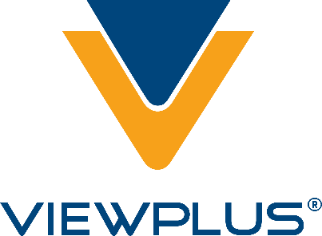**ViewPlus Technologies Inc.**

1965 SW Airport Ave.  
Corvallis, OR 97333  
541-754-4002  
sales@viewplus.com

**Anonymous Corvallis Couple**

**Anonymous Corvallis Family**

**College of Science**

**Gold Sponsors**

**Halau Hula O Hawaii**

Hawaiian Dance School

By Linda Marquez-Schmidt

541-754-6990

lindamm.schmidt@outlook.com

**Silver Sponsors**

**Peaceful Family Solutions, LLC**

"Be the parent you are meant to be."  
Alternative dispute resolution for divorce and custody  
Kristen Jocums, J.D.  
541-286-4738  
kristen@peacefulfamily.net

**Silver Sponsors (cont.)**

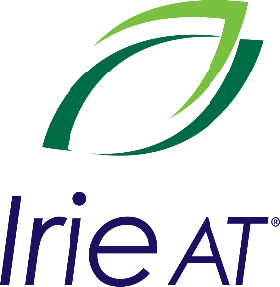**Irie-AT**

1-888-308-0059 (toll free)

+1 541-360-3007

sales@irie-at.com

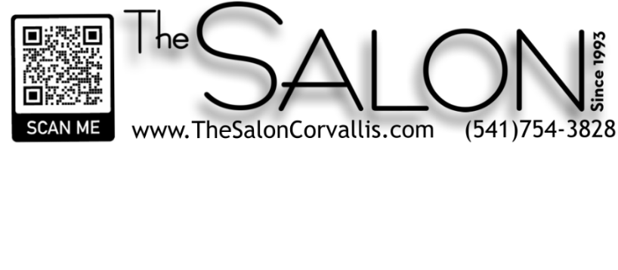

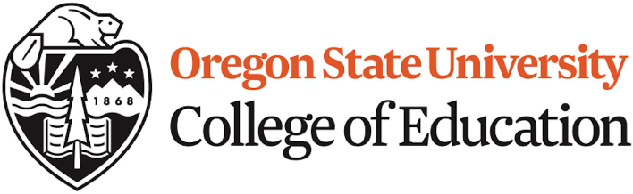

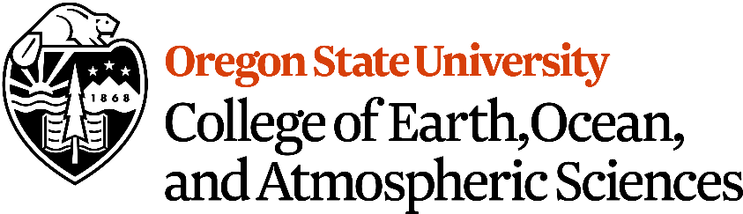

https://ceoas.oregonstate.edu/

**New Morning Bakery**

219 SW Second St.

Corvallis, OR 97333

541-754-0181

info@newmorningbakery.com