**How accessible is Albany? The city found out**

**Shayla Escudero**

It has almost been 32 years since the Americans with Disabilities Act was signed into law. Its aimed at prohibiting discrimination and giving people with disabilities the same opportunities as everyone else; however, most of the country is still not built for people with disabilities in mind…

Top of Form

Bottom of Form

After evaluating how easy it is — or not — to get around Albany, plans are being put in place to ensure the city is more equitable for its residents who have disabilities.

It wasn’t a surprise to city staff, who set out to evaluate and create a transition plan to comply with the Americans with Disabilities Act — that there's a lot of work that needs to be done to make Albany accessible for all.

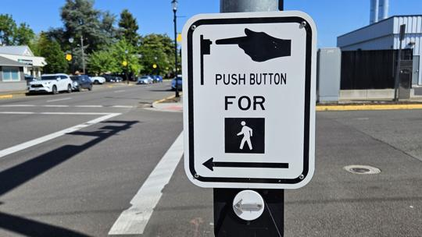

Photo Caption:

A crosswalk at Sixth Avenue and Ellsworth Street in Albany uses a voice recording to let pedestrians know when it is safe to walk.

SHAYLA ESCUDERO, Mid-Valley Media

Andrea Barnhurst takes her guide dog, a black Labrador named Bali, wherever she goes. She uses the same crosswalks, parking lots and public spaces that any Albany resident might. But as a blind person, she experiences those spaces differently, noticing shortfalls to which others may never give a second thought.

For instance, does the crosswalk she is using have an audible system to alert her when it is safe to walk? Is there a tactile marker at the edge of the curb to divide the sidewalk from ongoing traffic?

“Unless you live in my shoes, you don’t fully understand what it’s like to be me,” Barnhurst said.

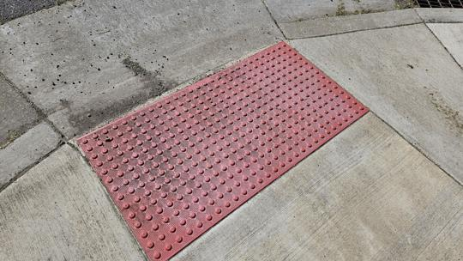

Photo Caption:

A tactile paver at the edge of an Albany crosswalk is painted red. The marker alerts people with low vision that there is a crosswalk or transition nearby. The preferred color is a bright yellow, since other colors are dull and not as easy to distinguish.

SHAYLA ESCUDERO, Mid-Valley Media

Blindness, like all disabilities, is a spectrum, she said. The majority of people in the blind community have some form of vision. So it’s important to think about the colors and contrasts of signage, so that blind people are able to read them, she said.

Barnhurst, a former Albany resident who lives in Tangent, was one of the members of the stakeholder group that provided suggestions to the city while formulating ADA transition plans.

When the city was working on specific guidelines for accessibility in the city’s right-of-ways, she told them how tactile markers at the edges of the curb were often painted colors that made it difficult for blind people to recognize.  Often blues and reds are chosen, and they're difficult to distinguish, she said. The preferred color is a bright yellow, she said.

As soon as she made the suggestion, the city started making changes to the markers, Barnhurst said.

As the only member of the blind community giving input, it was important for Barnhurst to have a seat at the table. The group also consisted of those with limited mobility and other disabilities.

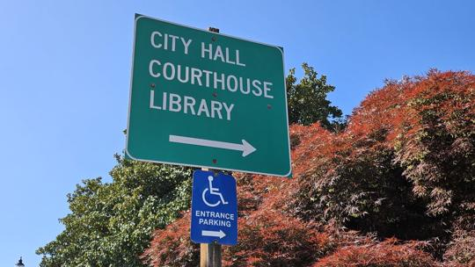

Photo Caption:

A sign points to an entrance that can accommodate mobility devices at Albany City Hall.

SHAYLA ESCUDERO, Mid-Valley Media

“I’m glad the city did this, I wish more cities did more to fix problems with accessibility,” she said.

Using a consulting service, Albany’s walkways, parks, policies, services and public spaces were evaluated to see how accessible they are to people with disabilities.

The action falls under a Title II requirement from the Americans with Disabilities Act to produce a plan and remove accessibility barriers over time. The plan, a two-year undertaking, was approved at the May 8 City Council meeting.

The report reviewed door sizes, counter and drinking fountain heights, curb heights, ramps for physical access as well as policies by looking into city code and surveying city staff. What resulted was a 400-page document outlining barriers, recommendations for improvements and future projects.

“It’s so easy to not think about it when you don’t have to, but it’s important to realize these are the things we need to change for the whole of citizens,” Library Director Eric Ikenouye said. He oversaw the plan and is the designated person to receive disability discrimination complaints.

Most of the city’s facilities were created decades ago, predating federal guidelines. So it isn’t a surprise that the to-do list to make the city more accessible was a long one, Parks and Recreation Director Kim Lyddane said.

The parks department has already made some headway in making public spaces more accessible. Whenever there is a park project, they address ADA shortcomings, but they also try to go above “bare minimum,” Lyddane said.

Some newer projects, such as **Lehigh park’s sensory playground**, are thought of with accessibility in mind, Lyddane said.

Having tactile elements in a playground can help blind children build on skills to eventually read Braille, Barnhurst said.

The parks department is also looking at doing some concrete work and adding more ramps to make public spaces more accessible. Signage changes and the amount of time a door opens to allow someone to pass through have already undergone changes at the Albany Community Pool.

Lyddane said she is excited to engage more with the people in the disability community. Sometimes, that means meeting families at playgrounds to see how equipment works for them and hear their feedback, she said.

Albany is slowly chipping away at the list, but it is a living document, Ikenouye said. Things will get added and removed.

"My hope is that all city staff grow in awareness of different accessibility issues to better serve everyone," he said.

To learn more about Albany’s accessibility plans, visit: **https://bit.ly/4bdku0P**.