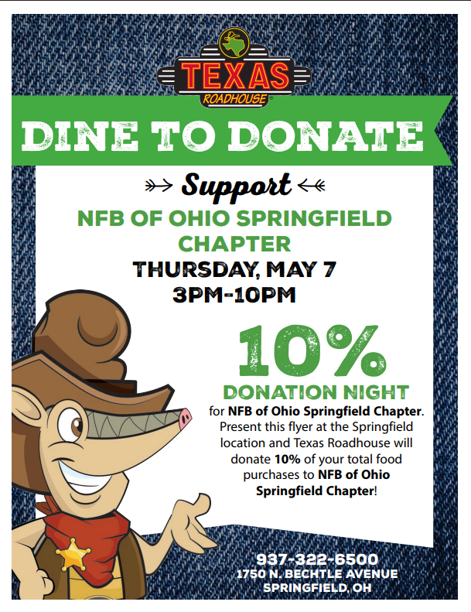
National Federation of the Blind of Ohio, Springfield Chapter
National Federation of the Blind oOOOOOOOOoooOhioOoOof

