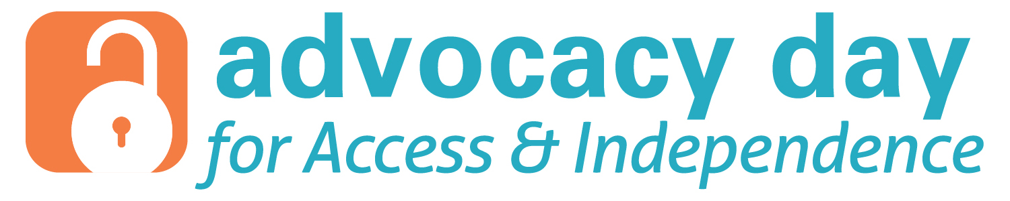
Join us on
April 26, 2016 9:30am!
On the North Steps of the SC State House

A rally to unlock the barriers for South Carolinians with Disabilities featuring:
- Speakers from the disability community
- Local allies
- Law and Policy Makers
- Support for meeting with your State Senator or Representative

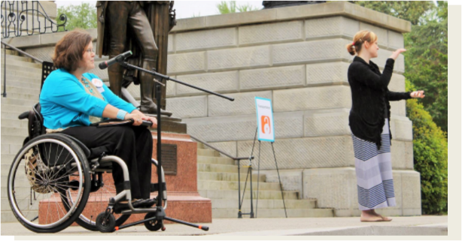
Join the Movement!
T-shirts available on first come, first serve basis.
Registration is FREE! To register or for more information:

Visit unlockingbarriers-sc.org
Or call (803) 779-5121 (voice)
(803) 779-0949 (TTY)

With a united voice, the disability community can band together to make South Carolina a more accessible and inclusive place to live!

