COLUMBIA CHAPTER NEWSLETTER - NOVEMBER 9, 2017

UPCOMING ACTIVITIES
There will be a BINGO Fundraiser on Saturday, November 11 at the Federation Center. Food will be served between 11:30 a.m. and 1:30 p.m. and the $6 menu is as follows: Your choice of a Hot Dog Basket, Hamburger Basket or Wing Basket with a salad. The fundraising BINGO takes place between 2:00 p.m. and 5:00 p.m. BINGO Cards will cost $4 for one, $7 for two and $10 for three cards. Our usual free BINGO will be held on Thursday, November 16.

SUMTER CHAPTER ANNOUNCEMENT
The Sumter Chapter of the National Federation of the Blind of South Carolina invites YOU. All tables have been reserved and we are now offering individual tickets at available seating at tables for $25 (While they last) for the gala…Sumter Chapter, National Federation of the Blind, 44TH Annual Fundraiser Christmas Gala, Tuesday, December 12, 2017, Keynote speaker Mr. Shawn Callaway, NFB of DC affiliate president, Trinity Missionary Baptist Church, 155 Wall Street, Sumter, SC 29150, 6:30 p.m. Semi-Formal Affair, Dinner served at 6:45 p.m., Donation $25.00
For give-a-way prize eligibility you MUST write your name on the back of the ticket before arriving at the gala and present at the door. If interested please respond.
Mega thanks, Debra Canty, Gala Planner and Organizer

ORLANDO NFB CONVENTION 2018 $1 BUS TICKETS
If you did not receive your 25 count pack of 2018 $1.00 Orlando bus tickets at last night’s Columbia Chapter meeting or if you need more, contact David Houck at 254-3777 to get yours sent to you. Sold ticket stubs and cash can be turned in to David Houck as well at the Federation Center. The winning ticket drawn at the January 6 Statewide Seminar will yield the purchaser $300, the seller $100 or if you bought your own ticket, $400. The chapter which sells the most bus fund tickets will receive $300 for its treasury. Let’s work hard so that the Columbia Chapter wins again!

2018 STATEWIDE SEMINAR
Get your 2018 calendar and mark that calendar now for January 6, 2018 Statewide Seminar which begins at 10:00 a.m. Don’t forget about the auction for the Federation Center and the NFB Orlando Convention bus ticket drawing! An NFB of SC Board of Directors meeting will take place during the luncheon.

NOVEMBER 9 COLUMBIA CHAPTER MEETING
President Tiffiny Mitchell gaveled the meeting to order at 6:15 p.m. Steve Cook welcomed everyone attending the meeting and monthly birthdays and visitors were recognized. Keep Wanda Sheck in your prayers as well as Steve and Brandon as Wanda had a foot amputated. The Church of the Harvest provided a delicious Thanksgiving dinner. President Mitchell recognized the church and Pastor Ken Jumper who gave the Thanksgiving devotional on Psalm 23. Levon Stack sang a few hymns and patriotic songs as well. Eighty chapter members were present and with volunteers from The Harvest, numbers swelled to 100 attending the meeting. Dr. Capps spoke, showing his gratitude for the work of The Harvest and for being able to be present for the evening.
NFB of SC President Frank Coppel addressed the gathering concerning the Statewide Seminar, Orlando bus ticket sales and the fact that attending other local chapter Christmas parties in December will prevent him from being at our December 14 chapter meeting. Those wishing to participate in the birthday pantry club for 2018 needed to contact Dorothy Barksdale at 765-1622 to give her your list of items by the November 30. There was no Treasurer’s report. The 50-50 drawing was made and Catherine Williams won $50. Isaiah Nelson reported that at 2:00 p.m. on Thanksgiving Day there will be a Thanksgiving dinner provided with all the trimmings at a cost of $10 per person. Transportation may be provided. Call Ike at 413-2434 before Thanksgiving week if you plan to attend.

Tiffiny Mitchell, President, Columbia Chapter, NFB of SC

The Harvest's Pastor Ken Jumper: Still Showing Up Every Day
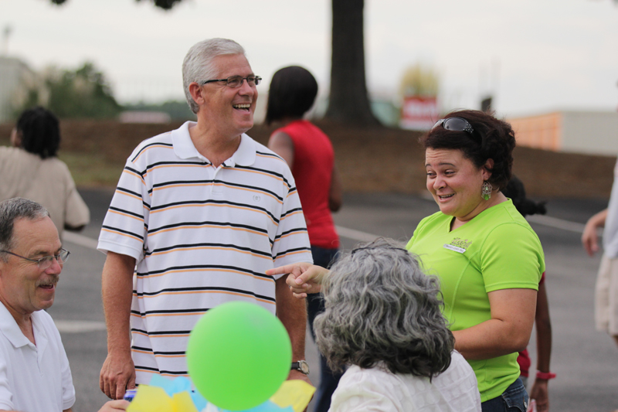
The Story
Log on to the Harvest’s website and you’ll find the following recap of the church history:
In 1988, Pastor Ken Jumper and his late wife, Connie, were serving under Pastor Arlie Whitlow and the Community Church in Northern VA when they felt the call to start a church in Columbia, SC. The first service at Church of the Harvest was held on August 13, 1989 at what was then Irmo Campus Middle School. We rolled out carpet, set out plants and preached the word to 30-50 people.
A couple years later in 1991, Harvest moved to the “Candi Lane” location near Riverbanks Zoo. God really grew a strong leadership core during these years and many memories were made. In the mid 1990’s we were able to purchase property on Hwy 378 and began construction on our very first building. We had many Saturday night prayer meetings on this property, dedicating our lives and service to His church. The first service in our new building was on Easter Sunday morning 1996.

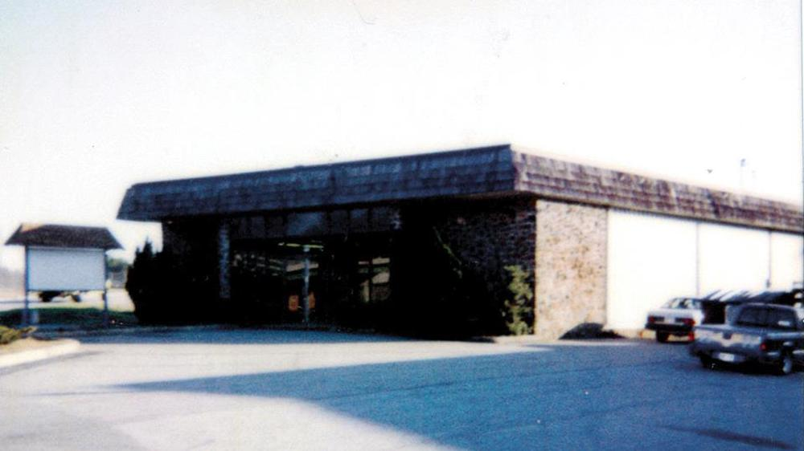
(Candi Lane building)
Since that day God continued to grow and bless our church. We extended our first building to make more room in the sanctuary and nurseries and eventually added our current sanctuary in 2006. In 2008, we expanded our territory and launched our first campus in Northeast Columbia! Then, in 2009 we had the opportunity to purchase the Whiteford Campus and Daycare and began services that September. Recently, we purchased a new building for our Northeast Campus and had our first service there in January 2014. It has been awesome to be a part of HIS story and we look forward to all God is going to do at Harvest in the coming years. To God be the glory.
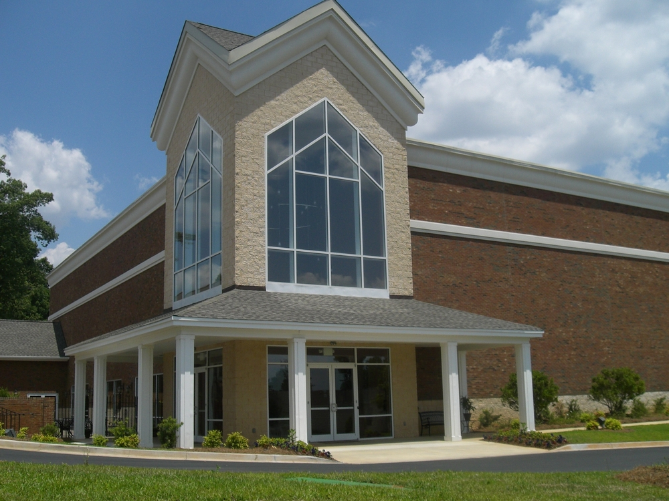
(Main campus sanctuary today)
The Story Behind the Story
Pastor Ken Jumper, affectionately known by all as “PK,” is the only pastor Lexington’s Harvest Church has ever known. Now in his early sixties, his good looks, soft spoken demeanor and stylish dress still render him immediately recognizable to many in the community. Some know him as their pastor. Others know him from his participation in many community events and organizations. And still others only know him from his morning segments on WACH Fox’s Thought For the Day.
By all appearances, one would assume the secret of his and the Harvest’s success are in large part due to his pleasant appearance, personality, charisma and penchant for cutting edge marketing, technology and social media engagement.
One would be wrong.
Despite his recognizability, few are familiar with the path that’s brought him to this point.
The Seeds of Success
Surprisingly, Pastor Ken does not attribute the success of the Harvest to any great talent, revelation or strategy. He attributes it in large part to the simple act of “just showing up every day.”
A product of parents who were “faithful every day” to work, family and community instilled in him an appreciation for faithfulness and consistency. “’They just showed up every day’” Pastor Ken stated, “and that obviously influenced me to never consider living my life any other way.”
Fast forward to 1988 as young Pastor Ken is about to leave his mentor Pastor Arlie Whitlow and start a new church in Columbia, SC, Pastor Whitlow imparts the almost humorous words of advice to him on how to achieve success as a pastor: “Just show up every Sunday and don’t do anything stupid.”
Little did he know that this heritage of “just showing up” would prove to be just the quality, the only quality, that could get him through what lay ahead.
A Rough Start
Just after starting their new church and right after the birth of their second daughter, Pastor Ken’s 25 year old wife Connie was diagnosed with life-threatening cancer. He spent the next 5 months driving to Duke Hospital immediately following the Wednesday night service and then returning home Saturday in time to preach the following day.
From Bad to Worse
Six months after Connie’s return from Duke, the young couple once again find themselves in an unexpected battle. Connie began to lose her eyesight as a side effect of the radiation treatments. Eventually she became completely blind leaving her husband as the sole caretaker of her, their two small daughters and their young church.
When asked if he ever questioned God, felt this was unfair and wanted to quit he responded “sure! Connie and I had our ‘I hate I’m blind days’ but at the end of the day, even though we didn’t understand, we knew God loved us and this was just a part of our journey. Running was never an option.”
“I still loved her but there were days I didn’t like her very much. But I had to remind myself that she didn’t want to be like that either. One of the revelations that kept me from becoming bitter was when God revealed Colossians 3:19 to me. It says ‘husbands love your wives, and be not bitter against them.’ It was then that I made the decision to perform acts of love toward my wife in spite of my emotions to the contrary. Eventually the acts overcame the emotions and bitterness wasn’t able to remain.”
Fast Forward
Fast forward 30 years, Connie begins suffering from Alzheimer’s and dementia. Yet instead of viewing this new challenge with a “why me” attitude, Pastor Ken stated that he felt he was “given the blessing of caring for one of God’s great saints. Through it all she never lost her faith.”
Connie passed away in 2013 at the age of 60. She and PK were married 37 years, 32 of them she was blind, and the last 5 in Alzheimer’s and dementia.
Seeds Produce Fruit
To what does Pastor Ken attribute the church’s success? Why do people seem to be drawn to the Harvest?
“I think my life’s path helps me to appreciate and sympathize with people’s struggles better. I can not only understand and minister to the person in the hospital, but also the person in the chair beside the bed. I’ve been there and done that. I know what they are going through.”
“Speaking to the message of suffering helped shaped the Harvest’s vision of being a refuge for the hurting. We might all be pretty people on the surface but look behind the curtain in everyone’s life and you will see that it’s not very pretty. We’ve all got struggles and issues.”
“I’ve got a young man right now in our congregation that will shortly die of cancer if God does not intervene and heal him. I can’t have fluff on Sunday. It’s got to be real.”
Not Just A Slogan
The Harvest’s mission is:
Creating a place of love and grace for all people where everyone is becoming a wholly, devoted, passionate, follower of Jesus Christ.
It’s popular these days for churches to have a slogan, or vision or mission statement that defines what their church is about. One that is catchy and marketable. Sometimes, in this big church age, one can’t help but wonder how sincere these statements really are. When considering the Harvest, that question never enters one’s mind.

